五年级英语期中测验题
听力部分略
笔试部分
一、找出划线部分发音不同的单词（5%）。

（ ）1、
（ ）2、
（ ）3、
（ ）4、
（ ）5、
A、sweater
A、brown
A、mouse
A、eat
A、tall
B、teacher
B、snow
B、cow
B、sheep
B、class
C、meat
C、yellow
C、coat
C、great
C、small

二、填上合适的词，使句意完整通顺（10%）。
1、I like beef, because it’s .
2、 is the first day of a week.
3、My mother isn’t tall. She’s .
4、Peaches and watermelons are .
5、Mr Li is very old, he’s very active.
6、We have on classes on and .
7、Today is Tuesday. Tomorrow is .
8、What’s her father ? He’s fat.
9、Mr Liang is our math teacher, we all like .
三、根据上句写下句，或根据下句写出上句（10%）。
1、A: ?
B:We have fish and tomatoes.
2、A: ?
B:Today is Friday?
3、A: ?
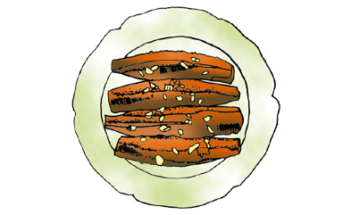
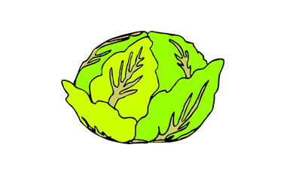
B:I often play ping-pong on Sundays.
4、A:What would you like for dinner?
B: .
5、A: ?
B:My art teacher is Mr Ma.
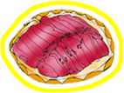

四、看图填空（10%）。
1、What would you like for dinner?
and ,pleas.
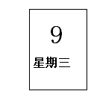
2、 day is ?
It’s .

do you ?
We have art, computer and Chinese.
3、I often in the evening.
4、I like apples. I bananas.

（但是不喜欢）
5、A:I’m heavy now.
B:What you have lunch today?

A:I have and .
B:Oh, no wonder（怪不得）！
6、A:What’s he like?
B:He’s and .
7、A:What do you have dinner?
B:I have two hamburgers. about you?
A:I have nothing. I’m hungry.
五、选择题（10%）。
（ ）1、What he do on Sunday?
A、do B、does C、is
（ ）2、What you like for lunch?
A、are B、do C、does
（ ）3、How many people are there your family?
A、in B、on C、with
（ ）4、What do you have Monday?
A、in B、on C、with
（ ）5、Tom fish very much.
A、like B、likes C、liking
（ ）6、I like apples very much, they’re sweet.
A、but B、and C、because
（ ）7、 time is it now?
A、How B、What C、When
（ ）8、What do you do on Sundays? I .
A、play violin B、play the violin C、plays the violin
（ ）9、It’s time lunch.
A、for B、to C、for have
（ ）10、Is she university student?
A、 a B、the C、an
六、把问句与答句连接起来（6%）。

What’s you aunt?
What’s your grandma like?
What’s the weather like today?
What do you have for dinner?
Do you watch TV at night?
Is Mr Zhao active?
I have beef and tomatoes.
She’s a nurse.
She’s old and kind.
Yes, he is.
No, I don’t.
It’s fine.

七、阅读短文，判断下列各题，对的打“T”，错的打“F”（5%）。
Zip:What’s your favourite food, Zoom?
Zoom:I like beef, but I’m heavy now. I have to eat vegetables. What about you, Zip?
Zip:I like chicken. It’s tasty. Do you like fruits, Zoom.
Zoom:Yes, carrot juice is my favourite It’s fresh and healthy.
Zip:I like fruits. But I don’t like strawberries. They’re sour.
1、Beef is Zoom’s favowrite food.（ ）
2、Zoom can eat a let of meat.（ ）
3、Zoom likes carrot juice because it’s fresh and healthy.（ ）
4、Zip likes strawberries because they’re sour.（ ）
5、Zip’s favourite food is chicken.（ ）

