小学五年级英语第二学期第五单元测试题
听力部分 略
笔试部分
- 根据答句写问句。（10分）
1. ______________________________________?
The kangaroos are jumping.
2. ______________________________________?
No, it isn’t. The bear is sleeping.
3. ______________________________________?
Yes, I can see two monkeys. They are swinging.
4. ______________________________________?
It’s June 1st, our Children’s Day.
5. ______________________________________?
Because I can plant trees in spring.
- 根据上下文的意思，补全下列对话。（10分）
Ken: ____________________________________?
Sue: I see two tigers.
Ken: ____________________________________?
Sue: They are near the river.
Ken: ____________________________________?
Sue: They’re swimming.
Ken: ____________________________________?
Sue: Yes, they can really swim.
Ken: ____________________________________?
Sue: No, I can’t see any elephants.

- 结合上下文和图画的意思在下面的短文的空格上填写适当的单词，将短文补充完整。（10分）
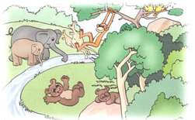
Look at the ________. There _________ many
animals here. The monkey is ____________.
The ________ are singing in the tree. The
elephants are __________ __________ by the
river. The kangaroos __________ __________.
Oh, look there, the little bear ______ ________
under the tree.

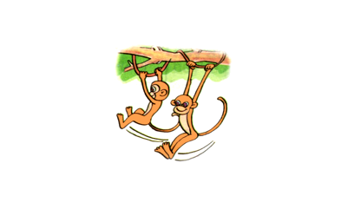
- 作文：看图写一写图上的动物正在干什么，写5句话。（10分）
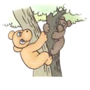

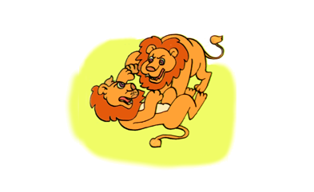


————————————————————————————————
————————————————————————————————
————————————————————————————————
————————————————————————————————
————————————————————————————————
- 阅读理解，选择正确的答案，把编号写在前面的括号里。（10分）
Miss white is a primary school teacher. She teaches math. She is very responsible (负责) and she loves all the students. Usually she gets up at 6:20 in the morning. But this morning she gets up at 5:40, because she is on duty today. First, she gets ready for classes at home, then she goes to school at 6:50. At 7:00, she comes back to school. Then she eats breakfast in the canteen. At 7:20, she stands at the gate (大门) of school and wait for her students to come back school.

( )1. When does Miss White usually get up in the morning?
A. At 6:20. B. At 5:40. C. At 6:30.
( )2. Why does Miss White get up so early this morning?
- Because she loves all the students.
- Because she is on duty today.
- Because she gets ready for classes.
( )3. Where does she eat breakfast?
A. At home. B. In a restaurant. (餐厅) C. In the school canteen.
( )4. What does Miss White do?
A. She is a music teacher. B. She is an English teacher.
C. She is a math teacher.
( )5. Does she get ready for classes this morning?
A. Yes, she is. B. Yes, she does. C. No, she doesn’t.

附加题：选词填空。（10分）
( )1. Can bear ___________? No, they can’t.
A. swim B. swimming C. swims
( )2. What is _______ mom doing? __________ cooking dinner.
A. your…. He’s B. you…. She’s C. your….She’s
( )3. There is a call ____________.
A. to you B. for you C. at you
( )4. _______ the tiger sleeping? No.
A. Is B. Are C. Do
( )5. _______ are the fish? They are in the river.
A. Where B. What C. Who
( )6. _______ pencil do you like best? I like the blue one best.
A. Which B. Where C. What
( )7. Why do you like summer? Because I can swim _____ summer.
A. on B. in C. at
( )8. _____ Sarah usually go to school at 7:00? No, she doesn’t.
A. Do B. Is C. Does
( )9. What’s the __________? It’s October _______, our National Day.
A. date….1th B. date….1st C. day….1st
( )10. How _____ are you? I’m fourteen.
A. much B. old C. many

