
级期中检测
英语试卷（5A）
班级___________姓名___________成绩___________
听力部分（30％）
- 听录音,圈出与录音内容相符的图片（5%）
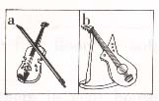
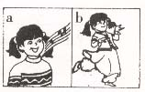
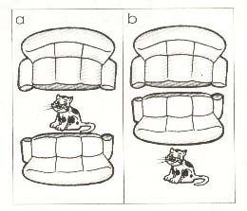

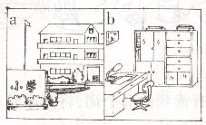
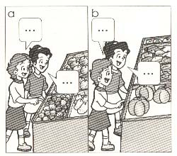

- 听录音,给图片标号(5%)
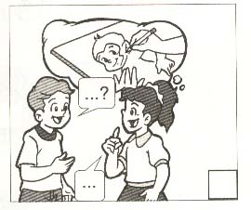
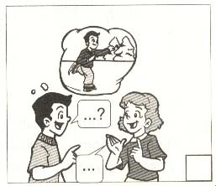
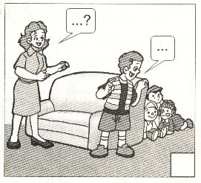

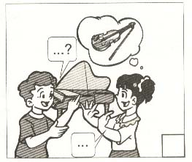
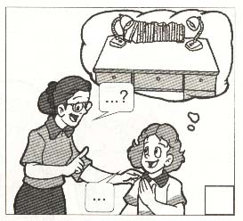

- 选择你听到的单词或词组（5%）
( )1.A. my parents B. his parents C. her parents
( )2.A. have an ice cream B. have a lesson C. have lunch
( )3.A. listen to me B. follow me C. let me try
( )4.A. together B. friend C. sometimes
( )5.A. on Sunday B. on Saturday C. on the first floor
- 根据你听到的句子，选择正确的答案（5%）
( )1.A. OK. B. No, there isn’t. C. Let’s go.
( )2.A. All right B. Glad to see you ,too. C. That’s all right.
( )3.A. It’s a desk. B. Yes, I do . C. There is a book.
( )4.A. I can sing a song. B. No, I can’t. C. I’m OK.
( )5.A. On the wall. B. A map of China C. Two.
- 听录音,完成对话,每空一词（10%）
Hello, I’m Mike Brown . I have a sister, Helen . My father is a _________ and my mother is a bus driver . They don’t _________ on Saturdays and Sundays . They like ____________ on Sundays . They like __________ ,but Helen and I don’t . We like ___________ table ___________ with our friends . In the evenings we watch TV . Sometimes Mike and I ___________ to ____________, but my ___________ don’t . They like __________ .
笔试部分（70％）
- 选择与给出单词划线部分读音相同的单词并将其序号填入括号内（5%）
( )1. apple A basketball B rabbit C plate
( )2. glass A class B glad C grape
( )3. bookcase A cat B map C table
( )4. sports A students B birds C this
( )5. she A these B very C red
- 补全单词并写出中文。（10％）
1. h _ _ se ( ) 2. l _ _ ge ( )
3. st _ dy ( ) 4. d__n___e ( )
5. m __ __k ( ) 6. l __sson ( )
7. f _ m _ ly ( ) 8.ch _ ck _ n ( )
9. _ v _ ning ( ) 10. d __ ck ( )
- 词组翻译（15％）
1. each other________________ 2. 看一看 _____________
3. good idea________________ 4. 在课桌下面_____________
5. live in a new house_____________ 6. 弹吉他 _____________
7.two o’clock in the afternoon_____________8. 骑自行车____________
9. a Halloween party_______________ 10.他的家庭________________
四、根据中文意思，完成下列句子。（10％）
1．在这幢大楼里有些电脑房吗？是的，有。
______ there ______ computer rooms ______ the building ? _______, there ______.
2. 在你的房间里有什么？ 有一个沙发在床边上和一个台灯在桌子上。
_________ in your ______________ ? There’s a ________ beside the bed, and there’s a ________ on the desk .
3．这个男孩会溜冰，但这个女孩不会，她会滑雪。
The ______ can ________ , but the _________ ________ . She can _________ .
4．你喜欢什么？我喜欢花。
________ do you _________ ? I like ____________ very much .
5.我会唱歌，我也喜欢唱歌。
I can ________ and I ______ _________ , too .
五、 情景匹配。（10％）
Ⅰ Ⅱ
( )1. How many candles do you need? A. Yes, there is.
( )2. Do you like pies? B. Good idea.
( )3. How much is the pumpkin? C. I can make a cake.
( )4. Is there a sports hall? D. No, I don’ t. I like chips,
( )5. Shall we go and play there? E. Ten yuan, please.
( )6. Can you put a book on your head? F. Yes, I can.
( )7. What can you make? G. Yes. I do.
( )8. Do you like pigs? H. I need ten candles.
( )9. What do you like ? I. We need some chocolate .
( )10.What else do you need ? J. I like puppets .
六、选择题（10%）
( ) 1. How many reading rooms ______ in the building?
A. there are B. are there C. there is D. is there
( ) 2. All the students are back _____ school .
A. to B. at C. in D. on
( ) 3. Now boys and girls , _______ me , please .
A. make B. learn C. follow
( ) 4. The bedroom is ________ the sitting room .
A. at B. on C. near D. in
( ) 5. It is ________ of the new term.
A. first day B. the first day C. a first day
( ) 6. Where _____ the music room ?
A. am B. are C. is D. ’s
( ) 7. There’s a map ____ China on the wall .
A. of B. on C. in D. from
( ) 8. Can you put a bike on your head? __________ .
A. Yes, there is B. Yes, I can C. Ok.
( ) 9. Are there ______ pictures on the wall?
A. some B. a C. any D. an
( ) 10.What do you like ? ___________.
A. I can sing B. Yes, I can C. I like skating
七、改错题(5%)
( ) 1、The boy can play basketball and the girl can play violin.
A B C
( ) 2、I like horse.
A B C
( ) 3、Are there some books on the desk ?
A B C
( ) 4、Helen can playing the piano.
A B C
( ) 5、Mike, here’re some toy cars to you.
A B C
八、阅读理解(5%)
This is a picture of our class. You can see twenty-eight boys and twenty- seven girls in our class. There is an American（美国的）student in our class. His name is David. His English is very good. We all like him. He likes eating bread and cakes. He likes drinking milk and apple juice. We like eating rice and drinking tea. We are very happy together.
( ) 1. How many students are there in the classroom?
A. twenty-eight B. fifty–five C. twenty- seven
( ) 2. David likes eating .
A. cakes B. apples C. bread and cakes
( ) 3. David likes drinking .
A. apple juice B. milk C. milk and apple juice
( ) 4. What do the Chinese students like eating and drinking?
A. rice and tea B. bread and milk C. cakes and juice
( ) 5. Where is David from?
A. China B. the USA(美国) C. Japan

