京翰教育温馨提示：同学们，在过去的学期里，我们曾付出了辛勤的汗水，今天就让我们尽情采摘成功的果实吧！
五年级英语期末试卷
听力部分(40分)

同学们，寒假又来临啦！现在就让我们在几十分钟内进行一次奇异之旅吧！

一、Listen and number (旅行即将拉开序幕，想赢取免费机票吗？只要把所听到单词的正确顺序排出来，就有机会哦!)(12分)

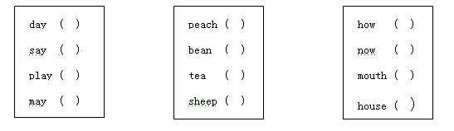

二、Listen, choose and write (登机啦！戴上“伸缩耳”，听听广播，把有用的信息填到正确的位置，你就会找到你的座位!)(10分)

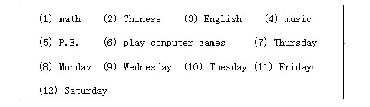

Model：I have an (3) class at 8:00 on (8) .

（1）At 10:00 on , I have a class.

（2）There is a class at 8:50 on .

（3）I have a class at 9:30 on .

（4）There is a class at 8:10 on .

（5）I can on and Sunday.

三、Listen and link. (空中小姐在分发物品，请你帮助她把一类“物品”连接在一起)(8分)

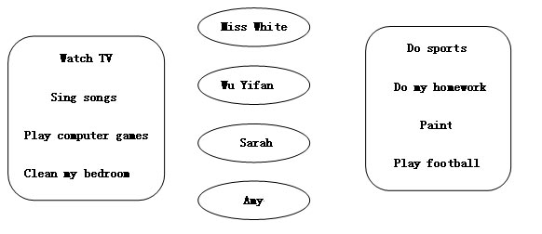

四、Listen and judge （机长哈利·波特终于出现啦！他要宣布什么呢？仔细听，判断，记得用√和×表示。）（10分）

（ ) 1. Jack is a student, he is eleven years old.

（ ）2. My favourite day is Friday.

( ) 3. Our art teacher is my favourite teacher.

( ) 4. We have music, math and art on Fridays.

( ) 5. We have cabbage and pork every day.

笔试部分（60分）

一、哈利·波特送你的第一件礼物是“魔法石”，它能帮你照出下面哪些单词是与众不同的哦！（5分）

( ) 1. A. river B. like C. bridge

( ) 2. A. use B. under C. much

( ) 3. A. now B. cow C. snowy

( ) 4. A. meal B. clean C. really

( ) 5. A. potato B. tomato C. path

二、哈利·波特玩咒语了，单词乱飞，你有本事把他们放回原位置，恢复原句吗？ (10分)

1. lunch, for, What, you, have, do, Mondays, on, (?)
________________________________________________

2. favourite, your, fruit, What’s, (?)
________________________________________________

3. are, end tables, the, there, near, bed, two, (?)
________________________________________________

4. active, very, She’s, (.)
_________________________________________________

5. can What you do (?)
________________________________________________

三、没有了魔法石的指点，这回看你的真本事了！请将问句和相应的答句用直线连起来。(6分)

1. Is there a lake near here? a. He’s tall and strong.

2. What’s he like? b. Yes, there is.

3. Can you set the table? c. I often do homework.

4. What do you do on Sunday? d. No, I can’t.

5. What’s in the box? e. Apples，They are sweet.

6. What’s your favourite food? f. There are many things.

四、“魔杖”是第二件礼物，赶快试试！把空中飞舞的单词定格在纸上。（10分）

( ) 1. ----____________ in your living—room?
----There’s a big closet, two end tables and two desks
A. Who’s B. What’s C. Where’s

( ) 2. How many ____________ do you have?
A. sheep B. sheeps C. sheepes

( ) 3. Today is Tuesday, tomorrow is _______________.
A. Thursday B. Wednesday C. Friday

( ) 4. Are there ______________ horses on the farm?
A. any B./ C. some

( ) 5. ______________, there are some pictures over there.
A. Read B. Watch C. Look

( ) 6. _____________ he helpful at home?
A. Can B. Are C. Is

( ) 7. I`d like some_____________ and eggplant.
A. potatos B. potatoes C. potato

( ) 8. Let ____________ clean the classroom.
A. her B. she C. she`s

( ) 9. Zoom _____________ do the dishes.
A. can B. cann`t C. can`t

( ) 10. ---- How _____________ is the pencil—case?
---- Twelve yuan.
A. many B. much C. old

五、“魔杖”的魔力已经失效，请你根据中文意思提示，用单词的适当形式填空，让“魔杖”恢复魔力吧！（5分）

1. Let ____________(我们) sweep the floor.

2. Miss White is my______________(中文) teacher.

3. They often ______________(打) Ping—pong on the playground.

4. The blackboard is in ________________(前面) of the classroom.

5. Don`t ______________(看) books on the bed.

六、飞机要飞向目的地啦！究竟是哪块神奇的领域呢？一起去看看吧！正确的打“T”,错误的打“F”（4分）

Hello. My name is Gordon. I am a student in Willow school. I get up at 6:30 and go to school at 7 o’clock in the morning. We have three classes in the morning and one in the afternoon.

On Monday, we have P.E. and art. I can draw beautiful pictures.

I love Tuesday. On Tuesday. I have science. Science is fun. And our science teacher is very funny. But my favourite class is computer. What about you?

We have three English classes every week, on Monday, Wednesday, and Friday. Our English teacher comes from the USA. He is tall and strong. He likes sports. Boys sometimes play football with him.

My father and mother are not at home on Thursday, so I have lunch at school. The food at my school is so yummy.

( ) 1. There are six classes in one day.

( ) 2. Gordon has no English class on Friday.

( ) 3. Gordon likes science and computer.

( ) 4. The food in Gordon’s school is good.

七、幻影显形，读短文，将括号中的字母排列成正确的单词，写在横线上。（10分）

Good morning. My (mean) is Peter. I am (riteneth) years old. I am at school now.

My school is not very (gib), but it’s very beautiful. There are many trees and flowers in the garden.

I like sports and often do sports with my friends. But it’s too hot (yotad), so I am at (mohe). I play (retucomp) games at home. We have a (slaml) dog at home. It’s (nowrb). It has two lovely eyes and two long ears. I call it Rabbit.

My house is very nice. My Mom cleans it every (ayd), so the (roflo) is very clean and I don’t wear slippers at home . But my mother doesn’t like it.

八、就要到达目的地了，如果你不能向大家介绍你自己，你就不能下飞机噢！

If you’re John, please write a short passage about yourself with the key words (根据所给信息写一篇小短文要求内容与所提示信息一致，不能少于9句话)（10分）
Name: John
Age: 12
Favourite Food: fish and green beans
Favourite clothes: T-shirt, jeans and sneakers
Favourite subjects: P.E and Social Studies
Favourite activities: do housework, go to the nature park
The others: tall, strong, short black hair ...

哈哈！喜欢这次奇异之旅吗？测试都过了吗？那就欢迎你下学期到霍格沃茨魔法学校学习！

