小学五年级第二学期英语第二单元自测题

班别：___________ 姓名：_____________ 分数：_____________
听力部分
一、听录音，选择所听到的内容，并把字母编号写在括号里。（10分）
（ ）1、A、ball B、board C、 fall
（ ）2、A、 winter B、swim C、windy
( ) 3、A、play B、skate C、make
( ) 4、A、summer B、sunny C、up
( ) 5、A、 play with snow B、make a snowman C、sleep a long time
( ) 6、A、fly kites B、plant trees C、play sports
( ) 7、A、go to Beijing B、go to Qingdao C、go to Harbin
( ) 8、A、What’s your favourite season? B、What’s your favourite fruit? C、What’s your favourite food?
( ) 9、A、I can skate B、she can skate C、He can skate
( ) 10、A、Why do you like winter ? B、Why does zhangpeng like winter? C、Why does she like winter?

二 、听录音,判断对错.(10分)
1
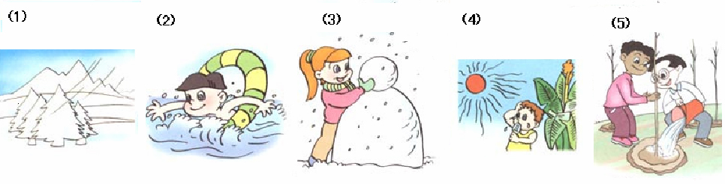

（ ） （ ） （ ） （ ） （ ）
2 ( ) (6) They climb mountains in fall.
( ) (7) I wear my T-shirt in winter.
( ) (8) It’s windy and cool in winter.
( ) (9) There are twelve seasons in a year.
( ) (10) In Beijing , it’s spring from January to March .

三、听答句选问句，并把编号写在题前的括号里。
（ ）1、A 、When is the best time to go to Beijing? B、What’s the weather like in Beijing? C、What would you like to do?
( ) 2、A 、Why does Amy like winter? B、Why does Mike winter?
C、Why do you like winter?
( ) 3、A、Can you plant trees? B、Do you plant trees?
C、Are you planting trees?
( ) 4、A、Does it often rain in fall? B、Is it cold in fall?
C、Is it cool in fall?
( ) 5、A、Which season do you like best? B、What season do you like? C、How many seasons are there in a year?

四、听录音，在空格中填上单词，将句子补充完整。（每空一词）（10分）
1. What would you like to do? I’d like to________ _________.
2. The leaves are green in _________. They are yellow in ________.
3. ________is good, but ________is my favourite season.
4. Why do you like winter? ____________ I can make a ___________.
5. _________ season does Amy like best? She ________ winter best.

五、听读一段对话，判断句子的对错，对的打“ √”，错的打“×”。
( )1、Jone likes winter best.
( )2、Mike can swim in the sea in fall.
( )3、.Chen Jie likes spring best.
( )4、Wu Yifan doesn’t like fall.Beacause it’s windy.
( )5、Wu Yifan likes his red shirt.

笔试部分
六、补充对话，根据上下文内容，选择正确的句子，使对话完整。并把恰当的句子填在横线上。（10分）
Chen: ____________________________ ,Sarah?
Sarah: It’s windy and warm.
Chen: ______________________________?
Sarah: Spring.
Chen: ______________________________?
Sarah: Because I can plant trees. __________________________________ ?
Chen: I like winter best.
Sarah: _________________________________ ?
Chen: Because I can skate.

a. Why do you like sping?
b. Why do you like winter?
c. What do you do?
d. What’s the weather like today?
e. What do you do in winter?
f. What’s your favourite season?
g. Which season do you like best?

七、阅读短文。（根据短文内容，选择最佳的答案，将编号填在括号里。）（10分）
Hainan is my hometown(家乡). It’s a very beautiful city.The buildings are tall,the trees are tall,too.Summer is the favourite season for many people in Hainan.It’s hot and sunny.The boys and girls can wear their sunglasses and beautiful T-shirts,they can swim in the sea,too. The favourite drink in Hainan is coconut(椰子) juice.It’s fresh and sweet.It’s very delicious. Spring is very warm in Hainan. Fall is cool.It seems that(似乎)there is no winter in Hainan.Because it’s warm and cool in winter.It’s not very cold.
( )1、 ________ is the favourite season for many people in Hainan.
A 、Spring B、Summer C、 Fall
( )2、It’s ________ in summer.
A 、hot and sunny B、 windy and cool C、 warm and cool
( )3、The boys and girs can _______ in the sea.
A 、play B、skate C、 swim
( )4、Spring is very________ in Hainan
A 、cool B、warm C、cold
( )5、It’s__________in winter in Hainan.
A、cold B、warm and cool C 、warm and hot

八、短文选词填空。（选择最恰当的词填在横线上，每空一词。）（10分）
（kites trees Chinese don’t cold in at swim spring best plant snows）
My name is Wei Hua.I’m a _________girl. I live _______ a big city.We have summer 、fall、winter and________.I like spring________. It’s warm and windy. We can fly _________.It’s the best time to________trees. I________like summer.It’s too hot. And I can’t__________. In winter it never ( 从来不 )________in our city. So it’s not very________.

九、根据答句写出问句。（10分）
1 A:__________________________________?
B: I like winter best.
2 A:_________________________________?
B: Because I can plant trees in spring.
3 A:__________________________________?
B: It’s sunny and hot.
4 A:_________________________________?
B: No,I can’t swim in the sea.
5 A:_________________________________?
B: There are four seasons in a year.

十、用英语写一篇作文。题目：My favourite season. 可以从天气、衣服、主要活动、饮食等方面说说你最喜欢的季节的特点。（不少于5句，10分）
________________________________________________________________________
_______________________________________________________________________________________________________________________________________________

