五年级英语上学期自查卷

学校 班级 座号 姓名
听力部分
- 听录音内容，将录音提到的内容的字母填在括号里。（10分）
（ ）1．A. March B. May C. Augst
（ ）2. A. first B. second C. third
（ ）3. A. why B. what C. when
（ ）4. A. plant trees. B. fly kites C. swim.
（ ）5.A.cleaning the room B. clean the room
C. listen to music
（ ）6. A. Aug.1st . B. Sept.10th. C. Dec. 25th
（ ）7. A. fifth B. five C. twelve
（ ）8. A. skate B. ski C. swim.
（ ）9 A. February B. September C. November
（ ）10. A.drawing pictures B. cook dinner
C. reading books
- 根据录音内容，判断下面的图片是否与录音内容相符，符的在图片下面的括号里打“”，不符的打“”。（10分）
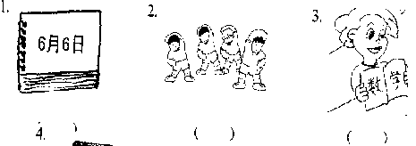



( ) ( )
三、听问句, 选答句。（10分）
（ ）1．A. Winter. B. Green. C. Football.
（ ）2. A. Aug.1st . B. Sept.10th. C. Oct.1st.
（ ）3. A. OK. B. Oh,no. C. You’re welcome.
（ ）4. A.Because I can plant trees.
B. Because it’s too cold.
C. Because I can swim.
（ ）5. A. Amy. B. Amy’s. C. Sept.10th.
四、根据录音内容，在句子的空格填上单词，将句子补充完整（每格一词）。（10分）
1． A: When do you ________ __________ ?
B: At _______ .
2. ________ is my __________ season. ________ I like to plant trees .
3. I usually _______ ________ on the weekend.
4. A: What is the date today? B: It’s ________ _______ .
五、听一段对话，并根据录音内容判断下列句子的正误，对的打“√”，错的打“×”。（10分）
( )1. Mike’s birthday is in October.
( )2. Mike likes winter best.
( )3. Children can skate in spring.
( )4. Winter is very cold.
( )5. John doesn’t like winter.
笔试部分

六、补全对话：根据上下文的意思选择适当的句子，将其编号填在下面对话的横线上。（10%）
- What’s the date today?
- Do you like winter?
- When is your birthday?
- What’s the weather like in fall?
- What’s the date ?
- Do you like fall?
Mike: __________________________________?
Chen:My birthday is in September .
Mike: ___________________________________?
Chen: It’s September 11th .
Mike: __________________________________?
Chen: Yes, my birthday is in fall .
Mike: ____________________________________ ?
Chen: It’s windy and cool .
Mike: ___________________________________ ?
Chen: Yes , I like fall. But my favourite season is summer.

七、阅读理解:根据上下文意思选择正确的答案,并将其字母编号填在题前的括号里。（10%）
Amy:When do you get up?
Mike: I get up at 6:40. I get up early because I have breakfast at home.
Amy: What about weekends?
Mike:Oh, I get up at 9:00 .
Amy: What do you do on the weekends?
Mike: Usually I watch TV and do my homework. Sometimes I go hiking . What about you?
Amy: Me too. And I often read books,too.
Mike: Tomorrow is Jan. 1st . Let’s go hiking together .
Amy:Great !
( )1. What’s the date today?
A. It’s Jan. 1st . B. It’s Dec. 31st .
( )2. Amy and Mike will ________ tomorrow.
A. watch TV and do my homework B. go hiking
( )3. Does Mike get up early on weekends ?
A. Yes . B. No .
( )4. Mike has breakfast at ________ on Mondays .
A. school B. home
( )5. Does Amy watch TV , do my homework and read books on the weekends ?
A. Yes . B. No .
八、短文填空：（根据短文的意思，在所给的词中选择合适的填在相应的空格中，使短文完整，每格一词。（10分）
(apples , Winter , summer, rains , plant , ski , snowman , in , cold ,often , swim , cool , Sometimes )
I love summer. It’s very hot in _________ . I can _______ in the sea. Spring is beautiful. But it often ________ . It’s hard to _______ flowers in the rain. In fall, I can pick _______ . I can eat a lot. ________ comes. It’s very ________ . ___________ it snows. I can ________ and make a __________.
九、根据答语,写问句. (10分)
- A: ____________________________________ ?
B: I am drawing pictures.
- A: ____________________________________ ?
B: I often play football on weekends .
- A: _____________________________________ ?
B: I have Chinese class at 9:50.
- A: ______________________________________ ?
B: My favourite month is July .
- A: ____________________________________ ?
B: My mother’s birthday is in March.

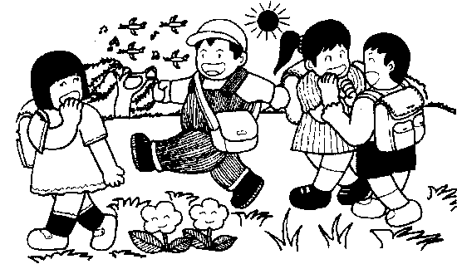
十、小作文。仔细看图，发挥想象，写一段话。可以介绍图中有几个人，他们在做什么，心情如何，当时的季节情况等，不少于5句话。（10分）

________________________

