小学五年级英语下学期第二单元自查题
班级 姓名 成绩
一、听音，选择（共10题，每小题1分）
（ ）1、A. 35,45 B. 45,35 C. 30,40
（ ）2、A. 6:50 a.m. B. 6:50 p.m. C. 6:15 a.m.
（ ）3、A. season B. see C. listen
（ ）4、A. farmer B. summer C. some
（ ）5、A. with B. which C. when
（ ）6、A. snow B. know C . now
（ ）7、A. cool B.good C.food
（ ）8、A. why. B. fly C. my
（ ）9、A. ball B. fall C.wall
（ ）10、A. Holloween B.Thanksgiving C. Christmas
二、听音，判断对错（共10题，每小题1分）
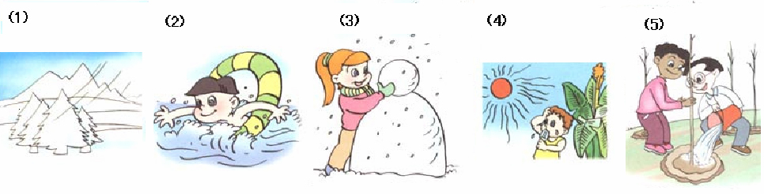
1. ( ) 2. ( ) 3.( ) 4.( ) 5.( )
( ) (6) They climb mountains in fall.
( ) (7) I wear my T-shirt in winter.
( ) (8) It’s windy and cool in winter.
( ) (9) There are twelve seasons in a year.
( ) (10) In Beijing , it’s spring from January to March .
三、听问题，选答句（共5小题，每小题2分）
（ ）1、A. At seven. B. At seven thirty. C. At eleven.
（ ）2、A. Read books. B. Go home. C.Do homework.
（ ）3、A. Winter. B. Summer. C. Because she likes to play with snow.
（ ）4、A. Summer. B. Swim. C. Sleep.
（ ）5、A. Computer and P.E.. B. Sunday. C. Tuesday .
四、听音，填词（共5题10空，每空1分）
1、What do you often do _________ ?
2、 A: do you like ?
B: Because it’s ________________.
3、Which do your parents like ______? B:________.
4、It’s ________and________in fall.
5、I can tress and fly in spring.
五、听一段对话, 判断下列五个句子的对错。（10分）
（ ）1、Everything is green in spring.
（ ）2、My favourite season is summer.
（ ）3、I like fall best because I can eat moon cakes.
（ ）4、It's cold and snowy in winter.
（ ）5、I often make a snowman in winter.

笔试部分
六、选择合适的句子，补全对话（共5小题，每小题2分）
What do you like to do? Can you make a snowman now? Is it windy and cold? What’s the weather like? What would you like to do? When do you eat breakfast? Can I make a snowman?
A: ?
B: I would like to go swimming.
A: ?
B: No, I can’t.
A: ?
B: I eat breakfast at 7:15 a.m..
A: ____________________________?
B: It’s warm and sunny.
A: ?
B: No,it isn’t.
七、阅读理解（共5小题，每小题2分）
There are four seasons in a year. Spring begins first. Summer is the second. Then it’s fall. Winter is the last season in a year. In China, the weather is not the asme in winter. In Beijing, it’s very cold. It often snows. People can play with snow and they must put on the coat. But in Hainan it’s not cold. It’s very warm. People there can go to swim in the sea.
( )1、What’s the weather like in winter in Hainan?
A.It’s very cold. B. It’s not cold.
( )2、How many seasons are there in a year?
A. four. B. five.
( )3、What’s the third season in a year?
A.Spring. B. Fall.
( )4、Can people see the snow in winter in Beijing?
A. Yes,they can. B. No, they can’t.
( )5、Can people make a snowman in winter in Hainan?
A. . Yes,they can. B. No, they can’t.
八、短文选词填空（共10空，每空1分）
Summer swimming sunny visit skate Spring green swim plant trees winter blue spring
The best time to go to Beijing is fall. It’s _____and cool. You can go to the Great Wall. When is the best time to go to Haibin? Of course_____. It’s windy and cold. But you can _____there._____ is the best season to go to Sanya. It’s sunny and hot. You can _____in the sea. What about Hangzhou? _____is the best time to go there. The sky is_____. The leaves are_____. It’s beautiful. You can______,too. When is the best time to_______ these places?
九、根据答句写问题（共5小题，每小题2分）
1、A： ？
B：I can swim in the sea in summer.
2、A： ？
B：It’s warm and sunny in spring.
3、A： ？
B：I like fall best.
4、A： ？
B：Yes,I can make a snowman in winter.
5、A： ？
B：Because I can fly kites.

十、看图作文（10分）
这是什么季节,你们都在干什么?心情如何?天气如何?
