2011年度第二学期
小学五年级英语第六单元自查题
班级 姓名 成绩
一、听音，选择（共10题，每小题1分）
（ ）1、A. twelve B. twenty C. twentieth
（ ）2、A. first B. third C. fifty
（ ）3、A. spy B. try C. fly
（ ）4、A. queen B. quiet C. quite
（ ）5、A. class B. grass C. glass
（ ）6、A. 10:15 B.12:10 C .10:50
（ ）7、A. 5093763 B.5324343 C.5094764
（ ）8、A. reading a book B. reading a letter C.reading a report
（ ）9、A. play B.say C.day
（ ）10、A. swimming B.swinging C. sleeping
二、听音，判断对错（共10题，每小题1分）
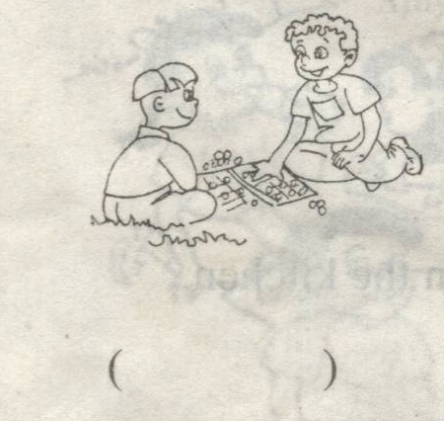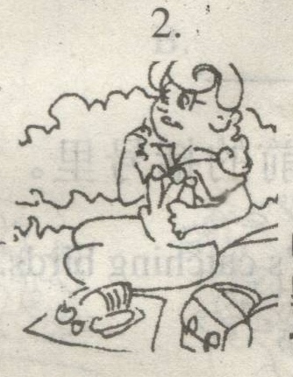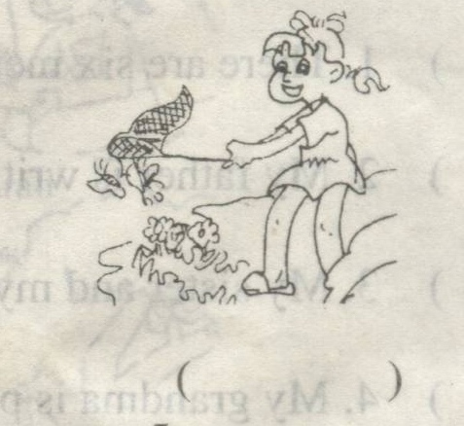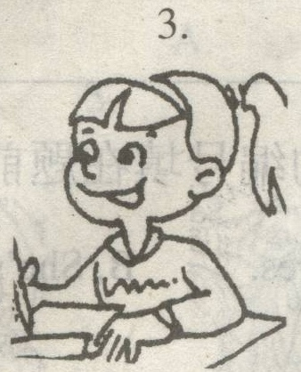
1. ( ) 2. ( ) 3.( ) 4.( ) 5.( )
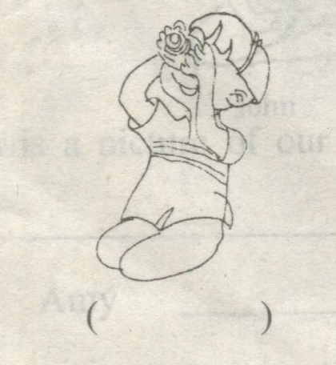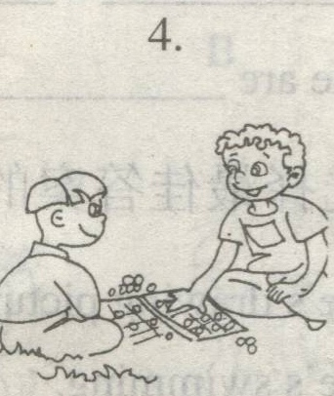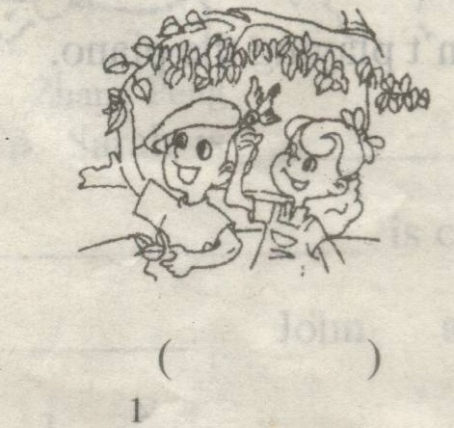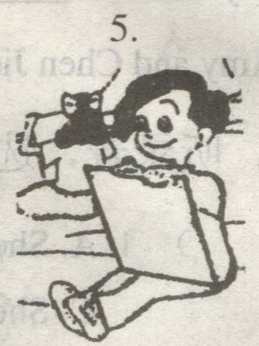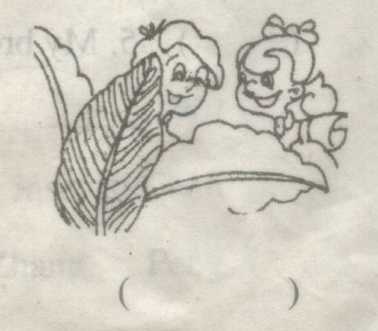
6. ( ) 7. ( ) 8.( ) 9.( ) 10.( )
三、听问题，选答句（共5小题，每小题2分）
（ ）1、A. Yes,I’m. B.Yes, I am. C.Yes,we are.
（ ）2、A. Yes, she is. B. She’s swimming. C.He’s swimming.
（ ）3、A. No,it isn’t. B. Yes,they are. C. Yes,we are.
（ ）4、A. It’s in the park. B. He’s in the classroom. C.She’s in the school.
（ ）5、A.My mother is cooking. B. He’s cooking. C. No, she isn’t.
四、听音，填词（共5题10空，每空1分）
1、Are _______ cooking? No, ______ not.
2、______she insects? Yes, she is.
3、Where is Zhang Peng? He’s ______the woods.
4、________are they______? They’re ______.
5、Look! She’s _______ ______us.
五、听一段对话, 判断下列五个句子的对错。（10分）
（ ）1、Today is Teachers’ Day.
（ ）2、Today is fine.
（ ）3、We are having a picnic in the forest.
（ ）4、Amy and Miss White are catching butterflies.
( ) 5、Mike is taking pictures for us.

笔试部分
六、选择合适的句子，补全对话（共5小题，每小题2分）
What can you see? Do you like them, too ? What is the monkey doing? What is it? What are the animals doing? Can you see any animals?
A: Hello.
B: ________________.
A: I’m cooking, _______________________?
B: I’m reading a book.
A: ______________________?
B: No, my sister isn’t reading. She’s playing.
A: ___________________ ?
B: My father is working.
A: ______________________?
B: He’s in the study. Hold on ,please.
A: Thank you.
七、阅读理解（共5小题，每小题2分）
Welcome to the Children’s Centre. Happy Children’s Day! You can do many things here. Look at these people. They’re very active. This is Chen jie. She’s drawing picrures. Mike is watching insects. Amy is reading a story book. Wu Yifan is playing chess with a man. Who’s the man? He’s Mr Black, Wu Yifan’s math teacher. He’s a smart man. John and Sarah are taking pictures. Where’s Bai Ling? Look! She’s over there, she’s writing a report on the Children’s Day. Her sister is singing and playing the piano.
( )1、Is Bai Ling singing?
A.Yes, she is . B.No, she isn’t.
( )2、What’s Mike doing?
A. He’s watching TV. B. He’s watching insects.
( )3、What’s the date?
A.It’s June 2nd .B. It’s June 1st .
( )4、What is Wu Yifan doing?
A.He’s playing chess. B. He’s playing sports.
( )5、What is Bai Ling doing in the Children’s Centre?
A.She’s singing and playing the piano. B.She’s writing a report.
八、短文选词填空（共10空，每空1分）
having playing student reading Saturday under fruits near happy students writing beautiful
It’s ______today. The______ and their teacher are ______a picnic. They are sitting______ a river. Some are ______ games. Some are eating ______. Some are singing and dancing. Who’s ______ books ______the trees? Oh, that’s John. And the teacher is ______ a report. How_______ they are!
九、根据答句写问题（共5小题，每小题2分）
1、A： ？
B：Chen jie is playing the piano.
2、A： ？
B：They’re playing sports.
3、A： ？
B：I’m climbing mountains.
4、A： ？
B：My sisters are catching butterflies.
5、A： ？
B：No, she’s dancing.
十、看图作文（10分）
仔细观察图中的人物正在干什么?请发挥你的想象,写一篇小短文.要求:条理清晰,意思连贯,语句通顺,不少于5句话.

