小学六年级英语下册第五单元试卷

听力部分（共30分）
Listen and circle. (听录音，圈出你所听到的字母组合。) （5%）
1．lk ik 2. RT IT 3. KFC UFO
4. JGM GJL 5. USA TPR
二．Listen and order (听录音，标序号。) （10%）

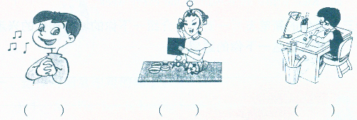
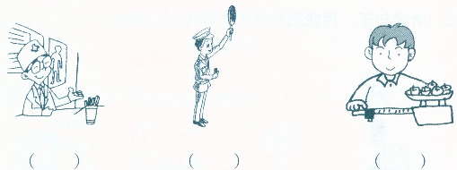
Listen and choose. (听音，选出你所听到的单词。) （5%）
1． A. bus B. bike. C. subway ( )
2. A. actor B. actress C. artist ( )
3. A. hospital B. bookstore C. school ( )
4. A. does B do C. doing ( )
5. A. teaches B. teach C. teaching ( )
四．Listen and judge. (听下列对话，请在与你所听内容一致的图片下方打
“√”，否则打“x”。) (10%)
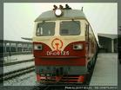
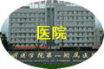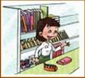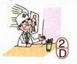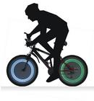

1. ( ) 2. ( ) 3. ( ) 4.( ) 5. ( )

笔试部分（共70分）
Put the letters in order. (把下列字母按正确的顺序排列。) (5%)
1．TSR 2. kij 3.nml
4. ZXY 5.jhi

二．Look and choose the right word. (看图片，选择相应的单词或短语。) （5%）
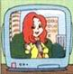

1.( ) A. TV reporter. 2. ( ) A. actress 3. ( ) A. by bus
B. accountant B. cleaner B. by train

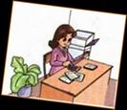
4. ( ) A. teacher 5. ( ) A. bookstore
B. student B. bank

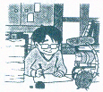
二、Look and judge. (看图，指出描述该图内容的句子是否与图意思一致。如一致，请打“√”，否则打“x”。) (10%)

（ ）1．Yongxian's father is a writer．

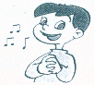

（ ）2．I'm going to be a cleaner．



（ ）3．Li Hai is going to be a TV reporter．

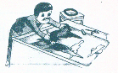
（ ）5．My father draws pictures. He's a painter．

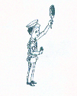
（ ）6．The tall man is a salesperson．


三．Look and choose. (根据图片选择句子)（10%）
1. ( ) A.—— What does your mother do? ——She is a TV reporter.
B. ——What does your father do? ——He is a policeman.

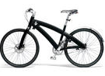
2. ( ) A. ——How does she go to work?
——She goes to work on foot.
B. ——How does he go to school?
——He goes to school by bike.


3．( ) A.—— Where does your aunt work?
——In the hospital.

B. ——Where does your uncle work?
——In the cinema.

4. ( ) A. She teaches Chinese. She is a Chinese teacher.
B. She likes drawing pictures. She is an artist.

5. ( ) A. I like playing the violin.
B. I like collecting stamps.

四．Read and choose. (读一读，选择恰当的选项,填在相应的括号内。) （15%）
1．What’s her name? ( )
A. Her name is Amy. B. My name is John. C. His name is John.
2. How old is he? ( )
A. I’m 13. B. He is 13. C. She is 13.
3. She sells things, she is a/an ( )
A. salesperson. B. artist. C. teacher.
4. does she go to Hong Kong? ——By plane. ( )
A. How. B. Where. C. What.
5. She is engineer. ( )
A. a B. an C.the
6. What does your father . ( )
A. does. B. do C.doing.
7. does your brother work? ——In a hospital. ( )
A. Where B who C. What.
8. He in a bank. ( )
A. works B. work. C. working
9. What does your mother do? ( )
A. She is a teacher. B. I am a teacher. C. He is a teacher.
10. Does your father work in a factory? ( )
A. Yes, he does. B No, he does. C Yes, he doesn’t.

六．Reorder the sentences. (连词成句。) （15%）
1． does what father your do ?
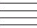

2. is actress she an .

3.does where work he ?

4. bus by goes school to she .

- does how he to go work ?

七．Reading comprehension. (阅读短文，判断句子。对的打“√”，否则打“x”。)
Mike：What are you going to be，John？
John：I like math，so I'm going to be an accountant.
Mike：What about you，Zhang Peng？
Zhang Peng：I like helping people，I can work for the police. So I'm going to be a policeman. What about you，Sarah？
Sarah：I like singing, so I'm going to be a singer. And you? Wu Yifan?
Wu Yifan：I'm here. I like cleaning the streets，so I'm going to be a cleaner.
( ) 1. John is going to be an accountant.
( ) 2. Zhang Peng likes math.
( ) 3. Sarah wants to be a singer.
( ) 4. Wu Yifan doesn’t like cleaning the streets.
( ) 5. Mike is going to be a policeman.

听力材料参考
一． 1. ik 2.RT 3. KFC 4 JGM 5.TPR

二． 1. He is a singer. He likes singing a song.
2. My father works in a hospital. He is a doctor.
3. Look at that policeman. He is so cool.
4. My uncle is a math teacher, he teaches me math.
5. She is a good actress.
6. My brother sells things. He is a salesperson.

三. 1. I go to the bookstore by bike.
2. She likes painting. She is an artist.
3. Let’s keep away from the hospital.
4. What are you doing?
5. She teaches us English. She is our English teacher.

四. 1. How can you go to ShangHai? I can go by train.
2. Where is the hospital? It’s next to the bookstore.
3. What does your mother do? She is a salesperson.
4. Does your father work in a school? No, he works in the bank.
5. What’s your hobby? I like riding a bike.

