小学六年级英语下学期U5试卷
（考试时间：40分钟 满分：100分）

听力部分（30%）
I. Listen and circle. 听录音，请圈出你所听到的单词或字母组合。 (5%)

（ ）1. A. singer B. writer C. actor D. artist
（ ）2. A. SOS B. WTO C. BBC D. UFO
（ ）3. A. engineer B. salesperson C. accountant D. policeman
（ ）4. A. actress B. cleaner C. doctor D. teacher
（ ）5. A. CEO B. CTV C. VIP D. PRC

II. Listen and choose.听读句子，选出正确的答案。(10%)

（ ）6．Mr Black is a ＿＿＿.
A．singer B．engineer C．teacher
（ ）7．____ does your uncle go to work?
A．What B．How C．Who
（ ）8．My sister goes to Beijing ＿＿＿.
A．on foot B．by plane C．by motorcycle
（ ）8．Miss Liang teaches English，She is a ＿＿＿.
A．cleaner B．singer C．teacher
（ ）10．John works in a ＿＿＿.
A．bus company B．car factory C．bike factory

III. Listen and tick. 听对话，在表格的适当空格内打“√”。(5%)

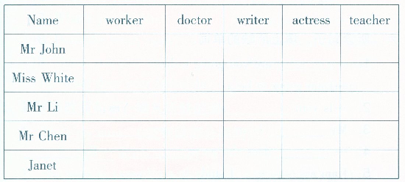

IV. Listen and match. 听读短文，用线把有关的词和图连接起来。(10%)
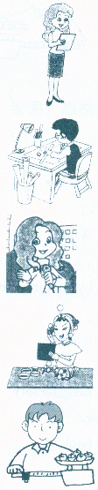

Father

Mother

Uncle

Aunt

Sister

笔答部分（70%）
I. Look and fill in the blanks.（按字母表顺序填充字母，注意区别大、小写形式）（5%）
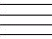
1、 j 2、 m 3、 P
4、 Y 5、 g

II. Look and judge看图，指出描述该图内容的句子是否与图意思一致。如一
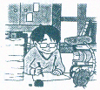
致，请打“√”，否则打“x”。(6%)

（ ）1．Yong xian's father is a writer．

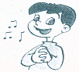
（ ）2．I'm going to be a cleaner．


（ ）3．Li Hai is going to be a TV reporter．

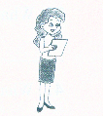
（ ）4．The woman is a nurse．

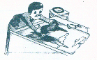
（ ）5．My father draws pictures，
he's a painter．

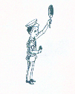
（ ）6．The tall man is a policeman．

III. Read and match.. 选择合适的词连线。(7%)

1．He always helps sick people in the hospital. artist
2．He can draw very good pictures. writer
3．He can sing songs very well． singer
4．He teaches children. doctor
5．He sells thingsin a shop． teacher
6．He goes to school from Monday to Friday. student
7．He writes something for the magazines or books. salesperson

IV. Read and write. 写出下列缩写形式的完全形式。(8%)

1. who's _________ 2. that's _______ 3. I’m _______
4. you’re _________ 5. what's ________ 6. isn't _______
7. I’ve ________ 8.hasn't _______

V. Read and choose. 选择填空。(7%)

( ) 1. The woman is old, but she looks _______.
A. good B. white C. young

( ) 2. _________, this is a photo of my sister.
A. Looks B. Look C. See

( ) 3. Is _______ a duck over there?
A. those B. that C. this

( ) 4. Excuse me, What's __________ name?
A. your B. our C. my

( ) 5. She is a girl. ______ name is Rose.
A. She B. He C. Her

( ) 6. -This is John, my friend.
-_______________________

A. How are you? B. What's your name? C. Glad to meet you.
( ) 7. _______ aunt is a nurse.
A. Me B. I C. My

VI. Read and order. 你能把下面的句子重新排列成一段通顺的话吗? (5%)

( ) Where does he work ?

( ) He is an engineer.

( ) What does he do ?

( ) He works in an air-conditioner company.

( ) This is my uncle.

VII. Read and choose. 选择 who, which, where, what, whose, how old, how, how many填空。(8%)

1. A: is Linda from? B: England.

2. A: is that man? B: He’s my uncle.

3. A: is your sister? B: She’s eleven.

4. A: friends have you? B: I have four.

5. A: are you? B: I’m OK, thanks.

6. A: book is this? B: It’s mine.

7. A: boy is your brother? B: That thin boy.

8. A: is that? B: It’s my pencil-box.

VIII. Read and choose. 根据汉语要求选择正确的英语句子。(4%)

( )1. 今天天气很好，咱们散散步吧。
A. It’s fine today. Let’s go for a walk.
B. It’s a bad day today. Let’s go on foot.

( )2. 你去买东西时，售货员会问你 ？
A. What can I do for you？
B. What do you like？

( )3. 你向别人介绍自己的老师时,你说_______
A. Kate, this is my teacher.
B. Kate, this teacher is my.

( )4. 你去医院看病时，医生要问你：_________
A. What’s wrong with you？
B. What’s this?

IX. Look, read and choose. 给下列句子选择合适的应答句，将答句前的字母代号填入括号内： (10%)
（ ）1．Where does he work? A. He's Mike.
（ ）2. What do you often do？ B. I like playing the violin.
（ ）3. How do you go to school? C. Yes，she does.
( ) 4. What is your mother? D. You're welcome.
（ ）5. Who's this boy? E. He works in a cinema.
（ ）6. What are you going to do？ F. He is a worker.
（ ）7. What's your hobby? G. I go to school by bike.
（ ）8. Does she teach math？ H. I often read newspaper.
（ ）9. Thank you very much. I. My mother is a nurse.
（ ）10. What does your father do？ J. I'm going shopping.

X. Read and judge. 读下面的 e-mail.并完成练习。（10%）
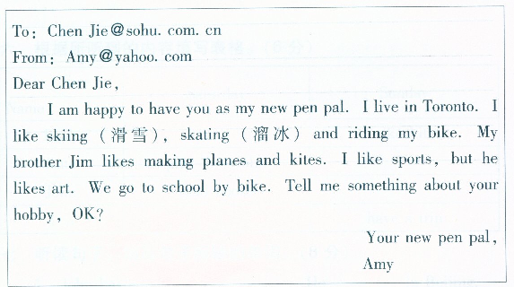

根据e-mail判断下列句子。正确的打“ √”，错误的打“×”

（ ）1. Chen Jie lives in Toronto.

（ ）2. Amy likes sports,

（ ）3. Amy likes swimming.

（ ）4. Jim is Amy's brother.

（ ）5. Jim likes making kites．

Tape script (听力材料)

I. 听录音，请圈出你所听到的单词或字母组合, 读1遍。

1. writer 2.UFO 3.accountant 4. actress 5.VIP

II. 听读句子，选出正确的答案, 读1遍。

I’m Mr. Black. I’m an engineer.

How does your uncle go to work?

My sister goes to Beijing by plane.

Miss Liang is a teacher, she teaches English.

John works in a bus company.

III. 听对话，在表格的适当空格内打“√” , 读1遍。

Mr. John: Hi, Janet. What do you do ?

Janet: Hello, Mr. John. I’m an actress. How about you ?

Mr. John: I’m a worker. By the way, what does Miss White do ?

Janet: She’s a teacher. What about Mr. Li ?

Mr. John: He’s a writer. Do you remember Mr. Chen?

Janet: Yes, of course. What does he do ?

Mr. John: He is a doctor.

IV. 听读短文，用线把有关的词和图连接起来， 读2遍。

This is the photo of my family. Look, this is my aunt. She is a TV reporter. That is my father. He is a writer. He always works hard. Look, that beautiful girl is my sister. She is an actress. This handsome man is my uncle. He is a salesperson. My mother is a teacher.

Keys

听力部分：

1—5 B B C A C 6—10 B B B C A

笔答部分：

II． 1. √ 2. x 3. √ 4. x 5. √ 6. √

V． 1. C 2. B 3. B 4. A 5. C 6.C 7. C

VI 4 3 2 5 1

VII. 1. Where 2. Who 3. How old 4. How many
5. How 6. Whose 7.Which 8.What

VIII. 1. A 2. A 3. A 4. A

IX. 1. E 2. H 3. G 4. I 5. A
6. J 7. B 8. B 9. D 10. F

X. 1. x 2. √ 3. x 4. √ 5. √

