牛津小学英语六年级期末试题
听力部分 (30%)
一、听录音，判断图意是否与所听内容相符。(听两遍) (8%)
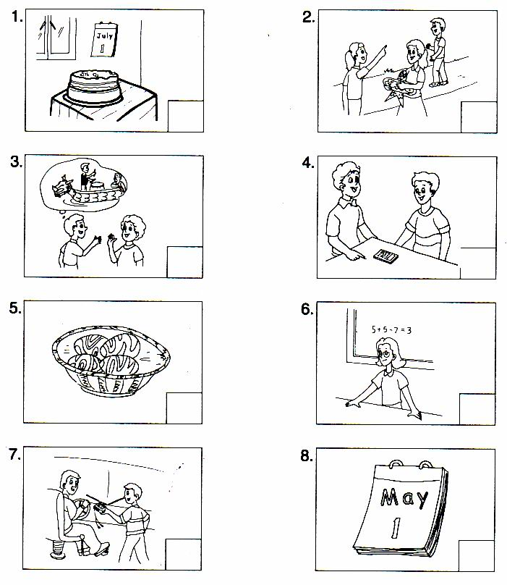

二、根据所听内容，选择正确答案。 (听两遍) (8%)
( ) 1. A. No smoking B. No parking C. No littering
( ) 2. A. his body B. everybody C. nobody
( ) 3. A. on the 28th of September B. on the 18th of September C. on the 8th of September
( ) 4. A. in the desk B. on the TV C. behind the TV
( ) 5. A. watered the tree B. stayed with his friend C. pulled up carrots
( ) 6. A. Jack B. Jack’s parents C. Jack’s friends
( ) 7. A. get off B. turn off C. take off
( ) 8. A. my B. mine C. me
三、听录音，仿照例句连线，并在横线上依次写出时间。 (听三遍) (8%)
例 Nancy --------- visited a farm last Friday
David play football 1.________________
Yang Ling had a party 2.________________
Helen made a model boat 3. ________________
Ben and his friends did his/her homework 4. ________________
四、根据所听短文内容，判断下列句子是否正确。 (听两遍) (6%)
( ) 1. We can see two pictures on the wall.
( ) 2. May is flying her kite.
( ) 3. Pingping and Dongdong are brother and sister.
( ) 4. They are twelve years old.
( ) 5. Pingping is sitting on the table.
( ) 6 The birthday cake is for Pingping and Dongdong.
笔试部分 (70%)
五、根据首字母提示，填词完成句子。(8％)
There are many trees in f_____ of our house.
Can you a_______ the s______ question?
We h_____ a sports day on the 3rd of A______.
On C________ day the students often sing and dance.
Is this skateboard y______? No, it’s not ours. It’s t_____.
六、选词填空，完成句子。(10%)
ate public signs date camp dumplings cooked after taste funny watched
What holiday comes _____ May Day?
We _____ some noodles for our lunch.
What _____ is it today? It’s the 1st of October.
There are some ______ in the library.
Helen, come and ______ the grapes. Oh, they are so nice.
People like eating _______ at Spring Festival.
Lily and her friends ______ a lot of food at the ______.
Mike ______ a _______ cartoon last weekend.
七、选择填空。 (10%)
( ) 1. I want to listen to music. I’d like _________.
A a mirror B a phone C a pair of earphones
( ) 2. —When’s __________?
—It’s on the 1st of October.
A National Day B Mid-Autumn Festival C Spring Festival
( ) 3. Tom_______ the bus and sat down quietly .
A. get off B got up C got on
( ) 4. —Where _________ you last Saturday?
—I _____ at home.
A are, am B were, were C were, was
( ) 5. After the party, Jack opened his Christmas presents ______ his friends.
A to B as C from
( ) 6. We had a long walk in the mountains. We were very _______.
A tired B cold C pretty
( ) 7. The cartoon is very funny. I ________.
A don’t like it B like it very much C I’m sorry to hear it
( ) 8. That sign on the building means ‘Danger’. You should _________ .
A stay away from it B come in and have a look C take off it
( ) 9. —_______ are the films?
—They were here just now.
A Whose B Where C When
( )10. Oh, my calculator is on the ground. Please _____ for ______.
A pick up it, me B pick it up , me C pull it up, us
八、从B栏选择A栏的适当答句，将序号填入括号内。 (8％)
A B
( ) 1. Where do you live? A. She is looking for her wallet.
( ) 2. Would you like a puppet as your present? B. Sorry, I don’t know. Let’s wait and see.
( ) 3. What’s Su Yang looking for? C. By bus.
( ) 4. What’s Jack’s New Year’s present? D. Of course.
( ) 5. How did you go to the zoo this morning？ E. Last Friday.
( ) 6. When did David make a kite? F. I live near Ben
( ) 7..Did you see my comb? G. She visited her relatives
( ) 8. What did Nancy do last Monday? H. Yes, you put it in that box.
九、完形填空。 (10%)
It is Sunday morning. Jack and his father __1__in a big bus. There are __2__ people in it. Some of __3__ come from America and some __4__ England or Canada. They are all friends. They are going to the Summer Palace(颐和园).There are two __5__ in the bus. One is a man. He is a driver. Now he __6__ the bus. The other is a young girl. She __7__ English well. She is now talking __8__ the Summer Palace. The other people are all listening __9__ her. They like the Summer Palace. They want __10__ it very much.
( ) 1. A. am B. is C. are D. be
( ) 2. A. many B. much C. a lot D. a little
( ) 3. A. they B. them C. their D. theirs
( ) 4. A. be come from B. is from C. are from D. comes from
( ) 5. A. China B. chinese C. Chinese D. English
( ) 6. A. drive B. drives C. is driving D. can drive
( ) 7. A. talk B. talks C. speak D. speaks
( ) 8. A. about B. with C. to D. for
( ) 9. A. with B. to C. for D. of
( ) 10. A. see B. seeing C. to see D. to look
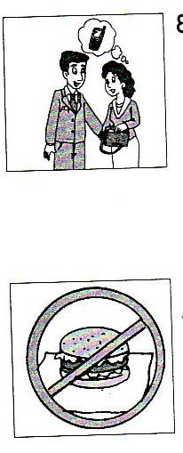
十、根据图片提示完成下列对话。(5%)
1 Man: Listen! ______ mobile phone is ringing?
Woman: It’s ______. I can’t find it.
Man: Is it in _____ bag?
Woman: No, it isn’t. But it _____in it a _____ ago.

2 Jim: Look _____ that sign. It’s interesting.
Tom: Yes, there is a big _______ .
Jim: ______ it mean ‘______ eating’ here?
Tom: I think so. Let’s go and _____ Miss Li.
十一、阅读理解。 (19%)
A 阅读下列表格，并根据其内容完成下列对话。 (9%)
Holiday | When | What do people do
Easter | March or April | make and eat Easter eggs
Halloween | October 31 | dress up in costumes,  make pumpkin lanterns
Mid-Autumn Festival | September or  October | eat moon cakes, play with lanterns and watch the moon
It’s Sunday evening. Ben and Gao Shan are talking about holidays.
Ben: What’s your favourite holiday, Gao Shan?
Gao Shan: ______________________________.
Ben: When is Mid-Autumn Festival?
Gao Shan: It’s __________________________._
Ben: What do people usually do ________ Mid-Autumn Festival?
Gao Shan: They ____________________________. Can you tell me something about your holidays?
Ben: Sure. Easter is very popular in America. It’s in_____________.
People usually make and eat _____________.
Gao Shan: I see. What’s your favourite holiday?
Ben: It’s__________. It’s_______ the 31st of October. People usually______________ and make pumpkin lanterns.
B 根据短文内容选择正确答案，将序号填在题前括号内。(10%)
Mr Smith lives in a village, but he works in a big city(城市). He goes to work by train every morning and comes home in the same way.
This morning, when he was reading his newspaper on the train, a man behind him said “Hello” to him and began to talk to him. “Your life is not interesting, isn’t it? You take the same train every morning, and you always sit in the same seat and read the same newspaper.” “How do you know all that about me?” Mr Smith said angrily(生气地).
“Because I always sit in the same seat behind you,” the man answered.
( ) 1. Mr Smith works ______.
A. in a village B. in a city C. in a town D. in the country
( ) 2. He comes back home from work _____.
A. by ship B. by bus C. on foot D. by train
( ) 3. When he is on the train, Mr Smith often ______.
A. reads books B. reads a newspaper C. talks to others D. listens to others
( ) 4. Mr Smith _________.
A. likes the man very much B. likes reading books
C. doesn’t like the man. D. has much money
( ) 5. The man knows Mr Smith because ________.
A. he is Mr Smith’s good friend
B. they work in the same factory
C. he sits behind Mr Smith on the same train every day
D. they live in the same village
2006年《牛津小学英语6A》期末试题听力内容及参考答案
一、
1. My birthday is on the 1st of June . This is my birthday cake.
2. —Whose hairdryer is it?
—Sorry, I don’t know. Go and ask him.
3. —What’s your favourite holiday?
—The Dragon Boat Festival.
4. —Is this a calculator?
—No, it isn’t.
5. —hen is Easter?
—It’s in March or April.
6. —Are they singing in the classroom?
—Yes, they are.
7 .I gave the CD Walkman to the driver and ask him to take it to the police station.
8 . Today is May Day. It’s a popular holiday.
二、
1. —What does this sign mean?
—It means ‘No littering’.
2. —Is everybody in?
—Yes, we are.
3. —When’s your birthday?
—It’s on the 8th of September.
4. —Where are my glasses?
—They’re behind the TV.
5. —Did you go to the farm last Sunday?
—Yes, we watered trees there.
6. —Who is the present from?
—It’s from Jack.
7. —It’s cold today.
—Don’t take off your coat.
8 —Whose mirror is it?
—It’s mine.
三、
例：—Where did you go last Friday, Nancy？
—I visited a farm with my cousin.
1. —Did you have a party last Christmas, David ?
—Yes, we did.
2. —What did you do just now, Yang Ling?
—I made a model boat.
3. —I did a lot of homework this afternoon. How about you, Helen?
—Me too.
4. —When do you usually play football, Ben?
—Every Sunday.
四、
There are two pictures on the wall. Look at them. There is a girl in Picture One. She is May. She has a nice kite in her hand. She wants to play with it. In Picture Two, we can see two boys. They are Pingping and Dongdong. They are twins. There is a big birthday cake on the table with twelve candles on it. Pingping and Dongdong are blowing out the candles. What lovely boys!
2006年《牛津小学英语6A》期末试题参考答案
一、 1.× 2 .× 3.√ 4 .× 5. √ 6. × 7 .√ 8 .√
二、 CBCC A A C B
三、 David play football 1. last Christmas
Yang Ling had a party 2. a moment ago
Helen made a model boat 3. this afternoon
Ben and his friends did his/her homework 4. every Sunday
四、 1. √ 2. × 3. × 4. √ 5. × 6. √
五、 front answer second had April Children’s yours theirs
六、 1. after 2. ate 3. date 4. public signs 5. taste 6. dumplings 7. cooked camp 8. watched funny
七、 1—5 CACCC 6—10 ABABB
八、 FDABCEHG
九、 1 C 2 A 3 B 4 C 5 C 6 C 7 D 8 D 9 B 10 C
十、 1. Whose mine your was moment 2. at hamburger Does No ask
十一、 A. ( It’s ) Mid-Autumn Festival.
It’s in September or October
at
eat moon cakes, play with lanterns and watch the moon
March or April
Easter eggs
Halloween，on
dress up in costumes
B. 1 B 2 D 3 B 4 C 5 C

