2009年六年级下册英语总复习题_试题_试卷
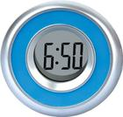
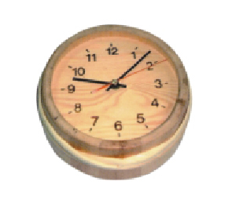
- ________________________________? 1 2
I usually get up at 6:50 in the morning.
- ________________________________?
Ann does morning exercises at 9:10 every day.
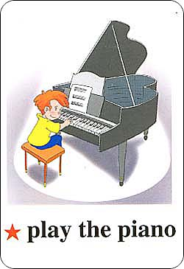
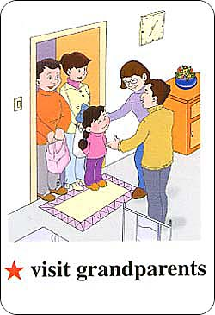
- ________________________________? 3 4
I often play the piano after school.
- ________________________________?
Yes, I often visit my grandparents on Saturday.
- ________________________________?
No, she doesn’t. She usually climbs mountains on Sunday.
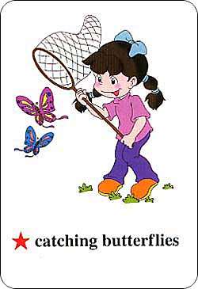
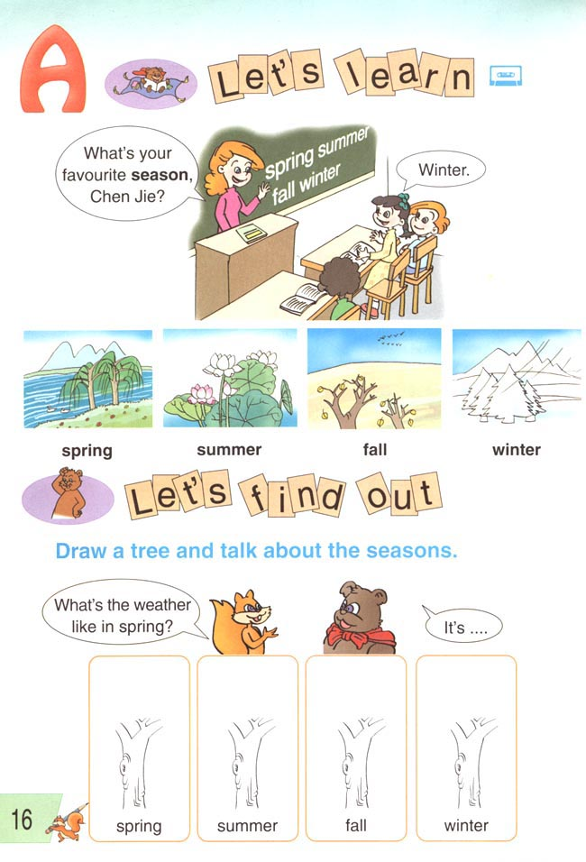
- ________________________________? 5 6
I like winter best.
- ________________________________?
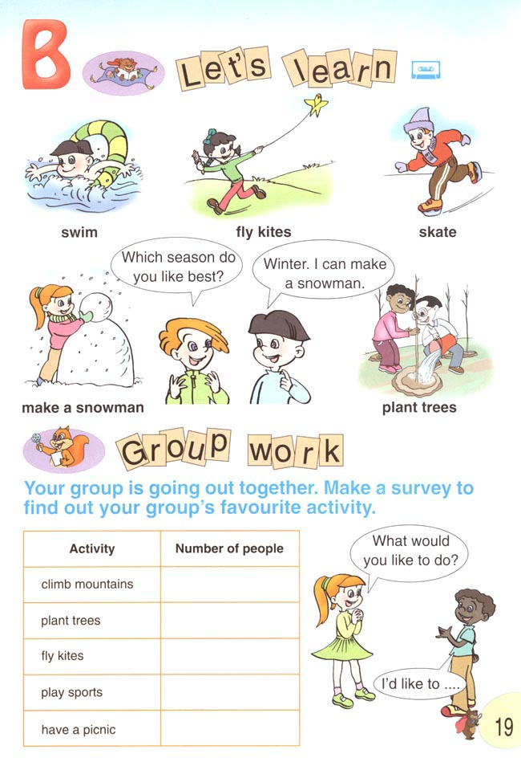
I can make a snowman in winter. 7 8
- ________________________________?
Because I like swimming in the sea.
- ________________________________? 9 10
It’s sunny and hot in summer.
- ________________________________?
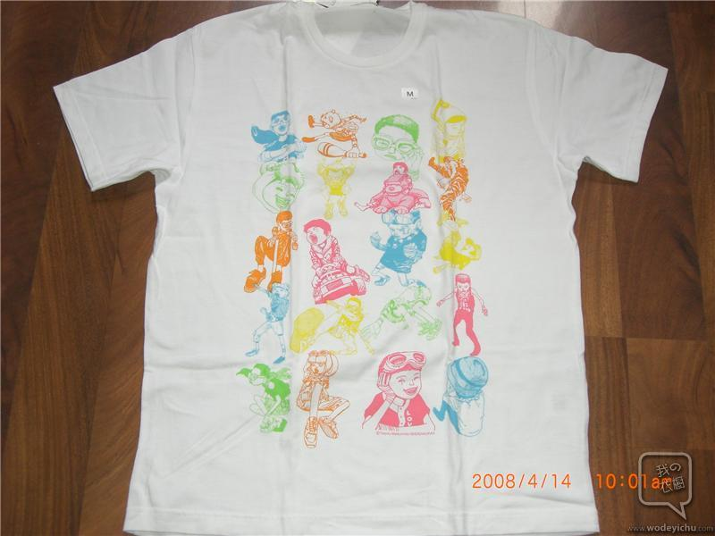
Because I can skate in winter.
- ________________________________? 11 12
2月
I wear T-shirt today.
- ________________________________?
My birthday is in February.

- ________________________________? 13 星期三 14 5月18日
Today is Wednesday.
- ________________________________?
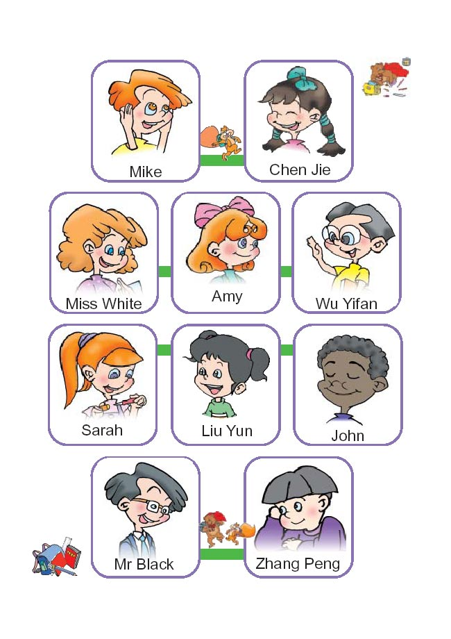
Today is May 18th.
- ________________________________? 15 4月 16
No, my birthday is in May.
- ________________________________?
Mike has a birthday in November. 17 10月 18
- ________________________________?
Yes, my birthday is in October.
- ________________________________?
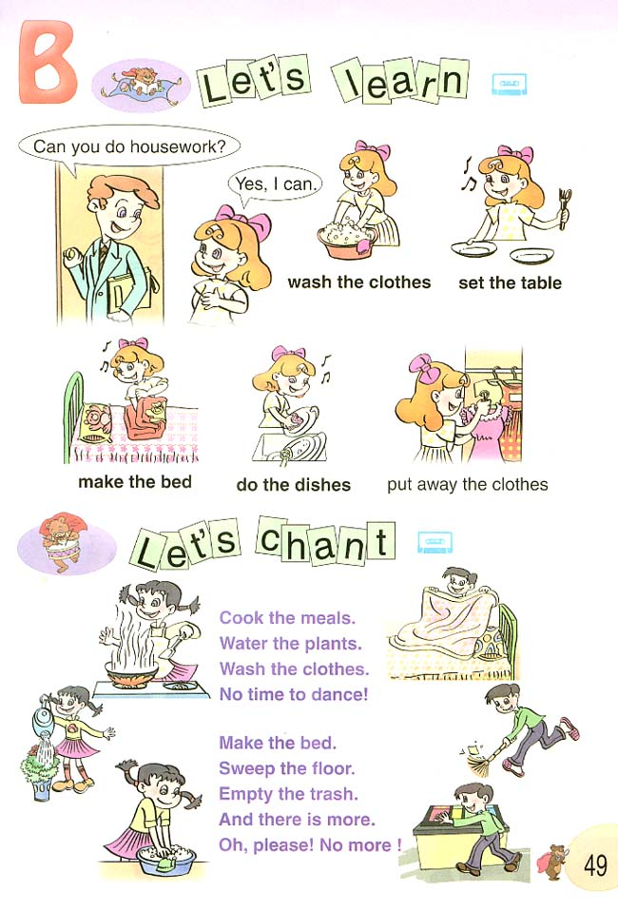
Mike likes summer best. 19 20
- ________________________________?
I am making the bed.
- ________________________________?


Yes, I can cook the meals. 21 22
- ________________________________?
My aunt is answering the phone.
- ________________________________?
Yes, the tiger is writing an e-mail in the study.

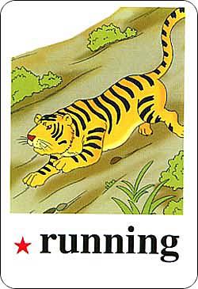
- ________________________________? 23 24
No, my grandpa is reading newspapers.
- ________________________________?
The tiger is running.

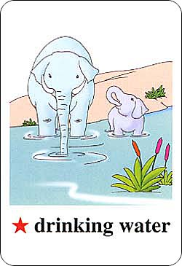
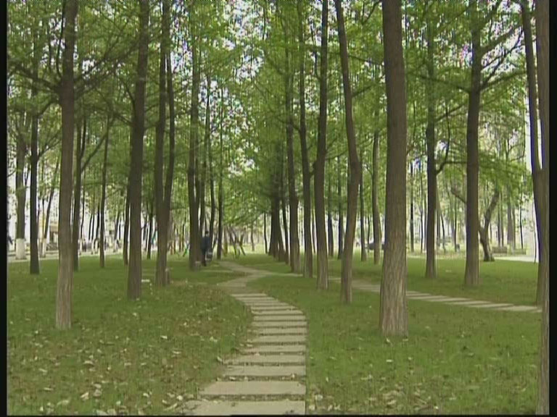
- ________________________________? 25 26
The elephants are drinking water by the river.
- ________________________________?
The students are in the woods.

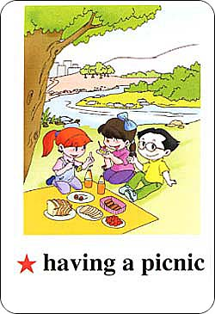
- ________________________________? 27 28
No, they aren’t. They are picking up leaves.
- ________________________________?
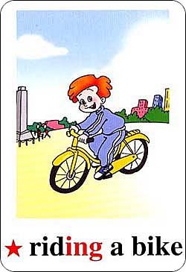
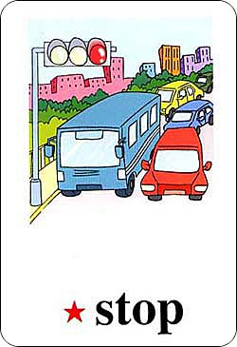
It’s a book on the desk.
- ________________________________? 29 30
I usually go to school by bike.
- ________________________________?
My sister usually goes to work by bus. 31
- ________________________________? 东莞
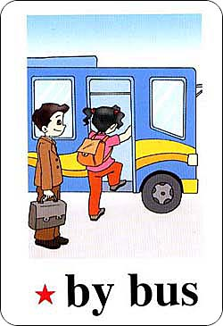
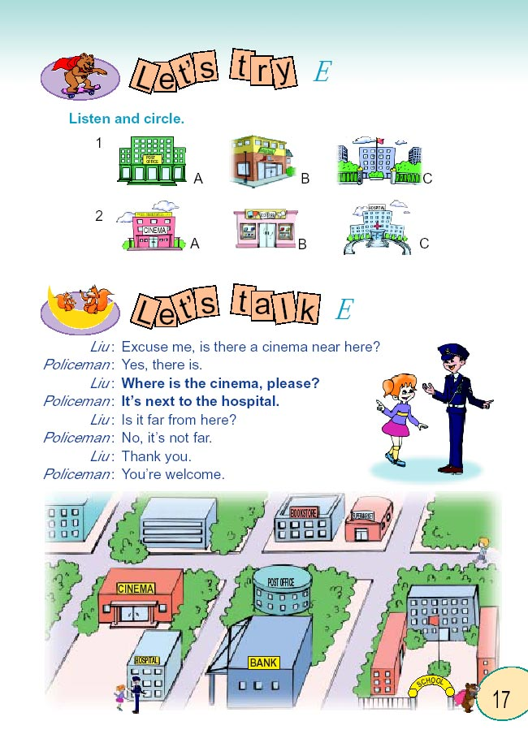
I live in Dongguan.
- ________________________________? 32
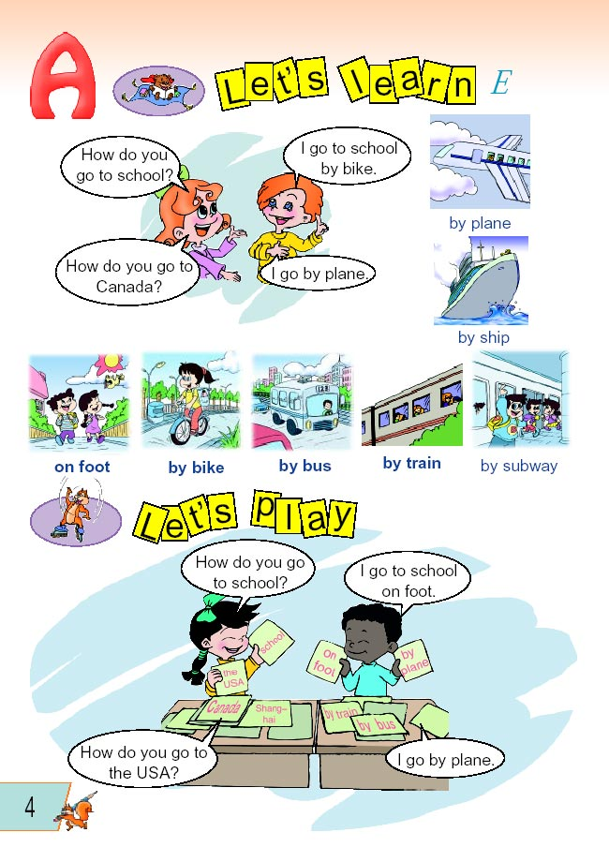
You can go to there by the No.12 bus.
- ________________________________? 33
Yes, you can. The bank is not far from here.
- ________________________________?
The post office is next to the hospital. 34 邮局 医院
- ________________________________?
It’s east of the bookstore. 35 书店 公园
- ________________________________?

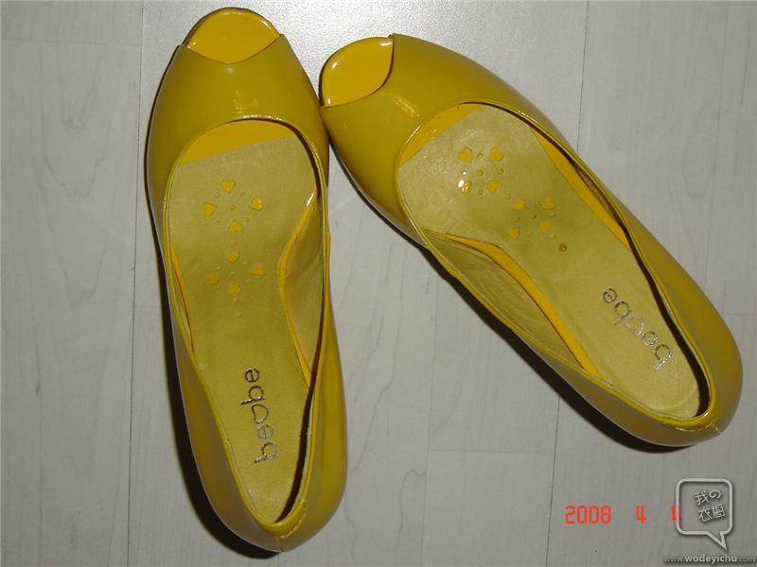
I’m going to the shoe store this evening. 36 37
- ________________________________?
I’m going to buy a pair of shoes in the shoe store.

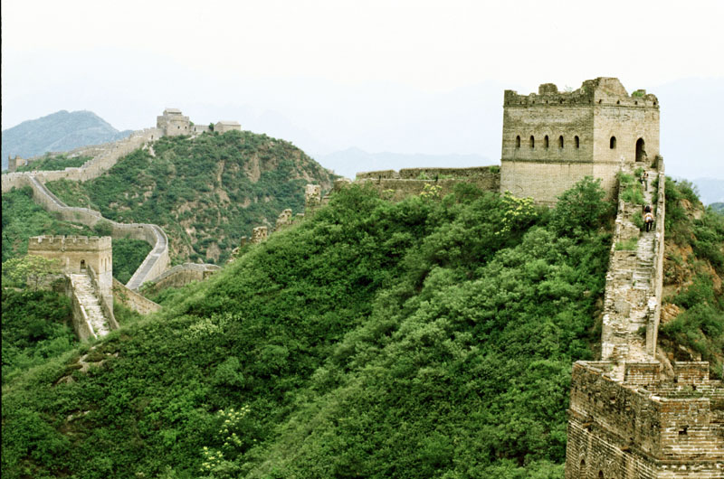
- ________________________________? 38 39
I’m going to the shoe store at 8:30. 8：30
- ________________________________?
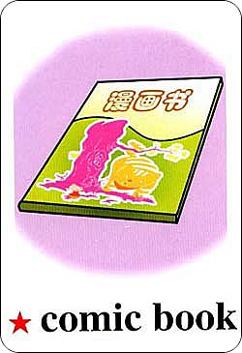
Sam is going to the Great Wall this weekend. 40 41
- ________________________________?
My mother is going to buy a comic book.
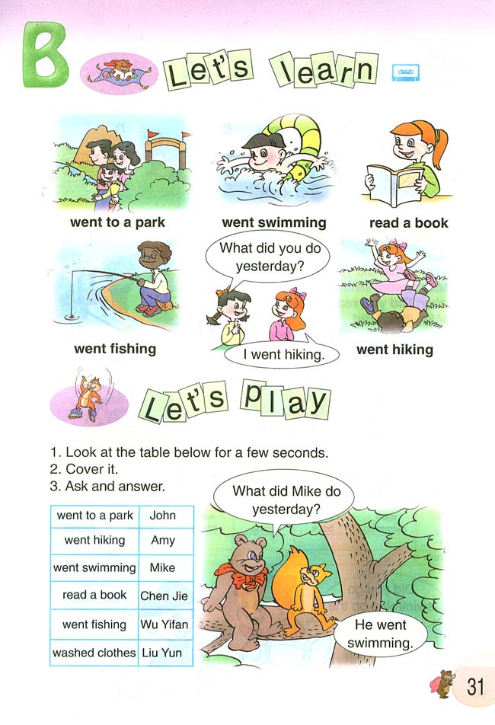
- ________________________________?
Yes, they are going to plant trees this weekend. 42
- ________________________________?
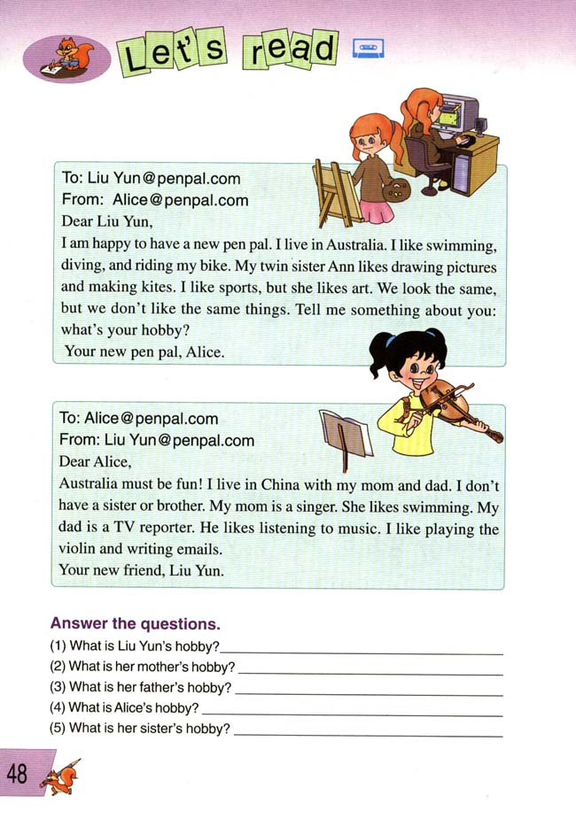
No, they aren’t. They are going to swim this Sunday.
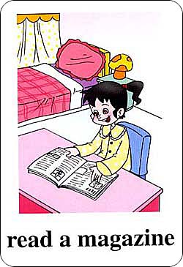
- ________________________________? 43 44
I like collecting stamps.
- ________________________________?

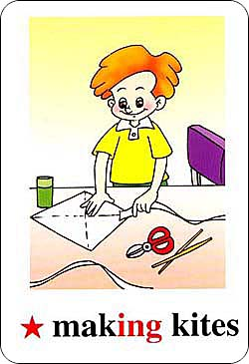
Ann likes drawing pictures. 45 46
- ________________________________?
Alice is tall and pretty.
- ________________________________?
No, Lily doesn’t like making kites. 47 48
- ________________________________? 数学 医院
No, she doesn’t. Miss White teaches English.
- ________________________________?
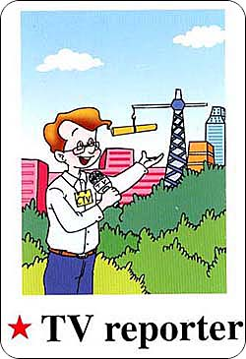
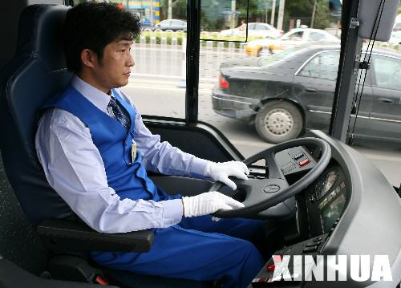
Yes, John’s father works in a car factory. 49 50
- ________________________________?
My father is a TV reporter.
- ________________________________?
My mother is a bus driver.

