2009年六年级下册英语综合练习卷_试题_试卷
（答题时间60分钟，满分100分）

听力部分（满分45分）略
笔试部分（满分55分）
六、Read and choose
阅读下面的对话，根据上下文，从所给的七个句子中选择五个句子，将对话补充完整，并将该选项前面的字母编号写在相应的横线上（每句2分，共10分）
A: Hi, Sarah. Were you at home last weekend?
B: _________________. I went to my grandparents’ home.
A: ___________________________________?
B: No, I didn’t go fishing. ________________________.
A: _______________________________?
B: I helped my grandparents pick apples.
A: Really? Are you going to their farm next weekend?
B: Yes, _____________________________.
A: I am. B: I don’t like fishing. C: Did you go fishing?
D: What can you do there? E: No, I weren’t.
F: What did you do there? G: Who did you go with?

七、 Read and choose the answers
A
阅读短文，选择正确的答案，并将其字母符号填在句子前面的括号里，每小题1.5分，共7.5分
During the summer holiday, my grandparents went to China. First they flew to Beijing from London. Then they went to Guangzhou by train. When they went to my home, I wanted to help my grandpa carry his heavy bag, but he did it by himself. They bought many presents for us. I got a dress. My brother got a toy plane. They took many dried fruits for us, they grew（种植） them by themselves. My grandparents are farmers. They are hard-working people.
( ) 1. Where are my grandparents from?
A. Beijing. B. London.
( ) 2. How did my grandparents go to China?
A. By plane. B. By train.
( ) 3. What was my present?
A. A dress. B. A toy plane.
( ) 4. I _________ my grandparents carry his bag.
A. helped B. didn’t help
( ) 5. My grandma is a _________.
A. teacher B. farmer
B
阅读短文，根据短文内容，判断对错，对的在题前的括号内打“√”，错的打“×”每小题1.5分，共7.5分
Mr. King has a car. In the morning he takes his children to school in his car. Then he drives to work. Mr. King and his children do not have lunch at home but Mrs. King does. She doesn’t go to work. She stays at home, does some shopping and does some cleaning in the morning. In the afternoon she usually goes to see some of her friends, has tea and talks a lot with them. Then she cooks supper for her family. Mr. King comes back home much later than his children. The children do not come back in their father’s car. They take a bus home. They usually come back home before five.
（ ）1. Mr King goes to work by car.
（ ）2. Mrs King doesn’t have lunch at home.
（ ）3. Mrs King is a housewife.
（ ）4. The children go back home by car.
（ ）5. They children come back home late.

八、Choose the words and finish the paragraph （选择合适的词填空，使短文的内容完整，每词只能用一次，每条横线1分，共10分。）
(going, thinner, friend, do, swimming, Sunday, go, shorter, friends, were, went, younger, did)
Mike and John are good _______. Mike is 164cm. He is 4cm ________ than John, and_______. John is 14. Mike is only 12. Mike is _______. Usually they ________ homework together on Sundays. Last _________, they _______ hiking and _______. They ________ happy. Next weekend, they’re _______ to the zoo.
九、Write down the question according to the answers.（根据答句写问句。第小题2分，共10分）
1._________________________________?
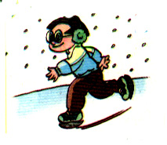
No, his uncle doesn’t live in the city.
2. _______________________________?
He is going to go skating.
3. _______________________________? Sun.
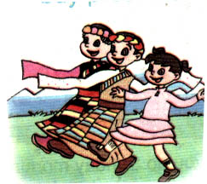
It is Sunday today.
4. ______________________________?
They are watching folk dances.
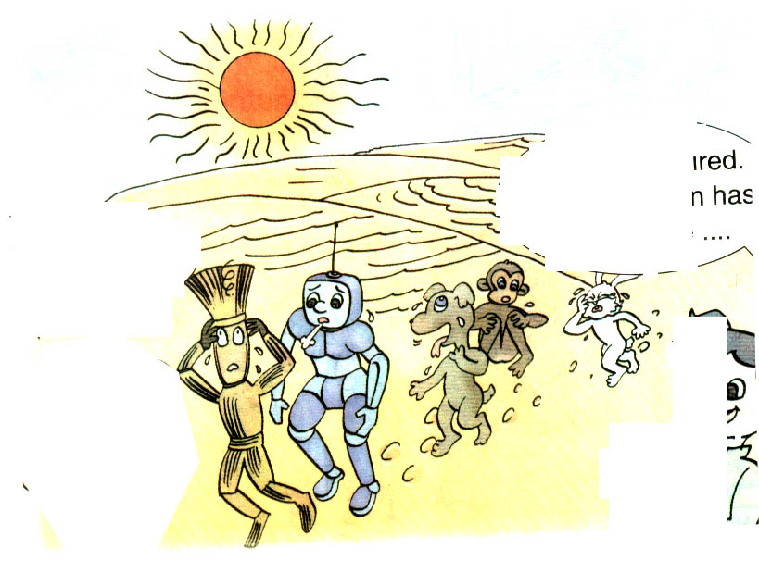
5.______________________________?
It’s sunny today.

十．Look and write（满分10分）
暑假就要来临了，下面的图片是你计划要做的事，请根据图片提示写写自己的暑假计划，不少于5句话。开头已为你写好，不算入五句话内。你可以选图表达。
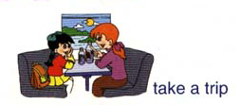
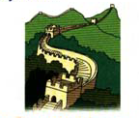
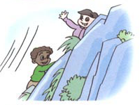
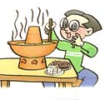

The summer holiday is coming.
___________________________________________________________
___________________________________________________________
___________________________________________________________
___________________________________________________________
___________________________________________________________

六年级英语综合测试卷(四)听力材料
一、Listen and choose（听录音, 选出跟录音相符合的一项，并将其字母编号填在题前的括号里 ）（每小题1分，共10分）
- Who’s taller than you in your class?
- Can you speak English?
- What is your favourite food?
- The library is west of the cinema.
- I like playing with snow in winter.
- I wear my shorts in summer.
- I usually do my homework at school.
- I went skating last weekend.
- What is the date today?
- I took pictures for my family last holiday.
C A B A B B A A B B
二、Listen and judge 听录音, 判断句子或图片的是否与录音内容相符, 相符的在相应题号下的括号内 打“√” , 不相符的打“×”（每小题1分，共10分）
1. The children are having a picnic in the park.
2. A: Is Zoom watering the flowers now?
B: No, he isn’t. He is drinking water now.
3. I am going to buy a dictionary in the bookstore.
4. Today is Teachers’ Day.
5. Look at the sprout. It is green.
6. Boy: I am 12 years old. What about you, Sarah?
Sarah: I am 13 years old.
7. A: Can you wash the clothes?
B: No, but I can water the flowers.
8.(男声) Look at the picture of my family. My parents are watching TV. My sister and I are doing homework.
9. A: What day is it today?
B: It’s Thursday.
10.(女声): How does your father go to work?
(男声): He drives to work.
1√2×3×4√5√6×7√8×9×10√
三、Listen and answer( 根据你在录音中的问题，将下面每组答句中最合适的答案选出来，并将其前面的字母符号填在句子前面的括号里，每小题2分，共１０分）
1. What was the date yesterday?
2. What are the tigers doing?
3. Did he go to Guilin last summer holiday?
4. Where did you go last Sunday?
5. What is she like?
1A2A3C4A5A
四、Listen and finish the sentences.（根据录音内容填写下列句子中所缺的单词, 使句子完整，每空只填一词，每词1分，共10分)
1. Mother: What is your English teacher like?
Peter: She is pretty.
2. Jimmy: Who is taller, you or me?
Tom: Me.
3. Peter: What did you do yesterday?
John: I went fishing.
4. Zip: What’s your favourite season?
Zoom: Spring.
5. Amy: Where is the post office?
Chen: It’s near the library.

五、Listen and judge（根据你在录音中听到的内容判断句子的对错，相符的在相应题号下的括号内打“√” , 不相符的打“×”，每小题2分，共10分）
Li Hua didn’t come to school yesterday morning. He went to see a doctor. He told the doctor he had a headache and a sore throat. He had a fever, too. The doctor said he got the flu and gave him some medicine. The doctor told him he must drink more hot water and stay in bed for a few days.
√ × √ × √
笔试部分答案(满分55分)
六、E C B F A
七、B A A B B √ × √ × ×
八、
friends, shorter, thinner, younger, do, Sunday, went, swimming, were, going
九、
1. Does his uncle live in the city?
2. What is he going to do?
3. What date is it today?
4. What are they doing?
5. What is the weather like today?
十、略
命题者：南城阳光中心小学梁咏来
修改者：市教育局教研室邓宁霞

