六年级英语根据答句写问句总复习题_试题_试卷
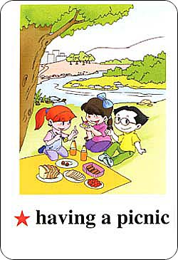
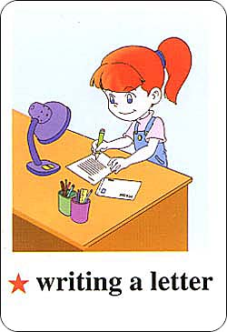
- ___________________________________? 1 2
They are having a picnic.
- ___________________________________?
I wrote a letter last night.
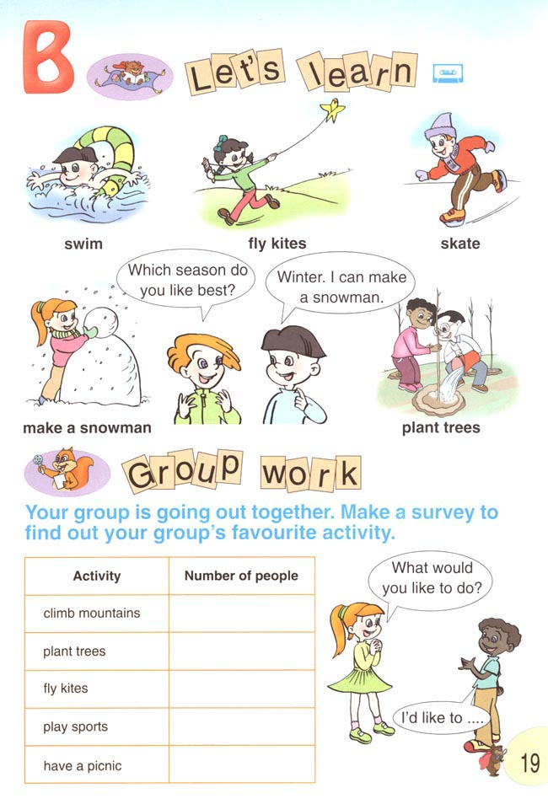
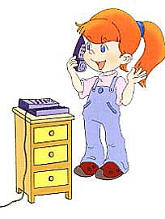
- ___________________________________ ? 3 4
I’m going to fly kites on the weekend.
- ___________________________________?
Sarah usually listens to music after school.
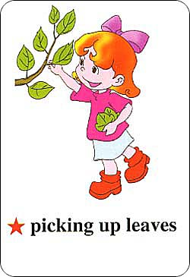
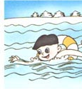
- ___________________________________? 5 6
Yes, they are going to pick up leaves this Sunday.
- ___________________________________?
Zhang Peng swam in the sea on May Day.
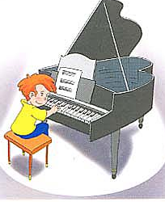
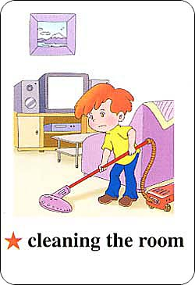
- ___________________________________? 7 8
I like playing the piano.
- ___________________________________?
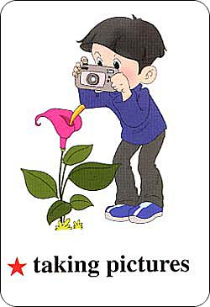
No, I watered the flowers yesternoon afternoon.
- ___________________________________? 10
I am a student.
- ___________________________________?
The boy is taking a picture.
- ___________________________________?
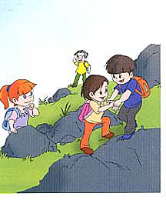
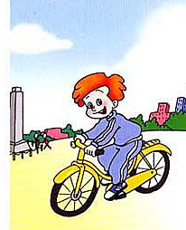
No, the students cleaned the room yesterday. 11 12
- ___________________________________?
Alax usually goes to school by bike.

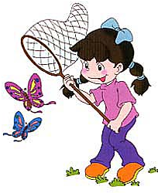
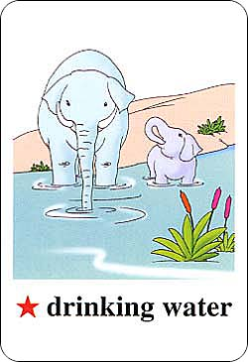
- ___________________________________? 13 14
Yes, Chen Jie is catching butterflies.
- ___________________________________?
The elepants are drinking water by the river.
- ___________________________________? 15 16
It’s spring now.
- ___________________________________?
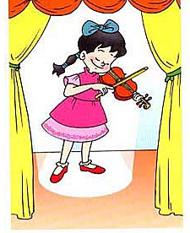
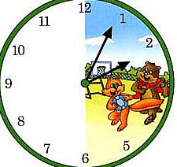
Because I like skating in winter.
- ___________________________________? 17 18
My sister likes playing the violin.
- ___________________________________?
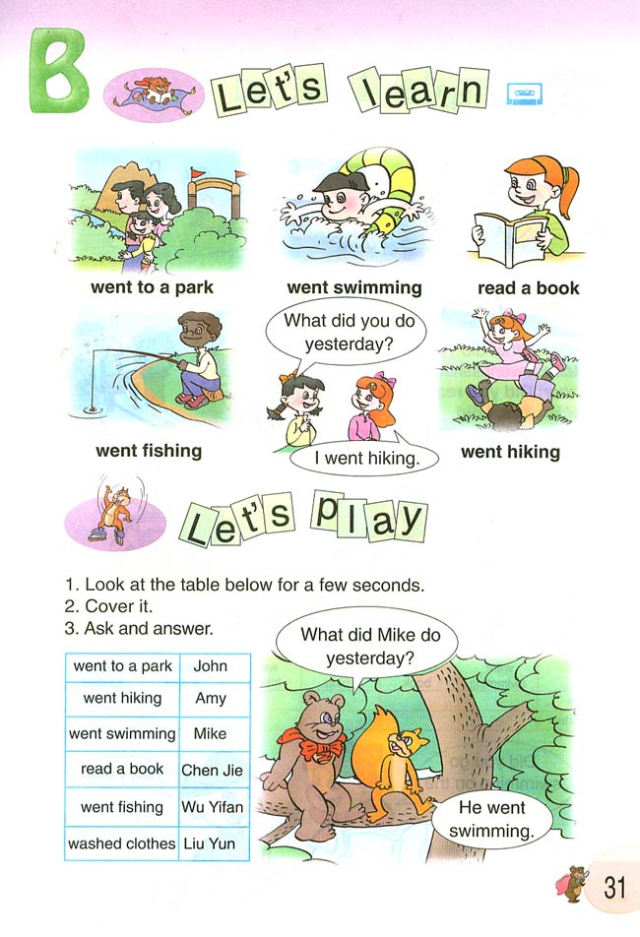
It’t 2:05 now.
- ___________________________________? 19
Yes, John likes fishing.
- ___________________________________?
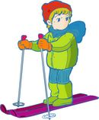
There are five people in my family.
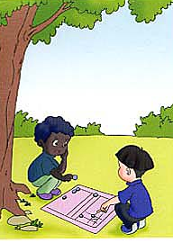
- ___________________________________? 21 22
He is going to go skiing this winter holiday.
- ___________________________________?
They usually play chess on the weekend.
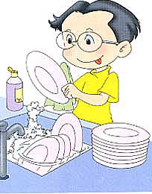
- ___________________________________? 23 24
I can do the dishes.
- ___________________________________?
No, Li Gang draw pictures last night.

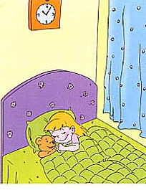
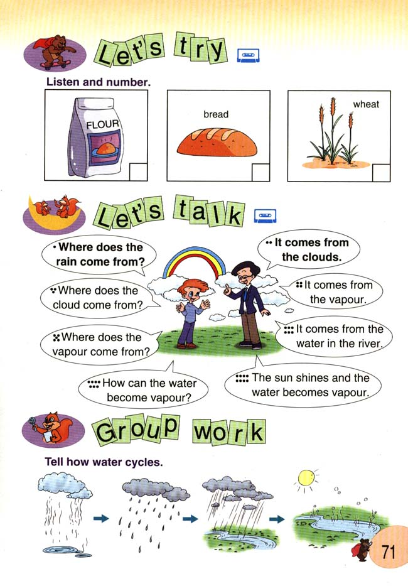
- ___________________________________? 25 26
The girl is sleeping.
- ___________________________________?
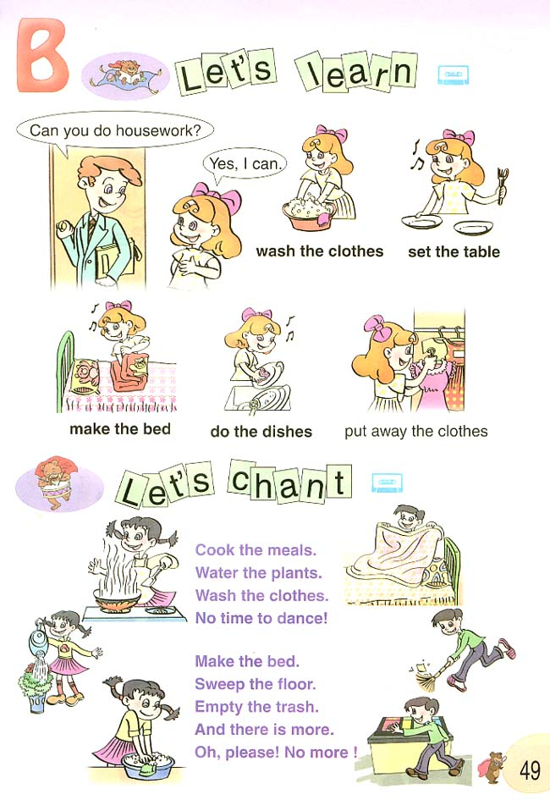
It’s rainy today.
- ___________________________________?27 28
Yes, Sarah can write a letter.
- ___________________________________?
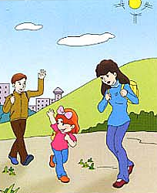
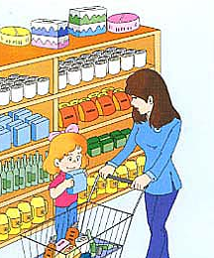
Yes, I am helpful at home.
- ___________________________________? 29 30
They are going to go hiking next Saturday.
- ___________________________________?
They are in the supermarket.
- ___________________________________? 31
There are two girls in the picture.
- ___________________________________? 32
I am washing the clothes.
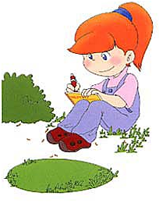
- ___________________________________?
No, my sister can’t write a report. 33 34
- ___________________________________?
We climbed mountains last weekend.
- ___________________________________?
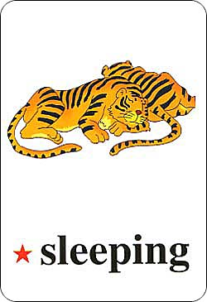
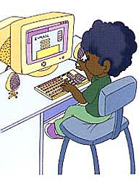
Two tigers are in the picture. 35 36
- ___________________________________?
John is going to write an e-mail this evening.

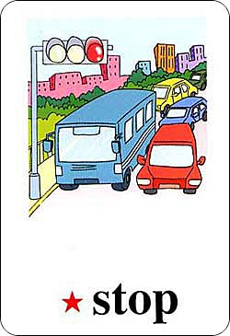
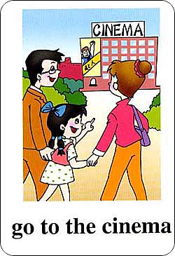
- ___________________________________? 37 38
There are three traffic lights in our country.
- ___________________________________?
They are going to the cinema.
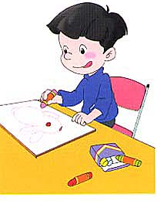
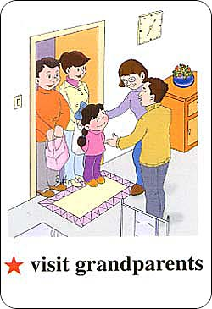
- ___________________________________? 39 40
No, the boy likes reading books.
- ___________________________________?
We are going to visit my grandparents next Saturday.
- ___________________________________? 41 42
I cook dinner for my family every day.
- ___________________________________?
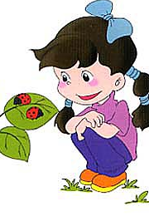
I can sweep the floor.
- ___________________________________? 43 44
She is watching insects.
- ___________________________________?
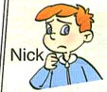
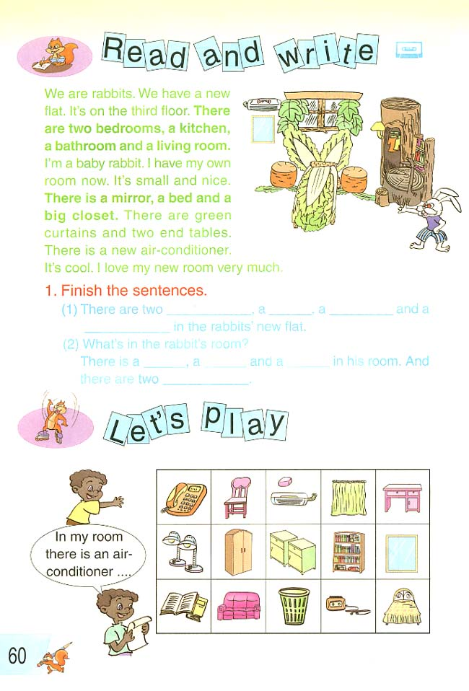
The rain comes from the clouds.
- ___________________________________? 45 46
Nick is bored.
- ___________________________________?
Yes, the phone is on the desk.
- ___________________________________? 47 48
There are two end tables in my bedroom.
- ___________________________________?
It’s on the wall.
- ___________________________________? 49
Yes, there are many books on the shelf.

