小学六年级新标准（下）英语期末测试题
（满分100分，90分钟内完成）
题 号 | 一 | 二 | 三 | 四 | 五 | 总 分
得 分

得 分 |  | 一、书写检测。（30%）

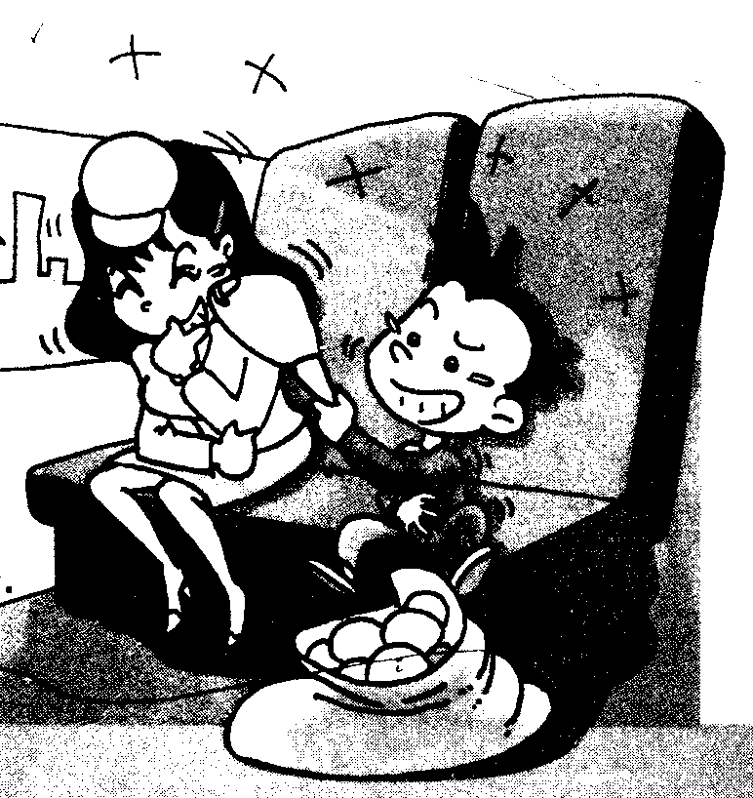

1、如图，将下列单词丢失的字母补充完整。(10分)
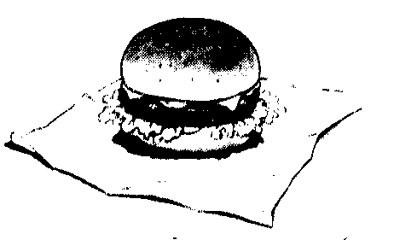
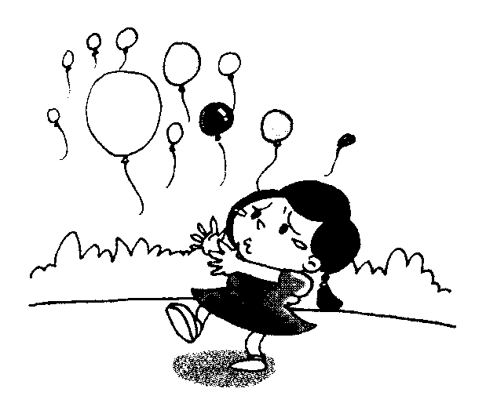
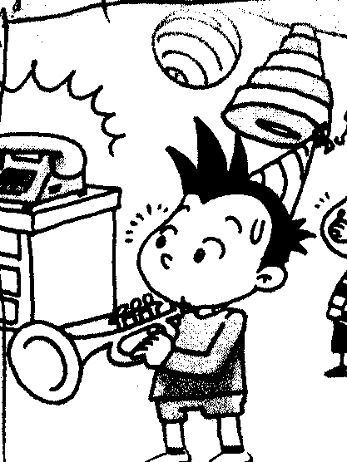

h_mb_rger ball_ _n tr_mp_t l_ _gh sp_ c _ ship
2、将下列打乱字母顺序的单词按正确形式写在四线格中，并翻译成汉语（10分）。
daroll potil dlchi tsdyu edmol

( ) ( ) ( ) ( ) ( )
3、将下列单词重新排列成完整的一句话，写在四线格上，注意标点及大小写。（10分）
are to Chinese we speak going .

you bought book this I .

Daming party having birthday a is .

you to want eat what do ?

is matter the what ?

得 分 |  | 二、单词，词组辨认。（20%）
1、按要求写出单词对应形式。（10%）
1、eat（现在分词）______________ 2、photo（复数）______________
3、get（过去分词）______________ 4、happy（反义词）____________
5、rainy（名词形式）______________
2、词组连线。（10%）
make a raincoat
wear to her friend
talk a video
get at some ducks
look off the bus

得 分 |  | 三、根据句型写出单词正确形式。（5%）
1、Children are __________（swim）in the water.
2、Yang Liwei __________(spend) about twenty-one hours in space three years ago.
3、I am going to ________(practise) my English.
4、Now I can ___________(write) in English.
5、Helen Keller ___________(is) born in America in 1880.

得 分 |  | 四、句型辨析。（20%）
1、根据图示，将句型补充完整。（10%）
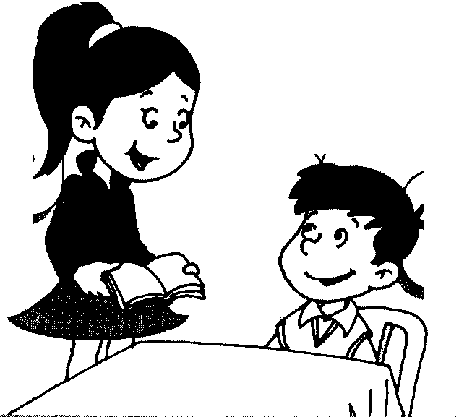
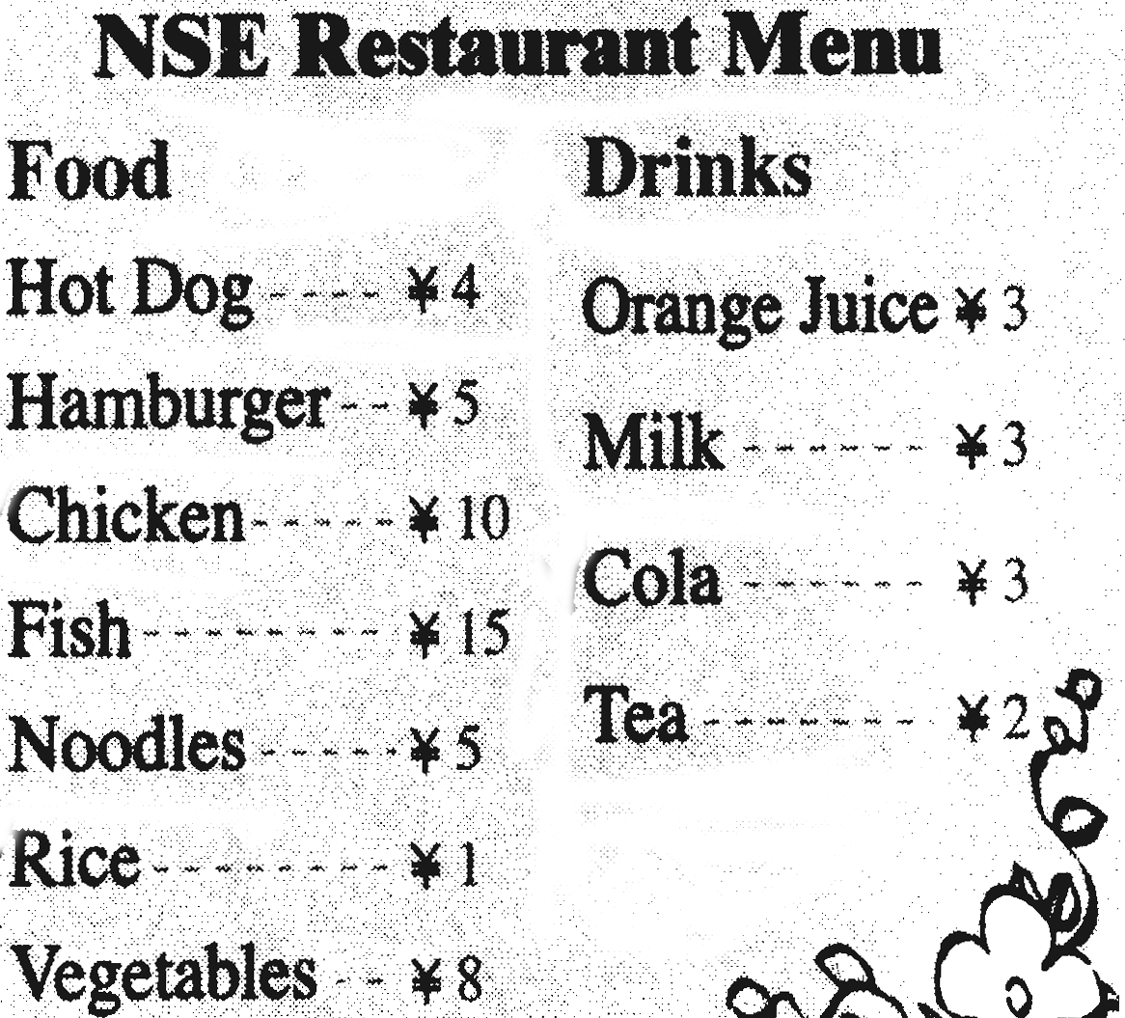
A: _______do you want to eat ?
B: I want _________and _______please.
√
A: What do you want to drink?
√
√
B: I want a _______,please._______ _______is it ?
A: It’s ________yuan.
B: ________ __________ ________
A: Thank you.
2、选择与图片对应的句子。（10%）
A、It’s raining now.The ducks are eating our picnic.
B、We are going to school at eight .
C、Why are you laughing ?
D、In October 2003 .Shen Zhou flew into space with Yang Liwei.
E、I am flying in the sky. You are waving to say goodbye.
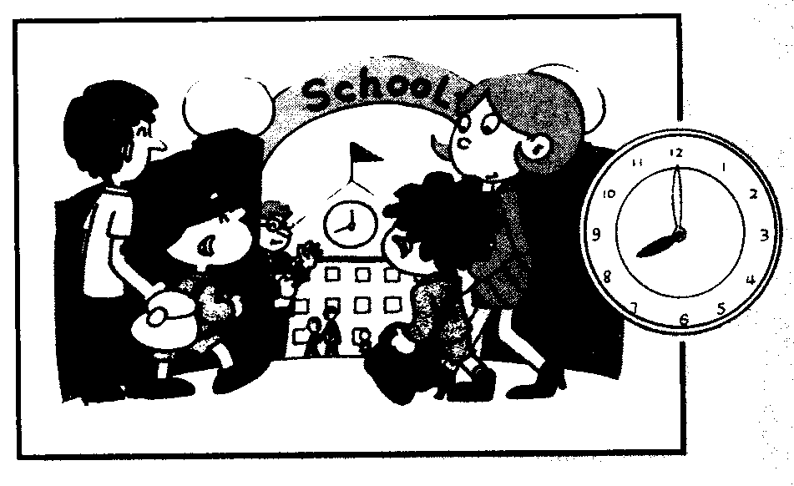
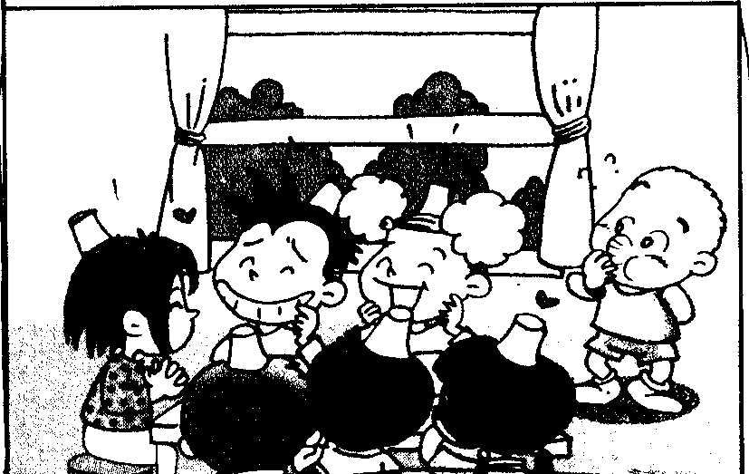
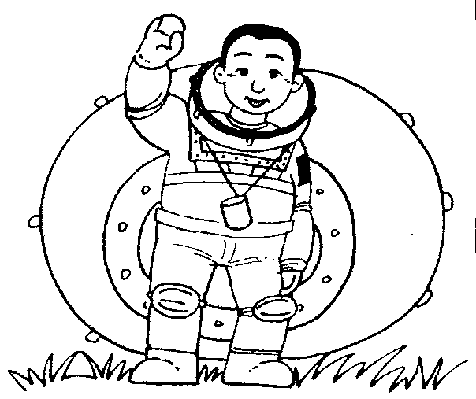
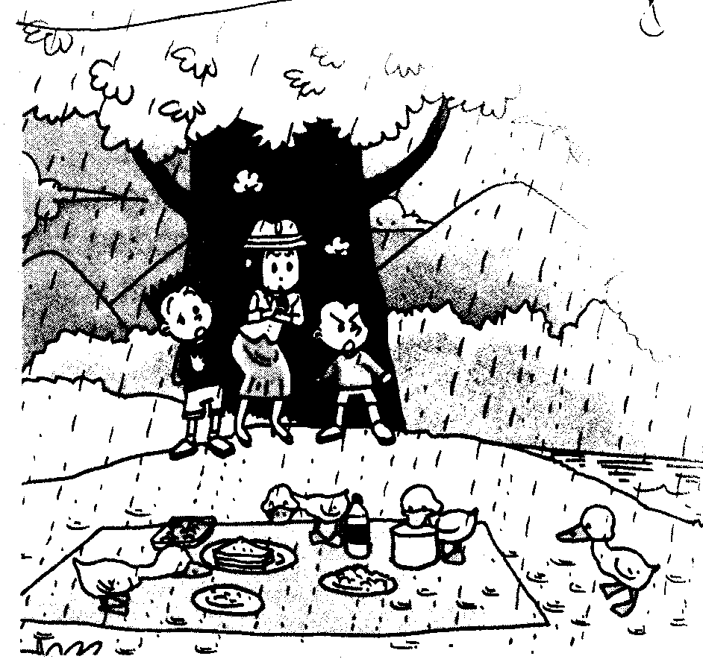
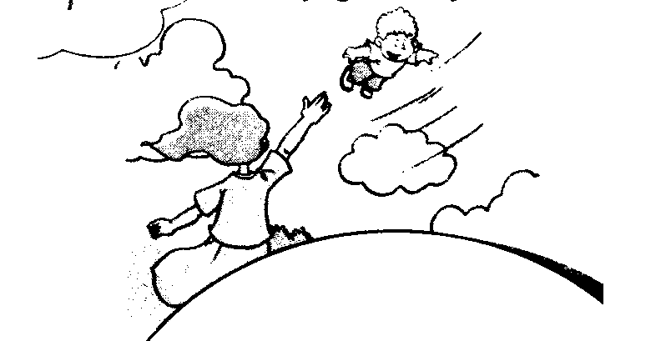

（ ） （ ） （ ） （ ） （ ）

得 分 |  | 五、能力检测。（20%）
1、根据课文选词填空。（10%）
rode ate was played game
drank saw went won watched

Daming and Simon ______ to a basketball game in America.They ___________their bicycles .They ______the game. They ______ their favourite team.Their team _______ very well and they ______.Daming and simon _________ hot dogs and ________ colas.It _____ a great______.

2、阅读理解，判断正（√）误（×）（10%）
Dear Henry,
How is everything? We all miss you. Last week, I want to Hawaii with Dad and Mom. It is really a wonderful place. We walked on the beach, swam in the sea, ate a lot of sea food and watched a very beautiful dance. It was so hot in Hawaii, but we had a good time there.
Here is a photo for you, Hope you like it. Please write me soon.
Yours,
Tom
（ ）1、Henry went to Hawaii with Dad and Mom.
（ ）2、Hawaii is really a wonderful place.
（ ）3、Henry and his parents watched a very beautiful dance.
（ ）4、It was so hot in Hawaii.
（ ）5、Tom and his family had a good time in Hawaii.

得 分 |  | 六、实践应用。（5%）
根据问句及你的实际情况写答句。
1、What’s your hobby? ______________________________________________.
2、Whose’s your best fridnd? __________________________________________.
3、What season do you like best? _________________________________________.
4、Do you watch TV every day? __________________________________________.
5、What did you do last week? ___________________________________________.

