小学六年级英语6A（上）模拟试卷
（考试时间为60分钟）
题号 | Ⅰ | Ⅱ | Ⅲ | Ⅳ | Ⅴ | Ⅵ | Ⅶ | Ⅷ | Ⅸ | Ⅹ | Ⅺ | 总 分 | 等 第
得分
阅卷人
听力部分（30分）
Ⅰ、听录音，选出你听到的单词或短语。（听两遍，共8题，每小题1分，计8分）
（ ）1、A. race B. grass C. glass
（ ）2、A. present B. parents C. presents
（ ）3、A. take a walk B. keep off C. take off
（ ）4、A. June 6 B. July 16 C. June 16
（ ）5、A. No parking. B. No littering. C. No smoking.
（ ）6、A. dear B. near C. year
（ ）7、A. wait B. away C. always.
（ ）8、A. shouldn’t B. mustn’t C. can’t

Ⅱ、听录音，给下列图片标上序号。（听两遍，共8题，每小题1分，计8分）
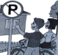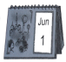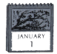
( ) ( ) ( ) ( )
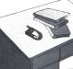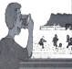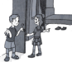
( ) ( ) ( ) ( )
Ⅲ、听录音，判断所听内容是否与图意相符，相符的打“√”，不相符的打“╳”。（听三遍，共8题，每小题1分，计8分）
2
1
4
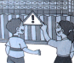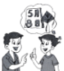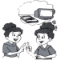
3
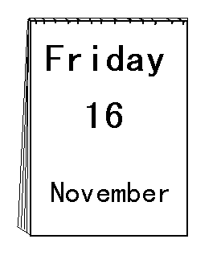
( ) ( ) ( ) ( )
8
7
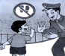
61
5
( ) ( ) ( ) ( )
Ⅳ.听录音，选出合适的应答句。（听三遍，共6题，每小题1分，计6分）
（ ）1、A. It means “Be quiet”. B. It means you should make noise. C.Yes,it does.
（ ）2、A. He likes dancing. B. She'd like a camera. C. He wants a camera.
（ ）3、A. It’s on the 4th of April. B. It’s the 4th of April. C. It’s on Thursday.
（ ）4、A. No, there weren’t. B. Yes, there wasn’t. C.No, there wasn’t.
（ ）5、A. It was under the table. B. They were on the sofa. C. They are on the sofa.
（ ）6、A. No,I'd like to. B.Yes, I'd like to. C.Yes, I like.

笔试部分(70分）
Ⅴ. 选择题。（共15题，每小题1分，计15分）
( ) 1. My little sister is only .
A.three year old. B. three years old. C.three years

( ) 2. I want to buy glasses for my grandpa.
A. a B. the C. a pair of

( ) 3.Jim and Ron are about Jack’s birthday.
A. saying B. talking C. speaking

( ) 4.What an game it is!
A. excite B.exciting C. excited

( ) 5. I usually my homework at seven o’clock.
A. did B. do C. does

( ) 6. My VCD here yesterday. Where it now?
A. is ,was B. were , are C. was , is

( ) 7. What is it today? It is Sunday.
A. date B. time C. day

( ) 8. What in the glass ? There some apple juice.
A is , is. B. is, are C. are ,is

( ) 9.My father likes music after lunch.
A. listening to B .listen to C. to listen

( ) 10. Here’s a photo of family for you . May I have one of ?
A. yours ,my B. my ,yours C. your, my

( ) 11.Ben is the candles on the cake . It's time for some cake.
A.buying B.blow out C.blowing out

( ) 12. When's your birthday, Andy?
A.At January B.On January C.In January

( ) 13. Mary is looking her camera.She can't find it.
A. for B.at C.around

( ) 14. Mr Smith looks around. There's nearby.
A.everyone B.no one C.some people

( ) 15. Many boys in our class often do their homework very .
A.much careful B.careful C.carefully

Ⅵ. 从Ⅱ栏中选出Ⅰ栏的正确应答，并将其序号填在括号内。（共8题，每小题1分，计8分）
Ⅰ Ⅱ
( ) 1 .Is the diary under the violin? A .It means “No speaking”.
( ) 2 .Would you like to come to Halloween party? B .No, it isn’t.
( ) 3 . Where are the photos? C. Of course
( ) 4 . Are the students walking in the playground? D.They’re behind the sofa.
( ) 5. What does the sign mean? E.Yes, they are.
( ) 6. Does she often walk to school? F. He's only three.
( ) 7. How old is your brother? G.No. She always goes to school by bike.
( ) 8. Do you have school from Monday to Friday? H.Yes,we do.

Ⅶ. 从方框内选出正确的词或词组完成句子。（共10题，每小题1分，计10分）
1. The sign on the grass says“ the grass”.
a lot of Keep off on the ground make noise comes up in Ben's class a yo-yo took some photos pick them up very exciting
2. There are signs in the park.They mean different things.
3. Jim is a new student .
4. You shouldn't in the library.
5. The park keeper to him and points to a sign over there.
6. Look,my films are .Can you for me.
7. The running race is .
8. Dad and I last week.
9. I'd like as my New Year present.
Ⅷ. 给下列句子重新排序。（共2题，每空1分，计8分）
1、a. It's the 7th of Septenber. 2、a. Listen, whose mobil phone is ringing.
b. What date is it today ? b. Is it in your bag?
c. Good idea . c. It's mine. I can't find it.
d. Let's make some cards forour teathers. d. No, it isn't.It was there a moment ago.
e. Oh, Teathers' Day is coming soon . e.Where is it?
→ → → → c a → → → →

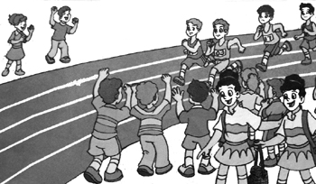
Ⅸ. .根据图片，填入所缺单词。（共4题，每空1分，计5分）
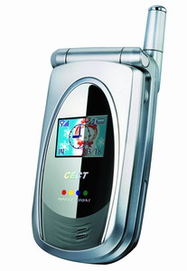
1.Today is Sports Day. All the students are very .
2. Whose is it? Perhaps it's Linda's.
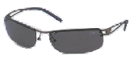
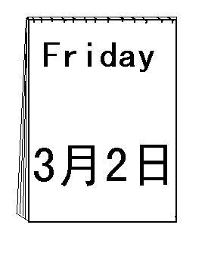
3.There is a pair of on the table. It's my mum's.
4.What date is it today? It's the second of .

Ⅹ.根据中文提示，完成句子，每空一词。（共4题，每空1分，计14分）
1.---爸爸,我能问你一些关于鸟的问题吗? --- Can I you some about birds,Dad?
--- 不。你现在应该去睡觉了。 --- No, you can’t. You go to bed now.

2. --- 你什么时候过生日？ --- is your ？
---在四月三日。 ---It’s on the of .

3.---你想要什么作为你的万圣节礼物？---What would you like as your Halloween ?
--- 我想要一个玩具火车。 ---- I’d like a toy train.

4. 我父母经常在晚饭后散步。 My parents often after super.

5.---这个标志是什么意思？ --- What this sign ?
---禁止吸烟。 ---It “No smoking”.
Ⅺ. 阅读理解。（共10题，每小题1分，计10分）
A.阅读短文，判断正（T）误（F）。
Sam and Tom are brothers.They are from America, but now they are in Shanghai. Today is their birthday. We can see a big cake on the table. There are a lot of presents on the table, too. Where are the childen? They are playing in the garden. Wang Ying is behind the tree.Tom is looking for her. Li Lei is running after Liu Tao. Beibei is playing ball games with Sam. All of the children are having a good time.
( ) 1.Tom and Sam are brothers.
( ) 2.There are lots of presents and two cakes on the table.
( ) 3.The children are playing in the garden.
( ) 4.Tom is looking for Wang Bing.
( ) 5.Sam and Tom are having a good time.

B.阅读短文，选择正确的答案。
Today is Sunday. All of us go to school early, but we have no lessons. Our teachers are going to take us to the zoo. We take buses there. We get there at nine thirty.
How beautiful the zoo is! There are many trees, some hills, and a big lake. It’s spring now, so the flowers are very beautiful. There are many people there, too. We like to watch monkeys. Some of them are playing on the hills. Some are having oranges, apples and bananas. We have a good time with them. We leave the zoo at half past three in the afternoon.
( ) 1.We have no lessons________________.
A. on Sunday B. on Friday C. on Saturday morning
( ) 2.We go to the zoo _____________ on Sunday.
A. by bick B. by bus C. on foot
( ) 3.There is _____________ in the zoo.
A. a small lake B. a big river C. a big lake
( ) 4.We are watching _________________ in the zoo.
A. the tigers B. the monkeys C. the horses
( ) 5.We leave the zoo at _____________ in the afternoon.
A. three thirty B. three o’clock C. three past three
命题：刘兰香 高乃军 审定：杨柳

