京翰主编点评：

同学们，这个学期很快就要结束了，想知道你英语学的怎么样吗？那就认真完成这张试卷吧，记得要仔细审题哦，祝你考出好成绩.

6A英语复习2 Name___________
听力部分30％
- 听录音，给相应的图标上序号。（听一遍）8%
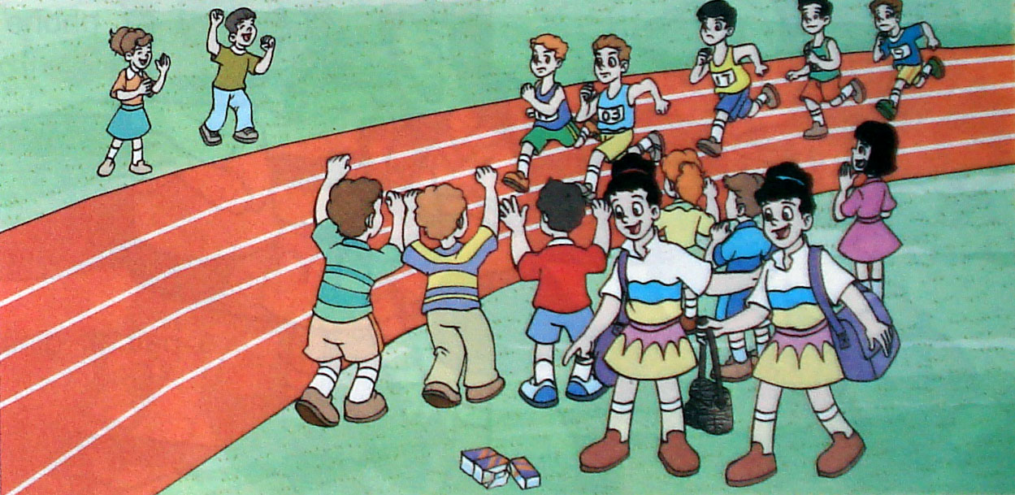
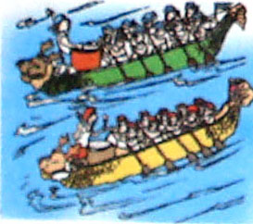
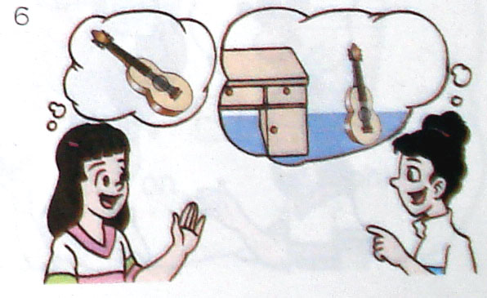
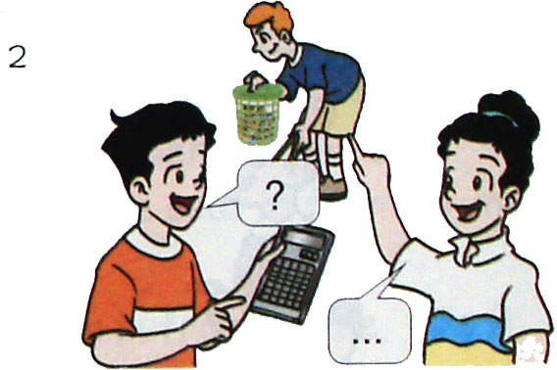

( ) ( ) ( ) ( )
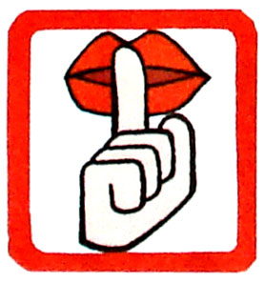
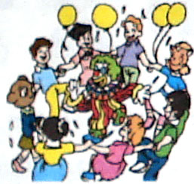
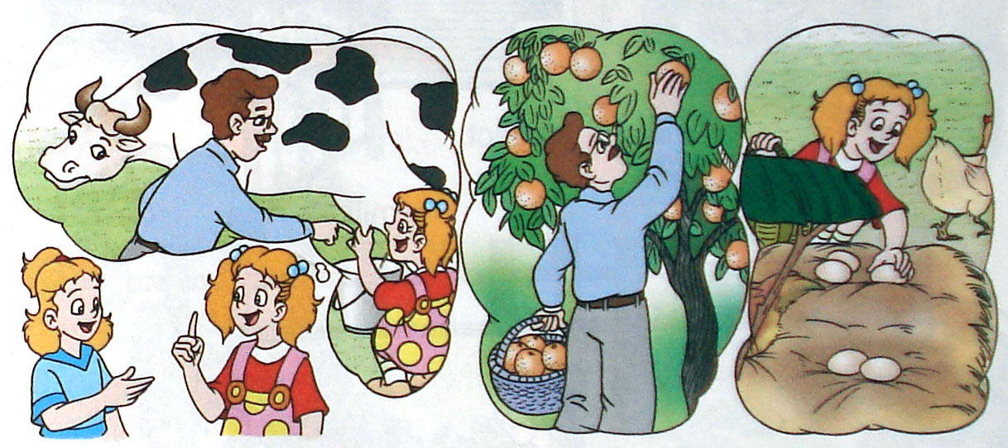
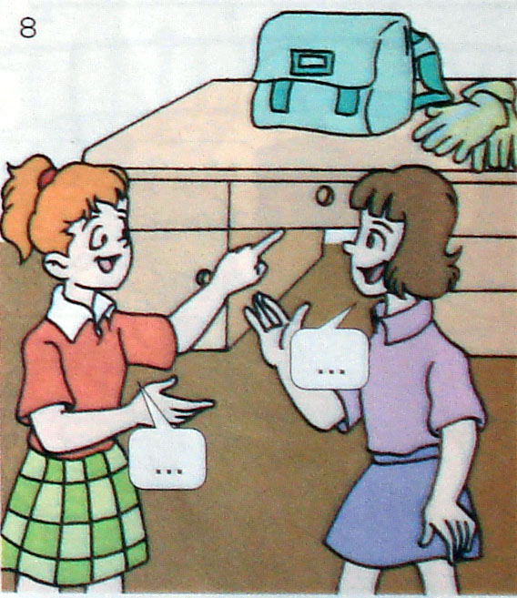

( ) ( ) ( ) ( )
二、听录音判断图片与录音内容是否相符。（听两遍）8%
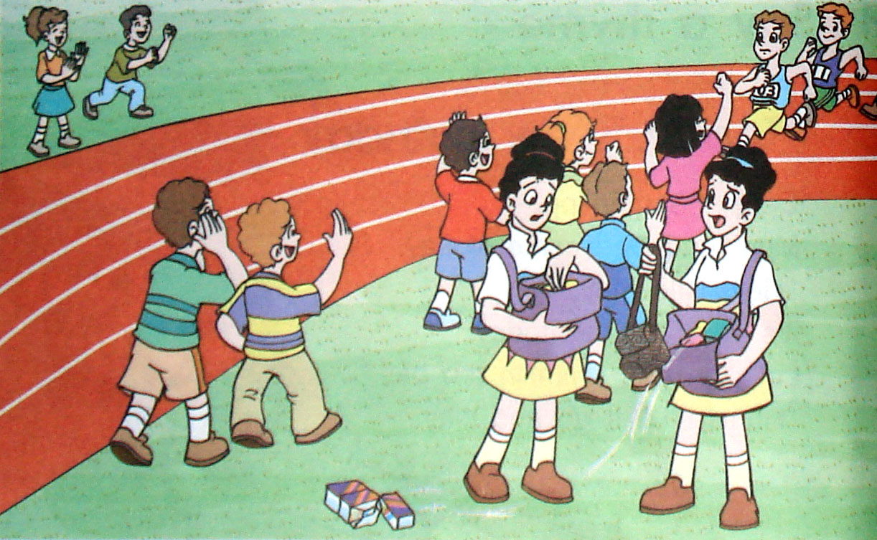
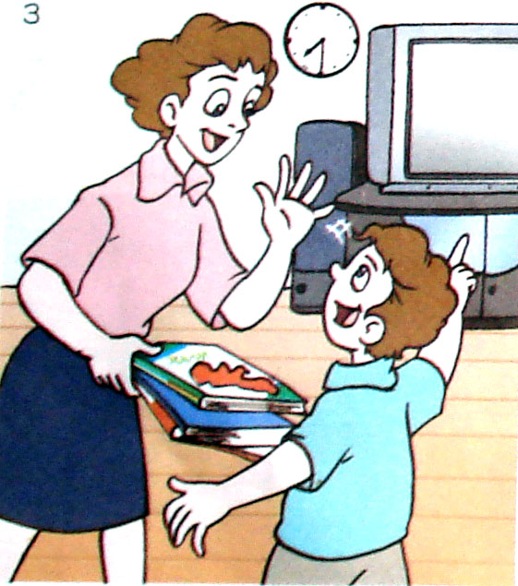
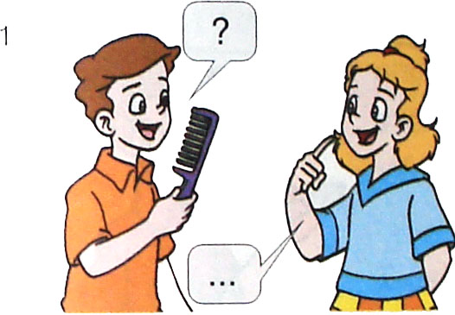
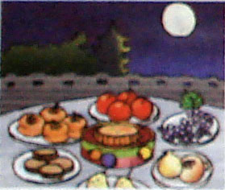

〇 〇 〇 〇

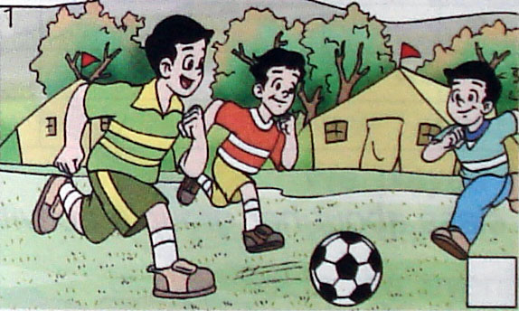
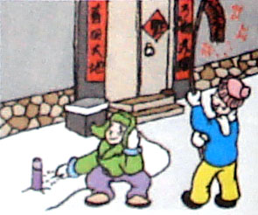
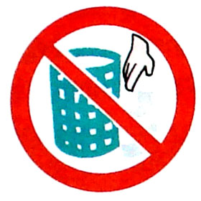
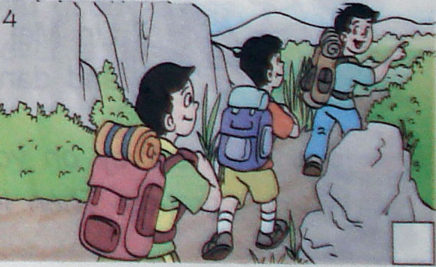

〇 〇 〇 〇

三、根据所听问句，选择正确的答句。（听两遍）5%
( ) 1. A. Yes, I do. B. No, I’m not. C. Yes, I did.
( ) 2. A. It’s Friday. B. It was fine. C. It wasTuesday.
( ) 3. A.I like it. B. I had a skateboard C. I’d like a calculator.
( ) 4. A. They’re mine. B. It’s mine. C. It’s his.
( )5.A. May Day. B. New Year’s Day. C.Halloween.

四、听录音，填入所缺单词。（听三遍）9%
1. It is the 27th of May. ___________Day is coming.
2. There are some___________on the farm.
3. Don’t____________the ball on the table.
4.___________you like a puppet as your birthday_________?
5. It means you___________make noise here.
6. Last______________, we had an Art Festival.
7. A lot of people__________to our__________and have a look at us

笔试部分70％
- 辨音。10%
( )1．their think ( )2．were where
( )3．collected planted ( )4．classroom room
( )5．cake cat ( )6．show how
( )7．hear ear ( )8．bus put
( )9．short shirt ( )10．child children
- 词组互译。10%
1)公共标志 _________________ 2) at the back of ________________
3) 寻找…_________________ 4) have a good time _______________
5) 7月15日_________________ 6) next to _________________
7) 刚才_________________ 8) Danger! _________________
9) 上个星期_________________10) keep off _________________

- 选择题。10%
( ) 1. They a lot of pictures last Sunday.
A. draw B. drew C. drawing
( ) 2. Tom a farm with his family last holiday.
A. visited B. visit C. visits
( ) 3. The children __ cows a moment ago. That _ fun!
A. milk is B. milked was C. milk was
( ) 4. Did you have a good time? Yes, I .
A. had did B. have did C. have have
( ) 5. ---Where you last week? ---I was _____ a camp.
A. are at B. was in C. were at
( ) 6. Look! I have a photo of ______family. Do you have one of ______?
A. my your B. my, yours C. mine yours
( ) 7. ----_____________ ----It’s his, I think.
A. Whose ruler is this? B. Where’s his ruler? C. Who’s ruler is that?
( ) 8. What an ______ game it is!
A. excite B. exciting C. excited
( ) 9. My uncle gave a new bike to ________.
A. theirs B. they C. me D. I
( ) 10. This is a photo of _____family. May I have one of ______?
yours; my B. my; yours C. your; my D. yours; mine

四、用所给词的适当形式填空。15%
1.The rubber ______ (is) in my pencil box now. It _____ (is) there last night.
2.Where are your ________( glass)? They’re between the _______. (lamp)
3.His coat is green. _______(her) is purple.
4.Look! Ben is __________( pull ) up the carrots now.
5.We______(had) a good time yesterday.We_____(eat) and______(drink)a lot.
6.This wallet isn’t ______ (my). It’s _______ (Mike).
7.My birthday is on the _______(one) of May.
8.Would you like _____ (milk) cows on the farm?
9.My parents _______ (go) to Shanghai last month.
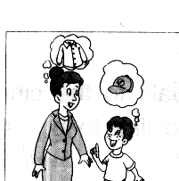
10.There are lots of _______(people) in the Suguo Supermarket on New Year’s Day.

五、看图完成对话。15%
1、David:Today is my _______ , Mum .
Mum:Is it ? Oh ,sorry .I forget it .
David :I’d like a red cap _______
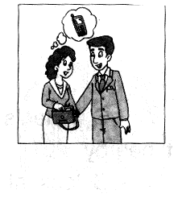
my birthday __________ .
Mum : OK . I’ll buy a_________ for you ,too .

2、Man: Listen ! _______ mobile _______ is ringing ?
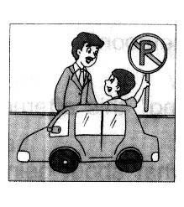
Woman : It’s mine（我的）. I can’t find it . _______ is it ?
Man : Is it _______ your bag ?
Woman : No , it isn’t . It _______ there a _______ ago .

3、Mike : We shouldn’t _______ our car here .
David : Why ?
Mike : Look at that _______.
It _______ ‘ _______ _______’ .
Dad: I’m sorry .

六、阅读理解，根据短文内容判断正误。10%
Yesterday was September 10. It was Teachers’ Day. We bought some flowers and presents to our teachers’ office. We thanked them for their hard work. Our teachers were very happy. In the afternoon we held a party in our school hall. Many students and teachers gave wonderful performances at the party. Our teachers sang and danced happily with us. All the teachers and students had a good time.

( )1.Yesterday was National Day.
( )2.We bought some flowers and presents to our teachers’ office.
( )3.Our teachers were not happy.
( )4.We held a party in the afternoon in the morning.
( )5. We all had a good time.

六年级牛津英语期末测试听力内容与答案
听力部分（20％）
- 听录音，给相应的图标上序号。（听一遍）（共8分）
1. Where is the guitar? It’s near the desk.
- Look, there are dragon boat races.
- Whose calculator is it ? It’s his .
- Where are the gloves? They’re beside the school bag.
- Keep quiet in the library.
- They sang songs at the Art Festival.
- There is a running race at Sports Day.
- We milked cows on the farm last week.
二．听录音判断图片与录音内容是否相符，相符的画〇 ，不符的画〇。（听两遍）（共8分）
1. Today is Sports Day. All the students are very excited.
2.Can I play computer games ? No, You should go to bed.
3. Whose comb is this? It’s hers.
4. Today is the 10th of October..
5. They’re playing volleyball.
6. My favorite festival is Spring Festival.
7. This sign means No littering.
8.We were on the farm last week.
T F F F F T T F
三．根据所听问句，选择正确的答句。（听两遍）（共4分）
1.Did you go to a party last weekend?
2.What day is it today?
3.What did you have as a birthday present last year?
4.Whose shoes are those?
5.What holiday comes after Christmas ?

