小学六年级英语教学质量检测题(联考)
一、听力测试。（共25分。A.E部分0.5分，B，C，D均为1分1题）
A）听录音，找出你所听到的内容。（读一遍，5分）
( ) 1. A. walk B. winter C. write
( ) 2. A. hungry B. hurry C. hundred
( ) 3. A. 2nd January B. 2nd June C. 2nd July
( ) 4. A. 12:15 B. 11:45 C. 11:15
( ) 5. A. pick apples B.pick oranges C. pick peaches
( ) 6. A. a snowball B. a brown ball C.a blue ball
( ) 7. A. at the first stop B. at the fifth stop C.at the third stop
( ) 8. A. who’s the glue from? B.who’s the glue for? C. whose is the glue
( ) 9. A. Nancy does’t do well in PE B. Nancy does well in PE
C. Nancy ‘s doing well in PE
( )10. A. His hobby is singing. B. Her hobby is dancing
C. His hobby is listening to music
B）根据听到的句子，选择相应的答语，并将其序号填入题前括号内。（读两遍）
( ) 1. A.Yes,I do. B. I like winter. C. Yes, I like winter best.
( ) 2. A. Well done. B. I hope so. C. That’s all right.
( ) 3. A. No,she isn’t. B.Yes,she is. C. No,she doesn’t..
( ) 4. A. It’s the 17th of April. B. It’s Thursday. C. It’s on the 17th of April.
( ) 5. A. Yes,he does. B. Yes,he was. C. Yes,he is.
C），根据听到的对话及问题，选择正确的答案,并将其序号填入题前括号内。（读两遍）
( ) 1. A. Spring Festival. B.Hallown. C. Christmas.
( )2. A. He picked oranges. B. He visited a school. C. He pulled up carrots.
( ) 3. A. SuHai. B. SuYang. C. Tom.
( ) 4. A. He’s asking the way. B. He’s doing shopping. C. He’s waiting for a bus.
( ) 5. A. It’s the fifth of August. B. It’s the sixth of August. C. It’s the seventh th of August
D）根据听到的短文内容，选出正确的答案，并将其序号填入题前括号内。（读两遍）
1.John Brown studies_______at school
A.piano B.Art C.PE
2. John Brown will stop his study in______.
A.April B.June C.July
3. John Brown______in the evening.
A.has dinner B.plays the piano C.studies English
4. John Brown sleeps______hours every day.
A.four hours B.eight hours C.nine hours
5. Why does he like the work?
A.Because he only works three nights a week. B. Because he only works from 4 to
C. Because he only works six days a week.
E)根据听到的短文内容，填入所缺单词。（读三遍）
Dear Ben:
Thank you for your letter.I’m very glad to be your________.
I’m in Grade six.I’m eleven________old.I’m one year________than you.My hobbies are________stamps and reading.My________subject is English.I can________English srories now.And I like________English songs.How about you?I have a family of three:my father,my mother and me.My________are doctors.My telephone number is 6298779. My e-mail is liyang@river.com. Please me soon
二、语音。找出每组单词中划线部分发音与其余二个不同的选项。（5分）
( ) 1. A. stamp B. plan C. black D.date
( ) 2. A. study B. duty C. must D. jump
( ) 3. A. ago B. close C. clock D. home
( ) 4. A. mean B. sweater C. heavy D. weather
( ) 5. A. blow B. now C.know D.snow
三、词汇。（15分）
A）英汉词组互译。（10分）
1. 品尝一个苹果 6. most of the time
2. 写信 7. ask for penfriends
3. 擅长画画 8. public telephone
4. 和我下棋 9. I hope so.
5. 值日 10. sing a popular song
B）根据句意及单词首字母提示，完成下列句子。（5分）
1．The Changjiang River is a very l river.
2. Look! The bus is c .
3. It’s Children’s Day. All the students are very e .
4. Ben and Benny are good at C .
5.He m many cakes for his friends yesterday.
四、选择填空。（10分）
( ) 1. We can go on outing in autumn.
A. a, a B. an, an C. an, /
( ) 2. This is our classroom. is next to .
A. your,our B. your, ours. C. yours,ours.
( ) 3.Does your friend have any hobbies ? Yes,He .
A. hobby is playing football B. like playing football C.likes playing football
( ) 4. is the first day of the week and is the first month of the year.
A. Monday,January B. Sunday,February C.Sunday,January
( ) 5. you like to come to the party? Of course.I’ll come them
A. Who,with B. Would,of C. would,with
( ) 6. What Jane ? She’s writing an e-mail to her pen friend.
A. will,do. B. did,do C. is,doing
( ) 7.I often walk to school,but by bike.
A. usually B. always C. sometimes
( ) 8.What you usually on Sundays? I usually watch TV at home.But last Sunday I to the park with my friends.
A. did,go,goes B.do,does,went C. do,do,went
( ) 9. I know “cm” is .
A. centimetre. B. kilometre. C. metre.
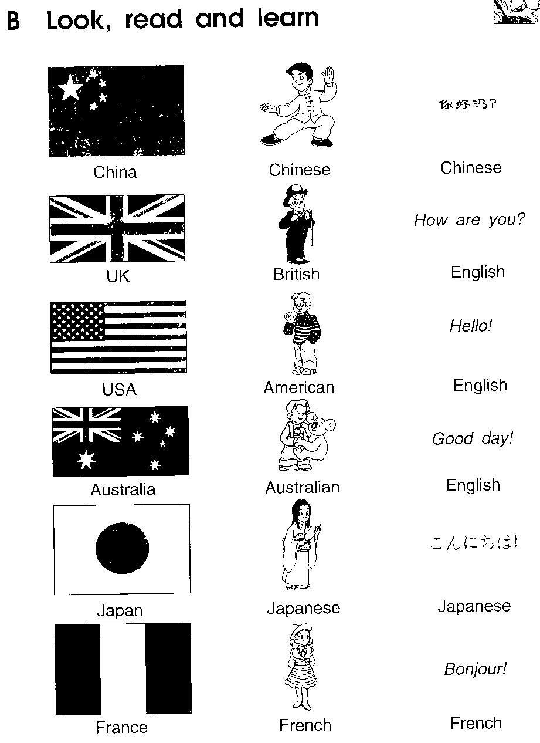
( ) 10. This is the national flag of .
A. the USA B. China C. the UK
五、选择方框中合适的句子完成对话，其中有一项时多余的。（共5分，每空格1分）
A: 1
B:Yes.And today is Sunday.Shall we go to the park?
- Whould you like to go rowing?
- There are a lot of students over there.
- What about seeing the animals in the zoo?
- It’s a sunny day,isn’t it?
- Oh,look at the flowers.
- I like to go rowing.
A: OK.Let’s go.
B: 2
A: How beautifully they are!
B: Look! 3
A: Yes.Some are boating,and some are singing
and dancing under the big tree,how happy they are！
B: 4
A:Oh,no.I’m not good at rowing.And the wind
is strong.
1 | 2 | 3 | 4 | 5
B: 5 答案：
A:OK.I like animals very much.

六、完型填空。（共10分。每小题1分）
Tom is an 1 boy.He’s twelve 2 .He’s two years 3 than his brother,Jim.Tom is 150 cm an Jim is 160 kilos and Tom is 60 kilos.Tom
wants 4 lose some weight(减肥)，so he tries not to eat too much food.He also 5 more exercise than before. Every morning he 6 earlier than Jim and he goes jogging for thirty minutes,He usually goes skating after school.After dinner.Tom often 7 , and Jim likes 8 at home.Now Tom is much stronger than Jim.Jim thinks he needs more 9 now. He and Tom will do ercise 10 .
( ) 1. A.Japanese B. England C.American
( ) 2. A.year old B.years old C.years older
( ) 3. A.old B.young C.younger
( ) 4. A.to B.for C.with
( ) 5. A.did B.does C.do
( ) 6. A.goes to bed B.goes to school. C.gets up
( ) 7. A.goes to bed B.eats lots of food C.goes for a walk
( ) 8. A. skiing B.swimming C.watching TV
( ) 9. A.homework B.exercise C.rest
( ) 10. A.together B. too C.also
七、根据上下文内容在每个空格内填入一个适当的词。（共10分，每空1分）
（B＝Ben D＝David）
B: David, do you often do on Saturday?
D:I do my homework and sometimes I help Mum housework.
B:How Sunday?
D:Ilike to go .So I often go swimming on Sunday.
B: your sister Nancy go you?
D:No,she .she shopping.She often shopping with my mother.
B:You have a happy weekend,David.
D:That’s right.
八、根据中文提示完成句子翻译，每空格填一词。（共10分，每空0.5分）
1. 历史博物馆离这儿有多远？大约两公里。
How is the History Museum here? It’s about kilometers away.
2. 我叔叔下周打算去日本。
My uncle is to Japan next .
3. 你昨天看京剧了吗？是的，它很有趣。
you a Beijing opera show yesterday? Yes, it’s very interesting.
4. 在上星期天的音乐会上，杨玲拉了小提琴。
Yang Ling the violin the concert last Sunday.
5.春天三月份来临，天气变暖和了。
Spring in March,The weather gets .
6.教师节是社么时候？它在每年的九月十日。
Teachers’ Day?It’s the 10th of Sptember.
7.我能要一些胶水吗？可以，给你。
I some ? OK,Here are.
九、阅读理解。（共10分，一题1分）
A）阅读短文，判断句子是否与短文相符，相符写“T”，不符写“F”。（5分）
It is Christmas Day, and there is a big party in the house. Guests（客人）come and go, but the party goes on. Then the bell rings. Some people says: “Come in!” And a small man opens the front door and comes in. Nobody knows him but the host（主人）goes to meet him and takes him to have a drink. The man sits there happily for an hour（小时）and a half and drinks. Then suddenly he stops and looks at the host. “Do you know, nobody invites（邀请）me to this party?” He says, “I don’t know you, I don't know your wife and I don’t know any of your guests. My wife and I want to go out in our car, but one of your guests’ cars is in front of our gate（大门）, so I come here to find him, my wife is waiting in our car for me to go back.”
( ) 1. A stranger（陌生人）comes into the house when there is a party.
( ) 2. The small man knows some of the people in the house.
( ) 3. When the small man comes in, the host is glad to meet him again.
( ) 4. The small man go to the house because he goes there to find a man.
( ) 5. Perhaps the small man’s wife is angry（生气）, because he doesn’t take her
to the party.
B）阅读短文，选择最佳答案。（5分）
Once（从前）a man stole one of Washington’s horses. Washington went with a policeman to get back the horse. But the man didn’t give the horse to Washington. He said it was his horse. Washington put his hands on the eyes of the horse and said t the man, “If（如果）this is your horse, you must tell us in which eye he is blind（瞎的）.” “In the right eye!” the man said. Washington took his hand from the right eye of the horse and showed the policeman that the horse was not blind. “Oh, I made a mistake（弄错了）,” said the man. “He is blind in the left eye.” Washington then took his hand from the left eye of the horse. It was not blind in the left eye, either. “I made another mistake（又弄错了）,” said the man. “Yes,” said the policeman, “and you know the horse is not yours. You must give it back to Washington.”
( ) 1. A man stole Washington’s .
A. money B. horse C. monkey D. rabbit
( ) 2. Washington went to get back the horse with .
A. a policeman B. a woman C. his son D. his father
( ) 3. Washington put his on the horse’s eyes.
A. one hand B. two hands C. one foot D. two feet
( ) 4. The horse was .
A. blind in left eye B. blind in right eye
C. blind in two eyes D. not blind
( ) 5. The horse was .
A. the other’s（其他人的） B. Washington’s
C. the policeman’s D. the thief’s

