PRACTICE 8
Vocabulary (11 marks)
Choose the most suitable answer and write its number in the brackets provided. (5*1=5 marks)

( ) 1. The clock has stopped working. You need to change the _________.
A. switch B. batteries C. plug D. chemicals
( ) 2. Nick stepped on the banana peel and _________.
A. flew B. bounced C. leapt D. slipped
( ) 3. The postman delivered to Meixiang a _________ from Japan.
A. parcel B. box C. case D. tube
( ) 4. The little boy __________ when he was praised.
A. shouted B. blushed C. cried D. screamed
( ) 5. The _________ of the choir is famous.
A. conductor B. principal C. singer D. leader
Answer the questions in complete sentences using the words in the brackets.
(3*2=6 marks)

6. Why did Mother give her the medicine? (fever)
________________________________________________________________________
________________________________________________________________________
7. What is the baby doing? (favourite toys)
________________________________________________________________________
________________________________________________________________________
8. Why was the wizard puzzled? (potion, did not work)
________________________________________________________________________
________________________________________________________________________

Grammar (38 marks)
Underline the correct word in each of the brackets. (15*1=15 marks)

9. The children ( is, are, am ) going for a picnic tomorrow.
10. ( Are, Is, Am ) these durians sweet?
11. Penny ( wake, wakes, waking ) up at six every morning.
12. Don't ( make, makes, making ) John feel bad for what he was done.
13. Uncle Paul has quit ( smoke, smokes, smoking ) last year.
14. May I ( borrow, borrows, borrowing ) your pencil?
15. My mother ( work, works, working ) as a secretary.
16. Janice has ( a, many, much ) toys.
17. Kate ( is, has, are ) reading a book.
18. We ( brushes, brush, brushing ) our teeth every morning.
19. Mrs Tan added ( many, few, much ) sugar into her tea.
20. The birds ( has, have, are ) just flown over the house.
21. Those are not his toys. They are ( me, my, mine ).
22. "Please ( has, have, having ) more tea," said Mrs Lee graciously.
23. Jackson ( talk, talks, talking ) in his sleep every night.

Rearrange the words to form correct sentences and end each sentence with a full-stop. (5*2 = 10marks)

24. are hide-and-seek The children playing
______________________________________________________________________
______________________________________________________________________
25. home John at reached eight o'clock
______________________________________________________________________
______________________________________________________________________
26. his family and live small Mr Tan in a town
______________________________________________________________________
______________________________________________________________________
27. stared at They other in each disbelief
______________________________________________________________________
______________________________________________________________________
28. can Tom be handle trusted to this
______________________________________________________________________
______________________________________________________________________

Vocabulary Cloze (10 marks)
Fill in the blanks with the correct words from the box.

chew | people | poisoning | ingredients
raw | eaten | digest | mixing
particular | taste | much | harmful

Almost all food can be (29) _________ without any cooking at all. Most (30) _________ eat (31) __________ fruits and vegetables in salads. Japanese, in (32) _________, like raw fish. However, some foods are (33) _________ softer and easier to (34) __________ if they have been cooked. They may also be easier to (35) __________. Thorough cooking also kills (36) __________ bacteria that might cause food (37) __________. Cooking often involves (38) _________ many different (39) __________ together. This can make food look and (40) ________ better.

Comprehension MCQ (16 marks)
Read the passage carefully. Then choose the correct answer and write its number (A,B,C or D) in the brackets.

The leopard, found in the jungles of Asia and Africa, belongs to the cat family. It is thought to be the most dangerous animal of its family. This is especially so because dogs are part of its selection of food. Though smaller in size, a leopard is equally strong compared to a lion or a tiger. It can carry the body of a dead animal twice its own weight.
The leopard is certainly more agile than the tiger and lion. Its movements are faster. The leopard can jump greater than three metres in the air. It can climb trees with unbelievable speed. The leopard is becoming less in number. It is hunted for its skin which is of greyish gold with dark spots. The leopard is basically a nocturnal animal although we can sometimes see it in the day.

( ) 41. The leopard is considered to be the most dangerous of the cat family
because it __________.
A. is stronger than the lion
B. eats human beings
C. carries the body of dead animals
D. eats dogs
( ) 42. The leopard is __________ a lion or a tiger.
A. smaller than
B. larger than
C. as big as
D. taller than
( ) 43. Another word for 'twice' is _________.
A. heavier B. three times C. double D. lighter
( ) 44. What is another word for dead animal?
A. prey B. predator C. carcass D. victim
( ) 45. The leopard is more agile than the tiger as it __________.
A. can jump in the air
B. moves more slowly
C. swims in the water
D. has dark spots on its skin
( ) 46. The most dangerous animal in the cat family is the ___________.
A. tiger B. lion C. kitten D. leopard
( ) 47. The leopard is becoming less in number because __________.
A. it climbs very fast
B. it is hunted for its skin
C. it lives in Africa
D. it is dangerous
( ) 48. A nocturnal animal is one that _________.
A. is active at night
B. sleeps at night
C. sleeps in the day
D. active in the day

Comprehension OE (16 marks)
Read the passage carefully and answer the questions that follow.

Before there were refrigerators, making cheese was a way of storing milk.
Fresh cheese is made by heating milk with lemon juice or vinegar. Most cheese is made from cow's milk. However, milk from other animals such as sheep, goats, buffalo, camels yaks and reindeer is also used. Hard cheese such as Cheddar and mature soft cheese such as Brie are made by adding rennet to milk. There are hundreds of different cheeses. Most cheese has a high fat content of around 40-50 per cent. Cheese is a good source of protein, calcium, vitamin B complex, vitamin A, O and E. A 100-gram piece of cheese contains the same amount of calcium as a similar quantity of bread and nearly as much as the same amount of milk. Fresh soft cheese does not contain as much calcium as hard cheese.

49. How did people store milk before the invention of refrigerators?
________________________________________________________________________
50. Name a type of soft cheese.
________________________________________________________________________
51. How is brie made?
________________________________________________________________________
52. How do we make fresh cheese?
________________________________________________________________________
53. Name two animals' milk from which cheese is made.
________________________________________________________________________
54. What kinds of vitamins are found in cheese?
________________________________________________________________________
55. How much calcium does a 100-gram piece of cheese contain?
________________________________________________________________________
56. Which kind of cheese contains more calcium: hard cheese or soft cheese?
________________________________________________________________________

Guided Writing (20 marks)
Write a story based on the pictures below. You may use the words and phrases in the box.
Housewarming
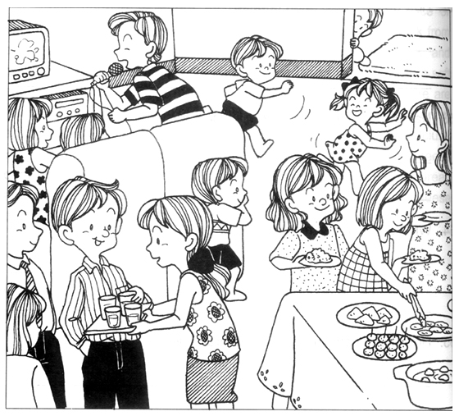

decorated | housewarming party | invited
karaoke | relatives and friends | played games
buffet style lunch | wonderful time

____________________________________________________________________________
____________________________________________________________________________
____________________________________________________________________________
____________________________________________________________________________
____________________________________________________________________________
____________________________________________________________________________
____________________________________________________________________________
____________________________________________________________________________
____________________________________________________________________________

ANSWERS
Primary 2 English
Practice 8

1. B | 2. D | 3. A | 4. B | 5. A

6. She had a fever.
7. He/She is playing with his/her favourite toys.
8. His potion did not work.

9. are | 10. Are | 11. wakes | 12. make | 13. smoking
14. borrow | 15. works | 16. many | 17. is | 18. brush
19. much | 20. have | 21. mine | 22. have | 23. talks

24. The children are playing hide-and-seek.
25. John reached home at eight o'clock.
26. Mr Tan and his family live in a small town.
27. They stared at each other in disbelief.
28. Tom can be trusted to handle this.

29. eaten | 30. people | 31. raw | 32. particular | 33. much | 34. chew
35. digest | 36. harmful | 37. poisoning | 38. mixing | 39. ingredients | 40. taste

41. D | 42. A | 43. C | 44. C
45. A | 46. D | 47. B | 48. A

49. Milk was stored as cheese.
50. Brie is a type of soft cheese.
51. It is made by adding rennet to milk.
52. Fresh cheese is made by heating milk with lemon juice or vinegar.
53. They are yaks and buffaloes.
54. They are vitamin B complex, vitamin A, O and E.
55. It contains the same amount of calcium as a similar quantity of bread and
nearly as much as the same amount of milk.
56. Hard cheese contains more calcium than soft cheese.

