小学二年级英语期末试卷_试卷
Listening Part
I. 听音，根据你听到的字母顺序为下列字母标号（第个字母读两遍12%）
( ) ( ) ( )

( ) ( ) ( )

II. 听音，补全单词（每个单词读两遍，8%）
M__ __ic
Sc en e

w__ __m
c__ l__

III. 听音，判断下列图片与你听到的内容是（T）否（F）相符（每小题读两遍，10%）
（ ） 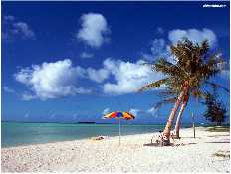 （ ）
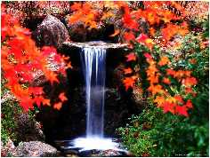（ ） 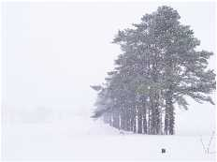 （ ）
IV． 听音，根据你听到的问句选择答句：（每个句子读两遍，10%）
（ ）1. A. Yes, I do. B. Yes, he does.
（ ）2. A. I walk to school. B. I go by plane.
（ ）3. A. We wear T-shirts. B. We wear sweater.
（ ）4. A. I watch TV, B. I go to school.

Writing Part
I. 朋友，用线条连接相应的大、小字母。（20%）
B | W | A | Y | H | M | L | R | N | T

w | i | b | m | y | t | n | a | h | r

II. 将下列每项组字母重新排列，组成单词，并与图片连线：（20%）

1. okbo |  | 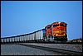
2. eywlol |  | 
3. ioln |  | 
4. npe |  | 
5. ratni

III. 选词填空：（20%）
A．sweaters B．T-shirts C．gloves D．sunglasses E．coats
F．jackets G．by bike H．walk I．By train
- In spring, we wear _____.
- In summer, we wear_____and_____.
- In autumn, we wear _____.
- In winter, we wear _____and_____.
- I_____to school.
- My father goes to school_____.
- We go to Beijing_____.
听力内容

I . 1. Pp 2. Jj 3. Ll 4. Mm 5. Qq 6. Kk
II. 1. Music 2. Science 3. Warm 4. cold
III 1. In spring , it`s cold. ( F ) 2. In summer, it`s hot. ( T )
3. In autumn, it`s cool. ( T ) 4. In winter, it`s warm. ( F )
IV. 1. Does your father go to work by bike? ( B )
2. How do you go to Shanghai? ( B )
3. What do you wear in summer ? ( A )
4.What do you do at the weekend? ( A)

