PRACTICE 2
Vocabulary (30 marks)
(A) Look at the pictures and underline the appropriate word in each of
the brackets. (6*2 = 12 marks)

1.
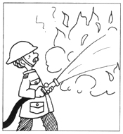 | The (policeman, clerk, fireman, postman) fights fires.
2.
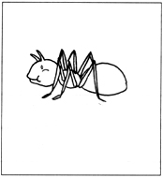 | The (ant, cockroach, bee, worm) has six legs.
3.
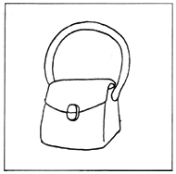 | Mother bought a new (wallet, handbag, briefcase, album).
4.
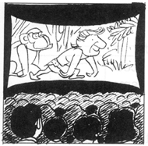 | We go to the (bookshop, cinema, restaurnat, hotel) for a movie.
5.
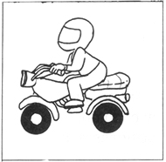 | Mimi likes to ride on a (bus, motorcycle, bicycle, train).
6.
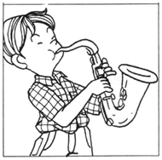 | Kenny plays the (piano, violin, saxophone, flute) very well.

(B) Choose the most suitable answer. Write its number in the brackets
provided.(5*2 = 10 marks)

( ) 7. The ice has ________ in the heat.
A. frozen B. boiled C. melted D. softened
( ) 8. Gloves help to keep our hands ___________.
A. warm B. cool C. cold D. smooth
( ) 9. I use the _________ to stick the papers.
A. scissors B. glue C. pen D. ruler
( ) 10. My father is a/an __________ in the army.
A. teacher B. accountant C. soldier D. businessman
( ) 11. Do not play with __________. They are dangerous.
A. pets B. toys C. games D. knives

(C) Match each picture to the correct word. (4*2 = 8 marks)

12.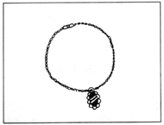* | *table
 | *chair
13.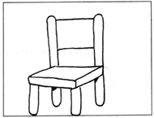* | *chair
 | *bracelet
 | *needle
14.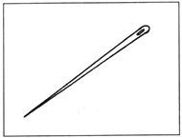* | *needle
 | *plate
 | *necklace
15.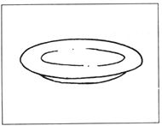* | *necklace
 | *bowl

Grammar (40 marks)
(D) Fill in the blanks with 'They', 'It', 'This', 'That', 'He' or 'She'.
(24*1=24 marks)
16.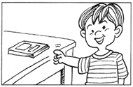 | ___________ is a book.  ___________ likes to read it.

17.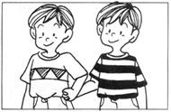 | ___________ are brothers.

18.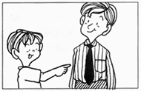 | ___________ is Mr Lim.  ___________ is my uncle.

19.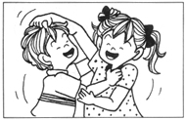 | Jeremy is my brother.  ___________ is very naughty.  Dawn is my sister.  ___________ is very naughty too.

20.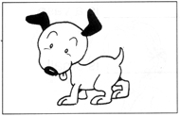 | I have a dog.  ___________ is very cute.

21.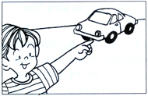 | ___________ is my father's car.  ___________ is blue.

22.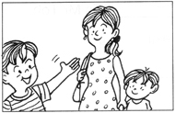 | ___________ is Mrs Lim.  ___________ is Jerry's mother.

23.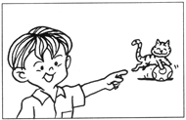 | ___________ is my neighbour's cat.  ___________ is very playful.

24.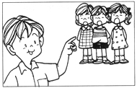 | ___________ are singing my favourite song.

25.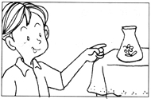 | ___________ is a vase.  ___________ is small.

26.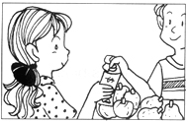 | ___________ is Mrs Tan.

27.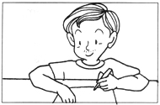 | __________ is Mr Toh.

28.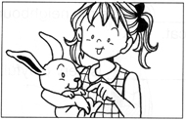 | __________ is a rabbit.  __________ is my pet.

29.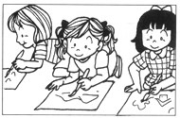 | __________ like to paint.

30.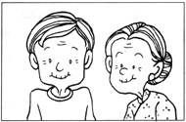 | __________ is my grandfather and __________ is my grandmother.

(E) Rearrange the words to form correct sentences and end each sentence
with a full-stop or with a question mark. (5*2=10 marks)

31. soup you like do
____________________________________________________________________
32. runs the away boy school from
____________________________________________________________________
33. is office my father to driving the
____________________________________________________________________
34. new about Mary excited school is her
____________________________________________________________________
35. seen she pig has a not before
____________________________________________________________________
36. enjoys Jane very swimming much
____________________________________________________________________
37. in beautiful the plants the garden are
____________________________________________________________________
38. afraid of Othman is lightning thunder and
____________________________________________________________________

(G) Comprehension (5*2=10 marks)
Read the passage carefully and answer the questions that follow.

Lisa has a dog. She calls it Sportie. Sportie only listens to Lisa. Sportie is very fierce to other people in the family and strangers. It barks at them and bites them. Sportie follows Lisa around the house. When Lisa has to go to school, Sportie will wait for her at the door. Sportie will wag its tail when Lisa comes home. It eats everything Lisa eats. It eats chicken but not chicken bone. It eats biscuits, fish and fish balls too. Sportie is not toilet-trained. Lisa's brother calls Sportie 'King' because Sportie does what it likes. Lisa protects Sportie from any punishment by the rest of the family.

39. In what way is Sportie fierce?
_______________________________________________________________________
40. What does Sportie do when Lisa goes to school?
_______________________________________________________________________
41. Does Sportie eat chicken bones?
_______________________________________________________________________
42. Why does Lisa's brother call Sportie 'King'?
_______________________________________________________________________
43. Why is there no punishment for Sportie when it misbehaves?
_______________________________________________________________________

(H) Written Expression (20 marks)
Look at the picture. Read the sentences.
My Uncle/Aunt
This is my uncle.
He is a taxi-driver.
He is tall and dark.
My uncle plays football with me.
He teaches me how to make paper airplane.
He buys me story books.
I enjoy doing things together with him.

Now write six or more sentences about your uncle or aunt.
_______________________________________________________________________
_______________________________________________________________________
_______________________________________________________________________
_______________________________________________________________________
_______________________________________________________________________

ANSWERS
(Primary 1 English)
Practice 2
A.
1. fireman | 2. ant | 3. handbag
4. cinema | 5. motorcycle | 6. saxophone
B.
7. C | 8. A | 9. B | 10. C | 11. D
C.
12. necklace | 13. chair | 14. needle | 15. plate
D.
16. That, He | 17. They | 18. This, He | 19. He, She | 20. It
21. That, It | 22. This, She | 23. That, It | 24. They | 25. That, It
26. She | 27. He | 28. This, It | 29. They | 30. He, She
E.
31. Do you like soup?
32. The boy runs away from school.
33. My father is driving to the office.
34. Mary is excited about her new school.
35. She has not seen a pig before.
36. Jane enjoys swimming very much.
37. The plants in the garden are beautiful
38. Othman is afraid of lightning and thunder.
G.
39. Sportie barks at people and bites them.
40. Sportie waits at the door for Lisa.
41. No, it does not eat chicken bones.
42. It is because Sportie does what it likes.
43. It is because Lisa protects Sportie from punishment.

