PRACTICE 6
Vocabulary (30 marks)
(A) Fill in the blanks with the correct words. (10*2 = 20 marks)

bicycle | softly | pony | lollipops | playground
plants | piano | gloves | carpenter | overseas

1.
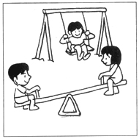 | The children are enjoying themselves in the ________________.
2.
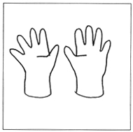 | Mother bought a pair of _________ for the winter.
3.
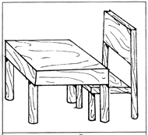 | Mr Lim is a ___________ who makes furniture.
4.
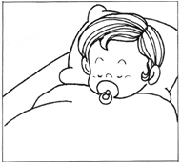 | Talk ______________ as the baby is sleeping.
5.
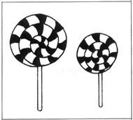 | The ______________ are really tasty.
6.
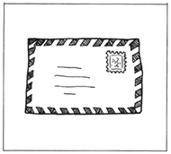 | Please write to me when you are _____________.
7.
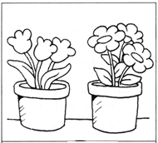 | Mother waters the __________ every morning.
8.
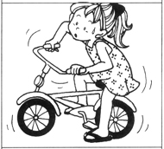 | Meiling is learning to ride a ____________.
9.
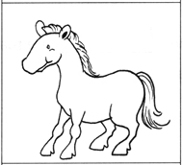 | I like that _____________ over there.  It took so gentle.
10.
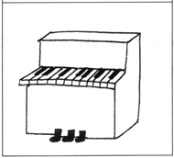 | My _________ needs tuning.

(B) Fill in the blanks with the correct words (10*1 = 10 marks)

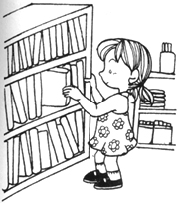 | 11. This is a ___________.  (market, bookshop, school)  12. It sells ____________ too.  (stationery, fish, cakes)
 | 13. Dustin is celebrating his ___________.  (national day, birthday, new year)  14. There are six ____________ on his cake.  (candles, matches, lights)
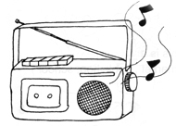 | 15. Switch off the ____________ if you are not listening to the programme.  (fan, radio, violin)  16. Don't waste _____________. (electricity, light, gas)
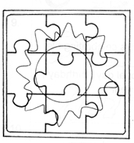 | 17. Ann is fixing a ______________.  (parcel, puzzle, map)  18. It is a ____________ of the sun.  (picture, calendar, paper)
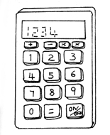 | 19. This is a ______________.  (compass, telephone, calculator)  20. It helps us to ____________ Mathematics problems.  (solve, open, find)

Grammar (40 marks)
(C) Underline the correct word in each of the brackets.
(16 * 1 = 16 marks)

21. I (do not, does not) watch television every night.
22. The girls (do not, does not) jog every morning.
23. We (do not, does not) like to eat bread.
24. She (do not, does not) know how to play the piano.
25. You (do not, does not) have to go to school on Sunday.
26. Mr and Mrs Lim (do not, does not) want to buy Tom a bicycle.
27. My grandmother (do not, does not) like vegetables.
28. The baby (do not, does not) cry.
29. We (listen, listens) to what Daddy and Mummy say.
30. They (play, plays) with the tortoise.
31. Thomas (read, reads) every day.
32. Mrs Tay (wash, washes) the clothes in the afternoon.
33. I (help, helps) my mother perpare lunch.
34. They (work, works) hard for better results.
35. Mother (buy, buys) a cake for my birthday every year.
36. My mother (drive, drives) well.

(D) Rearrange the words to form correct sentences and end each sentence
with a full-stop or with a question mark. (7*2=10 marks)

37. has weeks raining it many been for
_____________________________________________________________________
38. been boy has good always he a
_____________________________________________________________________
39. two coughing has days been for he
_____________________________________________________________________
40. good asked his Jason care to of the dentist
teeth take
_____________________________________________________________________
41. clean every day the has John to blackboard
_____________________________________________________________________
42. good have been childhood friends they since
_____________________________________________________________________
43. the east rises the sun in in sets and the west
_____________________________________________________________________

(E) Complete the sentences with the helping words. (5*2 = 10 marks)

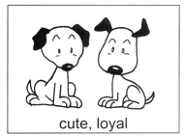 | Why does he love dogs?  It is because they ___________________.
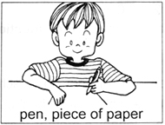 | What do we use when we write?  We use a _____________________________.
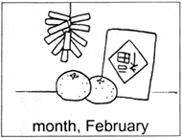 | When is Chinese New Year?  It is in the _________________________.
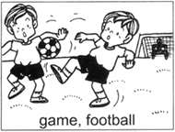 | What are they doing in the field?  They _________________________________.
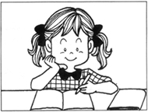 | Has she done her homework?  Yes, she _____________________________.

(F) Comprehension (5*2=10 marks)
Read the passage carefully and answer the questions that follow.

Johnny was sick last Friday. He did not go to school. He woke up in the morning with a terrible stomachache. He had to visit the toilet a few times. Johnny's mother took him to a doctor. The doctor asked Johnny some questions. After the examination, the nurse gave Johnny some medicine for his stomachache. Johnny could only eat porridge that day for ease of digestion. Johnny slept most of the time. He felt much better in the evening.

49. Why was Johnny not in school last Friday?
_______________________________________________________________________
50. What sickness did Johnny have?
_______________________________________________________________________
51. What did the doctor do?
_______________________________________________________________________
52. Why did Johnny eat only porridge that day?
_______________________________________________________________________
53. When did Johnny feel better?
_______________________________________________________________________

(G) Written Expression (20 marks)
Look at the pictures and write a story about the pictures.

Toothache
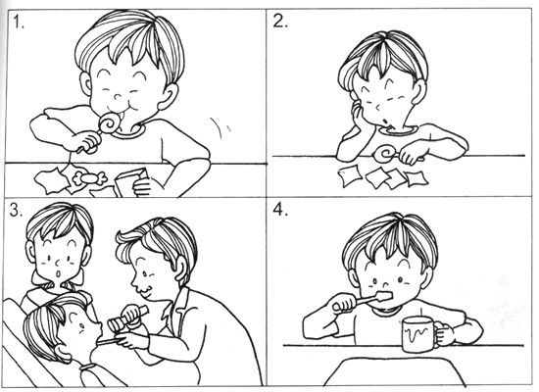

John likes to eat sweets. He does not like to brush his teeth. _____________________________________________________________________________
_____________________________________________________________________________
_____________________________________________________________________________
_____________________________________________________________________________
_____________________________________________________________________________

ANSWERS
(Primary 1 English)
Practice 6
A.
1. playground | 2. gloves | 3. carpenter | 4. softly | 5. lollipops
6. overseas | 7. plants | 8. bicycle | 9. pony | 10. piano
B.
11. bookshop | 12. stationery | 13. birthday | 14. candles | 15. radio
16. electricity | 17. puzzle | 18. picture | 19. calculator | 20. solve
C.
21. do not | 22. do not | 23. do not | 24. does not | 25. do not | 26. do not
27. does not | 28. does not | 29. listen | 30. play | 31. reads | 32. washes
33. help | 34. work | 35. buys | 36. drives
D.
37. It has been raining for many weeks.
38. He has always been a good boy.
39. He has been coughing for two days.
40. The dentist asked Jason to take good care of his teeth.
41. John has to clean the blackboard every day.
42. They have been good friends since childhood.
43. The sun rises in the east and sets in the west.
E.
44. It is because they are cute and loyal.
45. We use a pen and a piece of paper.
46. It is in the month of February.
47. They are having a game of football.
48. Yes, she has done her homework.
F.
49. It was because Johnny was sick.
50. He had a stomachache.
51. The doctor examined Johnny and asked him some questions.
52. It was because the doctor told him to eat only porridge.
53. He felt better in the evening.

