PRACTICE 8
Vocabulary (30 marks)
(A) Fill in the blanks with the appropriate words. (10*1 = 10 marks)

bouquet | fruiterer | nest | receipt | parcel
hurry | spider | badminton | portrait | giant

1.
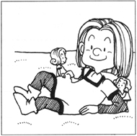 | John is a friendly _________ in the city of dwarfs.
2.
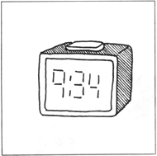 | Look at the time now.  You have to __________ or you will be late.
3.
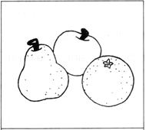 | Mother bought some fruits from the ___________.
4.
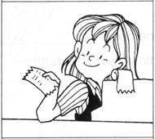 | The cashier gave Father a __________ for the goods he bought.
5.
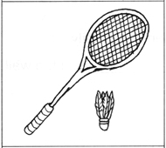 | Peter and Alan enjoy playing ____________.
6.
 | Mary sent Jonathan a ___________ from Japan.
7.
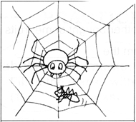 | Look at the __________ trapping the ant in its web.
8.
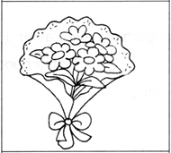 | Jane bought a __________ of flowers for her father.
9.
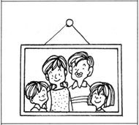 | There is a family _________ on the wall.
10.
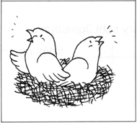 | The birds are in the _________.

(B) Fill in the blanks with the correct words. (10*1 = 10 marks)

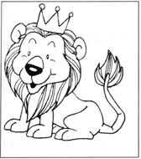 | 11. This is a ____________.  (tiger, lion, leopard)  12. It is the king of the ___________.  (flats, jungle, garden)
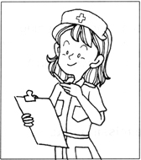 | 13. Kelly is a _________.  (doctor, nurse, chef)  14. She tends to ___________.  (patients, pupils, grocers)
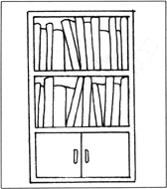 | 15. The books are arranged neatly on the _________.  (table, shelves, benches)  16. Please don't ___________ them up.  (mess, work, arrange)
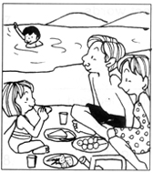 | 17. The Lee family is at the ___________.  (airport, beach, forest)  18. They are having a __________.  (ball, lesson, picnic)
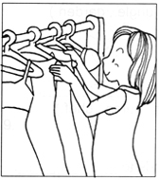 | 19. Mother is at a ___________.  (boutique, florists, cafeteria)  20. She is choosing an evening __________.  (swimwear, gown, shirt)

(C) Look at the pictures. Fill in the missing letters.(10*1 = 10 marks)

21. 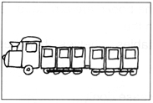  tr _ i _ | 22. 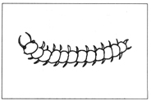  cent _ p _ _ e
23. 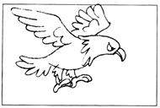  e _ g _ e | 24. 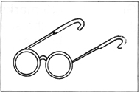  sp _ _ t _ c_ es
25. 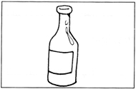  b _ t _ l _ | 26. 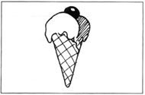  i _ e-c _ _ a _
27. 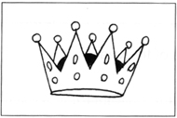  c _ _ _ n | 28. 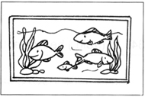  aq _ _ r _ _ m
29. 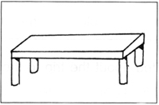  b _ _ c _ | 30. 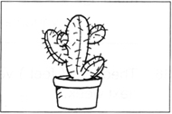  c _ c _ _ s
Grammar (40 marks)
(D) Write out the sentences, using the correct form of the verbs in
brackets. (15 * 2 = 30 marks)
31. Pete (go) to Taiwan every month.
____________________________________________________________________
32. He (shout) at his sister all the time.
____________________________________________________________________
33. Ray (clear) the rubbish daily.
____________________________________________________________________
34. It (rain) heavily at this time of the year.
____________________________________________________________________
35. Lisa (buy) the newspapers from the newsvendor every morning.
____________________________________________________________________
36. Theodore (feel) very excited about the trip to the zoo next week.
____________________________________________________________________
37. My father (read) me a story every night.
____________________________________________________________________
38. The baby (cry) whenever he is hungry.
____________________________________________________________________
39. He (swim) every day.
____________________________________________________________________
40. My mother (fry) chicken wings every weekend.
____________________________________________________________________
41. Herman always (lie) to the teacher.
____________________________________________________________________
42. Ivan (wait) for Irvin at the bus stop every afternoon.
____________________________________________________________________
43. Wendy (smile) whenever she is happy.
____________________________________________________________________
44. My sister (sleep) until ten in the morning.
____________________________________________________________________
45. Mandy (takes) the dog out for a walk every evening.
____________________________________________________________________

(E) Rearrange the words to form correct sentences and end each sentence
with a full-stop or with a question mark. (5*2=10 marks)

46. fever has to at home James he hign stay has because a
______________________________________________________________________
47. keep guard a we house to dog the
______________________________________________________________________
48. is grandmother old healthy my but
______________________________________________________________________
49. kind being James Lucerne so thanked to his family for
______________________________________________________________________
50. he every day fit exercises is he because
______________________________________________________________________

(F) Comprehension (5*2=10 marks)
Read the passage carefully and answer the questions that follow.

I am a Teddy bear. My name is Bearie. My young master is Vivian. She hugs me to sleep every night. She brings me everywhere she goes. I have been to many countries. I have very nice clothing. Vivian takes good care of me. She combs my fur every morning. She lets me sleep on her bed most of the time. She shows me to all her friends. All her friends like me because I look sweet and cuddly. They take turns to carry me. I like to stay with Vivian. I know she loves me very much.

51. What does Vivian do every night?
_____________________________________________________________________
52. How is Bearie able to visit other countries?
_____________________________________________________________________
53. Why do Vivian's friends like Bearie?
_____________________________________________________________________
54. What do Vivan's friends do when they see Bearie?
_____________________________________________________________________
55. Why does Bearie like to stay with Vivian?
_____________________________________________________________________

(G) Written Expression (20 marks)
Look at the picture and write a story about it. Use the helping
words given below.

Kite-Flying
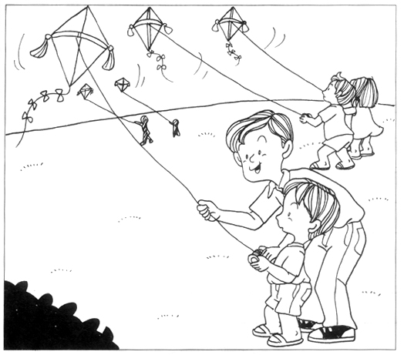

made a kite | fine day | park | windy
very high | fun | many people | taught to fly a kite

_______________________________________________________________________________
_______________________________________________________________________________
_______________________________________________________________________________
_______________________________________________________________________________
_______________________________________________________________________________

ANSWERS
(Primary 1 English)
Practice 8
A.
1. giant | 2. hurry | 3. fruiterer | 4. receipt | 5. badminton
6. parcel | 7. spider | 8. bouquet | 9. portrait | 10. nest
B.
11. lion | 12. jungle | 13. nurse | 14. patients | 15. shelves
16. mess | 17. beach | 18. picnic | 19. boutique | 20. gown
C.
21. train | 22. centipede | 23. eagle | 24. spectacles | 25. bottle
26. ice-cream | 27.
D.
31. Pete goes to Taiwan every month.
32. He shouts at his sister all the time.
33. Ray clears the rubbish daily.
34. It rains heavily at this time of the year.
35. Lisa buys the newspaper from the newsvendor every morning.
36. Theodore feels very excited about the trip to the zoo next week.
37. My father reads me a story every night.
38. The baby cries whenever he is hungry.
39. He swims every day.
40. My mother fries chicken wings every weekend.
41. Herman always lies to the teacher.
42. Ivan waits for Irvin at the bus stop every afternoon.
43. Wendy smiles whenever she is happy.
44. My sister sleeps until ten in the morning.
45. Mandy takes the dog out for a walk every evening.
E.
46. James has to stay at home because he has a high fever.
47. We keep a dog to guard the house.
48. My grandmother is old but healthy.
49. James thanked Lucerne for being so kind to his family.
50. He is fit because he exercises every day.
F.
51. She hugs Bearie to sleep every night.
52. Vivian brings Bearie everywhere she goes.
53. Bearie looks sweet and cuddly.
54. They take turns to carry Bearie.
55. It is because Bearie knows Vivian loves it very much.

