PRACTICE 9
Vocabulary (30 marks)
(A) Fill in the blanks with the correct words. (12*1 = 12 marks)

violin | chimpanzee | baking | helmet
terrapins | dining | canary | glutton
cobbler | computer | disturb | smoking

1.
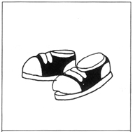 | My shoes need to be mended I am taking them to the _____________.
2.
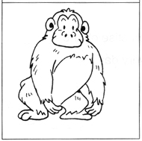 | Ah Meng is a _____________.
3.
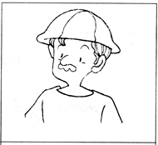 | My father is a labourer.  He wears a __________ when he works.
4.
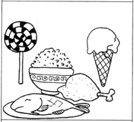 | Keith is a ___________. He loves to eat.
5.
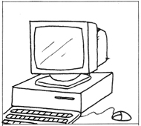 | John has been playing on the ___________ for the past hour.
6.
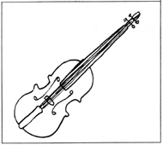 | I practise on the ____________ every day.
7.
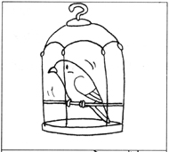 | The ___________ in the cage longs to be free.
8.
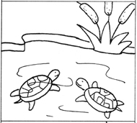 | Look! There are so many __________ in the pond.
9.
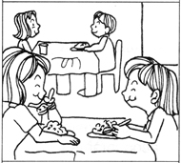 | Jessie and Hongli are __________ in a restaurant.
10.
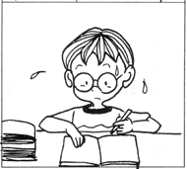 | Do not __________ Dan. He is studying very hard.
11.
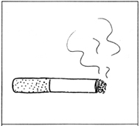 | __________ is bad for health. It causes lung cancer.
12.
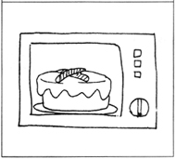 | Mother is __________ a cake in the oven.

(B) Choose the most suitable answer. Write its number in the brackets
provided.(8*1 = 8 marks)

( ) 13. There are many __________ in the hospital.
A. doctors B. accountants C. chefs D. cashiers
( ) 14. It is __________ of you to scream at her.
A. nice B. kind C. good D. rude
( ) 15. The patient went to the hospital in a/an ___________.
A. ambulance B. lorry C. van D. trolley
( ) 16. Please speak __________ in the library.
A. loudly B. softly C. rudely D. quickly
( ) 17. The old man takes a walk in the __________ every morning.
A. restroom B. depot C. park D. office
( ) 18. Singapore is a/an ____________ garden city.
A. awful B. ugly C. beautiful D. dirty
( ) 19. There are many ___________ in the mailbox.
A. pencils B. letters C. stamps D. coins
( ) 20. The __________ in the vase are withering.
A. flowers B. fruits C. food D. pens

(C) Fill in the blanks with the correct words.

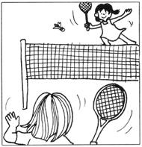 | 21. The girls are having a game of ___________.  (tennis, squash, badminton)  22. They are having a ____________ time.  (fun, silly, sad)
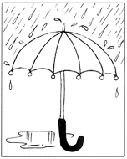 | 23. It is _____________.  (sunny, cloudy, raining)  24. Please bring an ____________ along.  (stick, umbrella, helmet)  25. You would not want to get ____________, right?  (wet, dry, smooth)
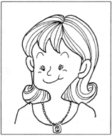 | 26. Mother is wearing a __________.  (bracelet, necklace, anklet)  27. Father _________ it for her.  (bought, snatched, begged)  28. She looks _____________.  (awful, gorgeous, puzzled)
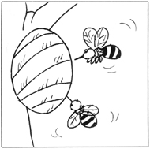 | 29. There is a bee ___________ in the garden.  (aviary, hive, nest)  30. The bees are making ___________.  (salad, honey, syrup)
Grammar (40 marks)
(D) Underline the correct word in each of the brackets.
(15 * 2 = 30 marks)

31. She (has, have) not been to the bird park.
32. We (has, have) finished the food.
33. I (has, have) not seen him for a long time.
34. My parents (has, have) given me some money.
35. He (has, have) not got a blanket.
36. James (has, have) a big toy plane.
37. They (has, have) bought a lot of fruits.
38. Mrs Tan (has, have) a headache.
39. My cat (has, have) run away.
40. Melissa and Mary (has, have) not been to China.
41. My mother (has, have) baked some cookies.
42. You (has, have) to do your homework on your own.
43. Mrs Tang (has, have) cleaned the table.
44. The hen (has, have) laid many eggs since Monday.
45. I (has, have) not written to Jim.

(E) Rearrange the words to form correct sentences and end each sentence
with a full-stop or with a question mark. (5*2=10 marks)

46. slipped on hurt Lisa the she floor her ankle when wet
____________________________________________________________________________
47. is worried tests mother Jim's for him he has for as
done badly his
____________________________________________________________________________
48. holiday going to they Japan this are December for a
____________________________________________________________________________
49. wishes for birthday a computer he his for
____________________________________________________________________________
50. to be grows up Henry a teacher he when wants
____________________________________________________________________________

(G) Comprehension (5*2=10 marks)
Read the passage carefully and answer the questions that follow.

Ronald was on his way to school when he saw a blind man. The blind man was waiting to cross the road. There was nobody around to help him. Ronald went up to him. He held the blind man by the elbow and led him across the road. The blind man was very grateful. Ronald learnt that the blind man wanted to go to the post office. Ronald brought him to the post office before he rushed to school. when he reached his school, he was very late. Ronald explained to his teacher what happened. His teacher did not scold him. Instead, she praised him for his kindness.

51. What was the blind man doing when Ronald saw him?
_______________________________________________________________________
52. What did Ronald do when he saw the blind man?
_______________________________________________________________________
53. Where did the blind man want to go?
_______________________________________________________________________
54. Why was Ronald late for school?
_______________________________________________________________________
55. Why did Ronald's teacher praise Ronald?
_______________________________________________________________________

(H) Written Expression (20 marks)
Look at the picture below. Write five sentences about it.

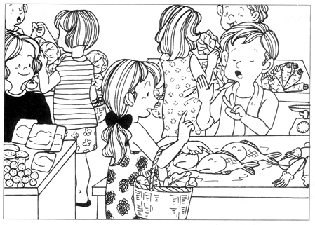

1. _________________________________________________________________________
2. _________________________________________________________________________
3. _________________________________________________________________________
4. _________________________________________________________________________
5. _________________________________________________________________________

ANSWERS
(Primary 1 English)
Practice 9
A.
1. cobbler | 2. chimpanzee | 3. helmet | 4. glutton | 5. computer | 6. violin
7. canary | 8. terrapins | 9. dining | 10. disturb | 11. Smoking | 12. baking
B.
13. A | 14. D | 15. A | 16. B
17. C | 18. C | 19. B | 20. A
C.
21. badminton | 22. fun | 23. raining | 24. umbrella | 25. wet
26. necklace | 27. bought | 28. gorgeous | 29. hive | 30. honey
D.
31. has | 32. have | 33. have | 34. have | 35. has | 36. has
37. have | 38. has | 39. has | 40. have | 41. has | 42. have
43. has | 44. has | 45. have
E.
46. Lisa hurt her ankle when she slipped on the wet floor.
47. Jim's mother is worried for him as he has done badly for his tests.
48. They are going to Japan for a holiday this December.
49. He wishes for a computer for his birthday.
50. Henry wants to be a teacher when he grows up.
G.
51. He was waiting to cross the road.
52. He helped the blind man cross the road.
53. He wanted to go to the post office.
54. He brought the blind man to the post office.
55. It was because Ronald was kind.

