牛津小学英语第二册阶段检测试卷
Listening 50%
- (听音，圈出正确的图片) 8%
- 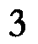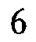2）
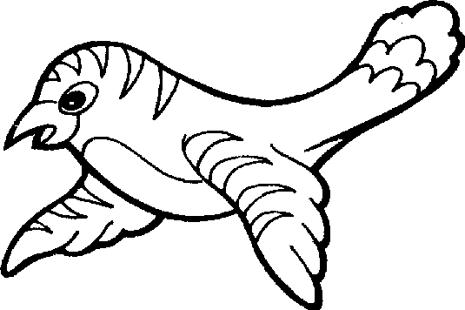

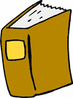

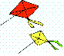
3) 4)

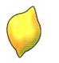
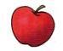
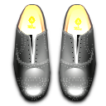
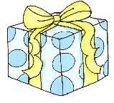
- 6)


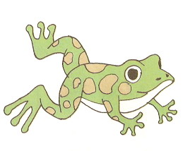
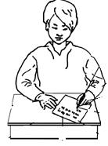
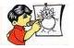
7) 8)

- (听音，选出你所听到的单词或句子，把A或B写在括号内。)16%
（ ）1. A. rabbit B. rubber
（ ）2. A. bird B. blue
（ ）3. A. balloon B. brown
（ ）4. A . a red apple B. an orange orange
（ ）5. A. six little frogs B. six paper frogs
（ ）6. A. Colour the leaf. B. Pick out the green leaf.
（ ）7. A . How many kites? Eight . B. How many rabbits? Seven.
（ ）8. A. I see two butterflies. B. It’s a yellow butterfly.

- Listen and number(听音，给单词或图片编号)10%
1．purple yellow pink brown blue
( ) ( ) ( ) ( ) ( )

2.
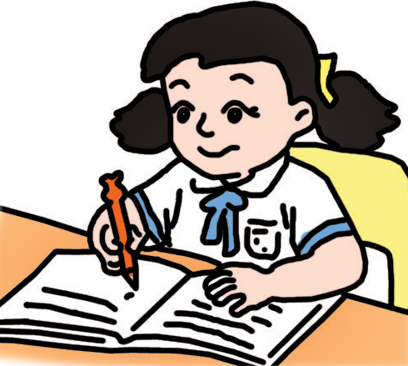
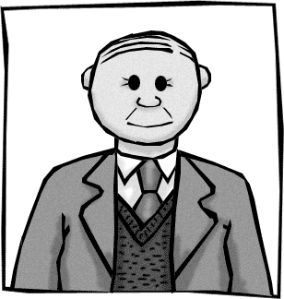
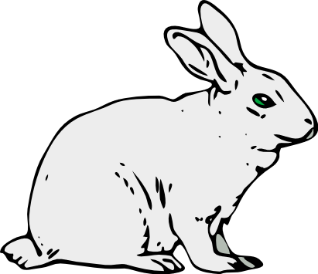
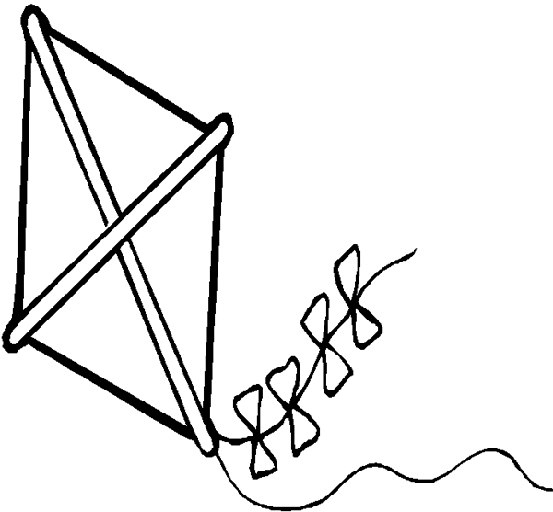

( ) ( ) ( ) ( ) ( )

- (从图片中选出你所听到的，把字母写在横线上) 10%
1.I see ______. 2.It is a pink___.

3.I have ______. 4. Make _____ kites

5.It is _____.
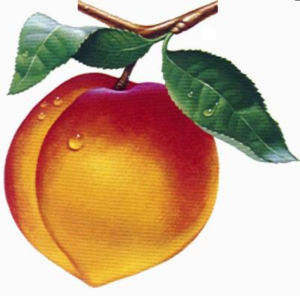
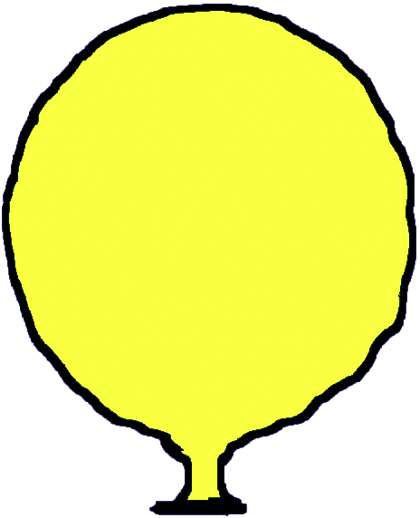
8

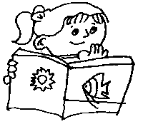
A B C D E
Ⅴ (听音，根据选择正确的图片) 6%
( )1. A. B.
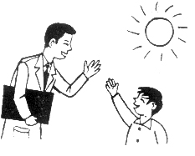
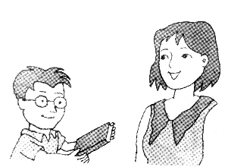
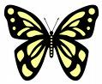
( )2. A. B.
( 3. ) A. B.

Reading 笔试部分50%
Ⅰ.写出所给字母的邻居，注意大小写8%
K __ ， _ L ， j ， h ， ___Q
___ R ____ ， ___ U____ ， ____ T____ ， ____ v _____
Ⅱ . 根据图片圈出框内的单词。（8％）
1.
q | c | b | i | r | d | n | j

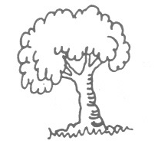
2.
s | a | g | r | e | e | n | j
颜色

7
3.
a | u | s | e | v | e | n | f

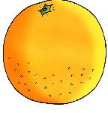
4.
a | p | o | r | a | n | g | e | e | f

Ⅲ根据生活中见到的物品颜色，将单词的编号写在图片下面的括号里6%
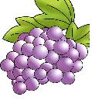
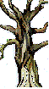
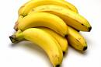
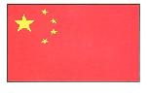
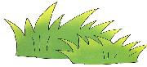

( ) ( ) ( ) ( ) ( ) ( )

(A)red (B)yellow (C)orange (D)brown (E)green (F)purple

Ⅳ (看图，符合图意的用“√”表示，不符合的用“X”表示) 8%
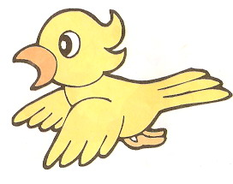
1）
I see a bird. ( )

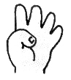
2)
I’m seven years old. ( )

3）
It is a tree. It’s green. ( )
4）
I can write. ( )
\

Ⅴ 选择。（把编号写在括号里）(5%)
( )1．Look, it’s ________ apple.
A. a B. an
( ) 2 . -How many _______________? -Eight.
A. birds B. bird
( )3. -What colour is it? -____________.
A. It’s orange. B. It’s an orange.
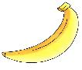
( ) 4. -Is it blue? -_________.
A. No. B. Yes.

( ) 5. 你看到天上飞的风筝，想问朋友他是什么颜色：
A. What do you see? B. What colour is it?

Ⅵ 连线. (5%)
What colour is it? ● ● I see a butterfly.
Good morning, Miss Li.● ● Very well, Thank you.
Goodbye, Mr. Liu. ● ● Good morning, Tom.
What do you see? ● ● It’s blue.
How are you? ● ● Goodbye, Tom.

