牛津小学英语一年级期中检测试题
听力部分
一、听音，选出你所听到的字母组合,单词或句子，并把它圈起来。
1. A. FEM B. EFW 2. A. JGQ B. GQJ
3. A. hxy B. xya 4. A. mwn B. wnm
5. A. aunt B. uncle 6. A. bird B. blue
7. A. make B. pick 8. A. postman B. policeman
9. A. He is a milkman. B. Is he a milkman?
10. A. I see a rabbit. B. I like the rabbits.

二、听单词，根据所读的顺序编号。
1. draw write fold make pick see
( ) ( ) ( ) ( ) ( ) ( )
2. Follow me. Turn left. Turn right. How many kites? Colour the kites.
( ) ( ) ( ) ( ) ( )

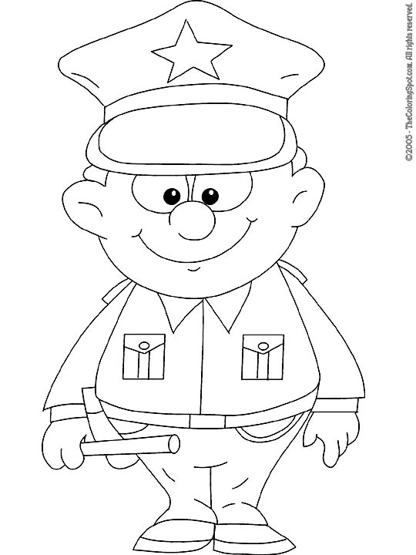
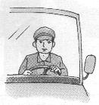
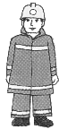
3.

( ) ( ) ( ) ( ) ( )
三、听单词，圈出你所听到的单词。
1． | blue | red | white |  | 2． | uncle | postman | policeman
 | yellow | green | pink |  |  | driver | grandmother | fireman
 | brown | black | purple |  |  | brother | grandfather | milkman
四．听录音，选择正确的句子，将字母编号写在相应的括号内。
policeman（ ） (A) I see six birds.
postman （ ） (B) I have eight kites.
driver （ ） \(C) I am tall.
teacher （ ） (D) I see ten bees.
fireman （ ） (E) I can dance.
五、听句子是否与下面的句子内容相同一致，一致用√不一致用×
( ) 1． My uncle is Ben． ( ) 2． Is that a rabbit ?
( ) 3． I see a bird ( ) 4． What clour is it?
( ) 5． He is a postman . ( ) 6. How many sweets? Ten.
六、听问句，选出最佳答语，将其字母编号填在括号里。
( ) 1． A． I am five B． I am fine．
( ) 2． A． It’s green． B． Yes, it’s green.
( ) 3 . A． Happy new year. B．Thank you.
( ) 4． A．I see two frogs. B． I like the frogs
( ) 5． A． Yes, he is a milkman. B．No, he is a fireman.
笔试部分
一． 写邻居
_____K ____L____ ___ j___ ____h___ ____Q____

___ Z _____s____ R_____ ______ N _____ j_____

二、看图，把正确答句的编号写在相应问句的括号内。
1． Is it a bird ?（ ） A． No, he is policman


2． What colour is it? （ ） B．I see a four ballons．

3. Is he a postman ? （ ） C．No，it is a bee．


4. What do you see ? （ ） D．Two．

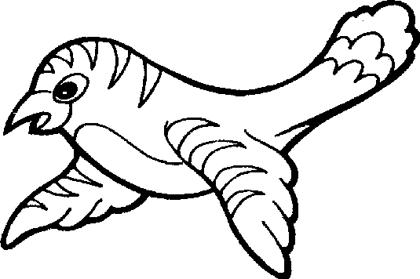
5. How many birds? （ ） E．It is purple．

三、圈出不同类的词
1. aunt uncle driver father
2. write fold draw sweets
3. orange short purple blue
4. policeman fireman grandmother teacher
5. rabbit bird frog doll
四．根据图片把单词补充完整。
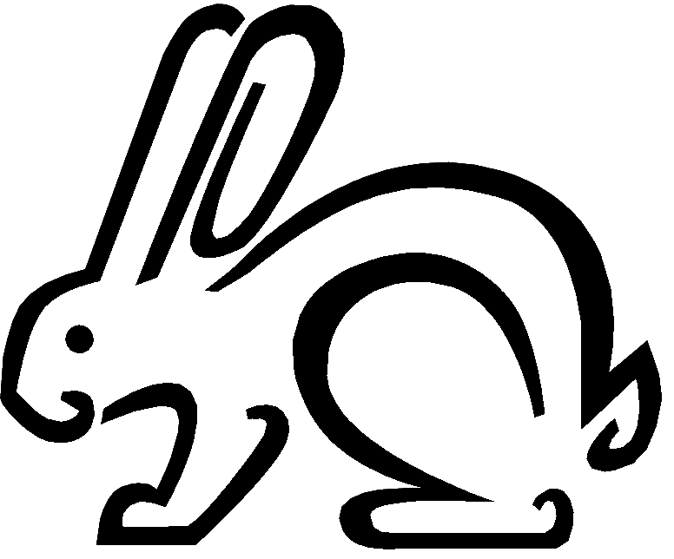
gr__nd__ __ther r__ bb__t

p__l__cem__n t__ __ l

五．根据图片选择填空
1. I see two ________.
A. bird B. birds

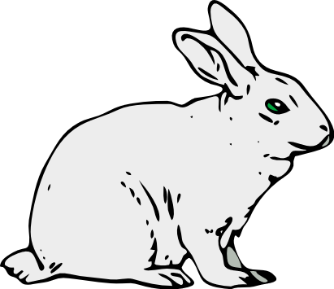
2. I _______ a rabbit.
A. am B. is

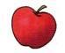
3. I have _____.
A. an apple. B. a apple
4. Is he a fireman? _____.
A. Yes, he is a fireman. B. No, he is postman.

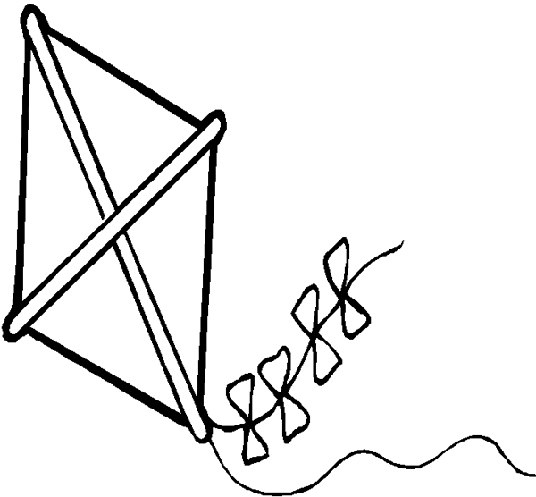
5. How many ______? One_____.
A. kites, kites B. kites, kite

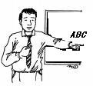
6. Follow _____.
A. I B. me

六.从右边方框中选择正确的答案完成对话,把字母编号写在横线上。
―― _____________ do you see? I see a __________.
- kite
- blue
- What
- No
- How many
—— __________________kites? One .
―― Is it _____________?
―― __________, it is red

七、看图，在正确答案的括号内打勾

1． 2 + 3 = five ( ) three ( )

2.
My aunt is a driver.( ) My uncle is a driver.( )

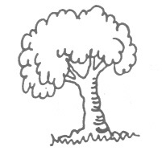
3.
It’s a green tree.（ ） It’s a green leaf. ( )

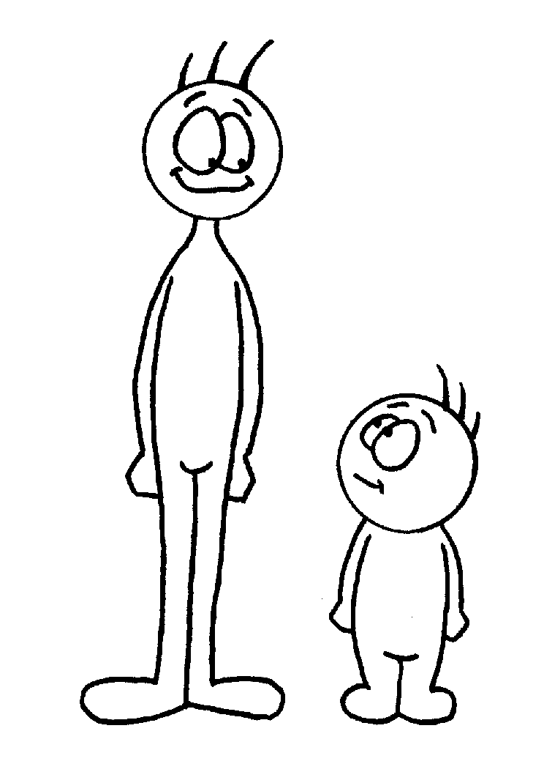
4.
Tom is short . ( ) Tim is short .( )

Tom Tim

5． Turn left. ( ) Turn right.( )

八、根据情景，选择正确的表达方式。
1 ．告诉别人你有个叔叔，应说：( ) A． I am uncle . B． I have an uncle.
2 ．告诉妈妈“蝴蝶是黄色的”应说：( ) A． It’s a butterfly． B． It’s yellow.
3 ．想知道看到的东西是什么颜色，应问：( ) A．What do you see? B．What colour is it?
4 ．想知道姐姐是不是司机，应问：( ) A．Is he a driver? B．Is she a driver?.
5 ．想知道有几只鸟，应问：( ) A． How many birds? B．I see eight birds.
6. 告诉别人你是个子高,应说: ( ) A. I am tall. B. He is tall.

