牛津小学英语一年级下学期期中测试题
I. Listen and tick (听音，勾出正确的图片)20%
1. 2.

( ) ( ) ( ) ( )

3. 4.

( ) ( ) ( ) ( )
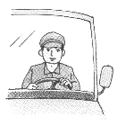
5. 6.

( ) ( ) ( ) ( )

7. 8.
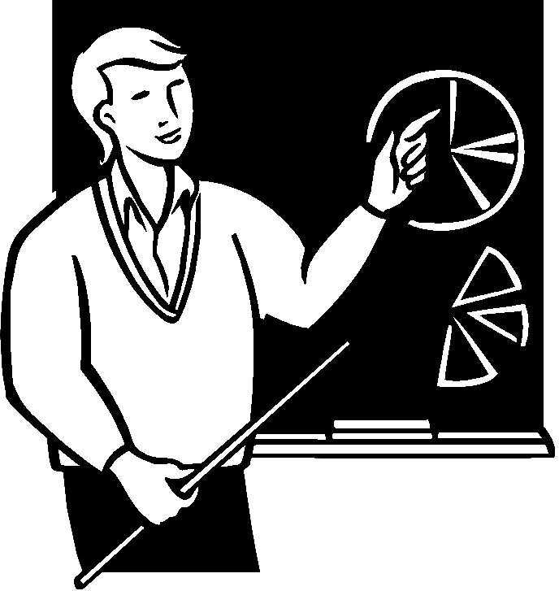
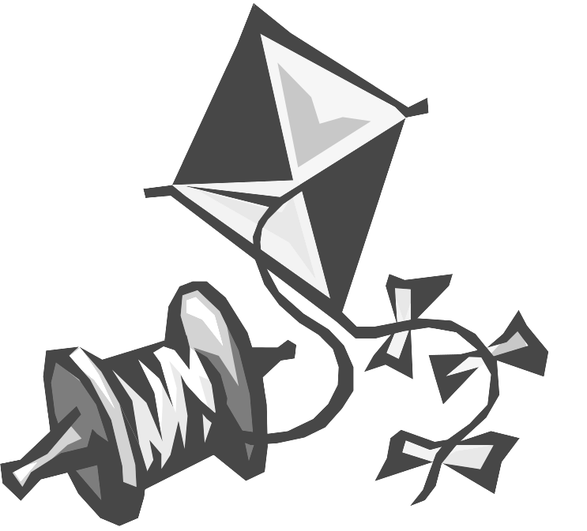
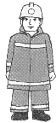

( ) ( ) ( ) ( )
9.

( ) ( ) ( ) ( )
II. Listen and choose（听音, 圈出正确的单词, 将字母代号写在括号内）8%
( )1. A. seven B. eight ( ) 2. A. nine B. kite
( )3. A. green B. blue ( ) 4. A. brown B. yellow
( )5. A. tall B. short ( )6. A. aunt B. uncle
( )7. A. grandfather B. grandmother ( )8.A. bee B. bird
III. Listen and circle （根据听到的内容，圈出相应的数量）8%
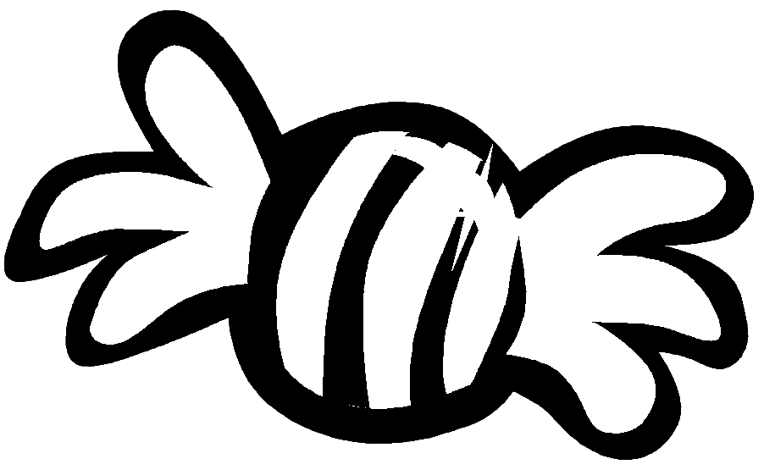
1. 2.
3. 4.

IV.Circle the correct word (听句子，在括号中打√)8%
1. A. He is a postman. ( ) 2. A. It is red. ( )
B. She is a teacher. ( ) B. It is red and purple.( )
3. A. I like my pencil. ( ) 4. A. How many apples? ( )
B. I like my ruler. ( ) B. How are you? ( )

V. Listen and draw(根据问句，圈出正确的答句，将字母代号写在括号内)6%
( )1. A. Yes, it is green. B. It is green.
( )2. A. I see a bird. B. I like a bird.
( )3. A. Happy new year. B. Thank you.
( )4. A. Seven. B. Yes.
( )5. A. Yes. B. No.
( )6. A. No, he is a postman. B. Yes, he is a postman.
Writing(笔试练习) 50%
- 写邻居.(4%)
____ d ____, _____ g, F____ , ____O____, ____ q ____
- Read and choose(圈出不同类的词)6%
1. red blue pink banana
2. father mother uncle driver
3. seven eight fine ten
4. bag tall short big
5. bee bird butterfly big

6. peach pear balloon orange
- Read and circle (读单词，在字母框中圈出所给单词)8%
brown blue present uncle mooncake driver colour postman
g | f | d | b | r | o | w | n | o | w | k | z | l
d | p | r | e | s | e | n | t | b | l | e | c | h
s | c | o | m | o | o | n | c | a | k | e | x | z
y | g | r | e | b | l | u | e | c | l | d | c | b
e | u | n | u | n | c | l | e | a | u | t | p | k
s | r | a | b | c | o | l | o | u | r | n | m | r
g | p | p | o | s | t | m | a | n | i | l | w | j
z | i | k | f | r | d | r | i | v | e | r | b | r

postman present driver purple show colour follow left right short

g | b | p | u | r | p | l | e | n | b | v
b |  | r | s | h | o | w | n | i | d | h
t | l | e | f | t | s | i | k | d | s | b
d | l | s | b | s | t | f | n | r | h | d
s | g | e | f | h | m | o | z | i | o | d
l | e | n | l | p | a | l | d | v | r | z
y | g | t | d | t | n | l | n | e | t | n
i | v | o | c | o | l | o | u | r | k | o
e | r | i | g | h | t | w | u | s | g | i
r | z | s | v | o | x | v | e | z | z | f

- Choose(选择正确的答案, 将字母代号写在括号内) 5%
( )1.What do you see? I ______ a book. (A. see B. like )
( )2. What is it? It is _____ orange. (A a B. an )
( )3.___ a milkman? Yes, he is a milkman.( A. Are you B. Is he )
( )4. My father is ____. My mother is tall, too. ( A. short B. tall )
( )5. _____ me your card. ( A. Show B. Look )

ⅥLook and choose(根据图片,在括号里圈出正确的单词) 10%


1. Is he a （ milkman, driver）?

2. I am ( five, six ) years old.

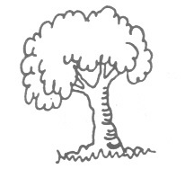
- I see a tree. It is ( white, green ).

- Look at my ( grandfather, grandmother ).
He is old.

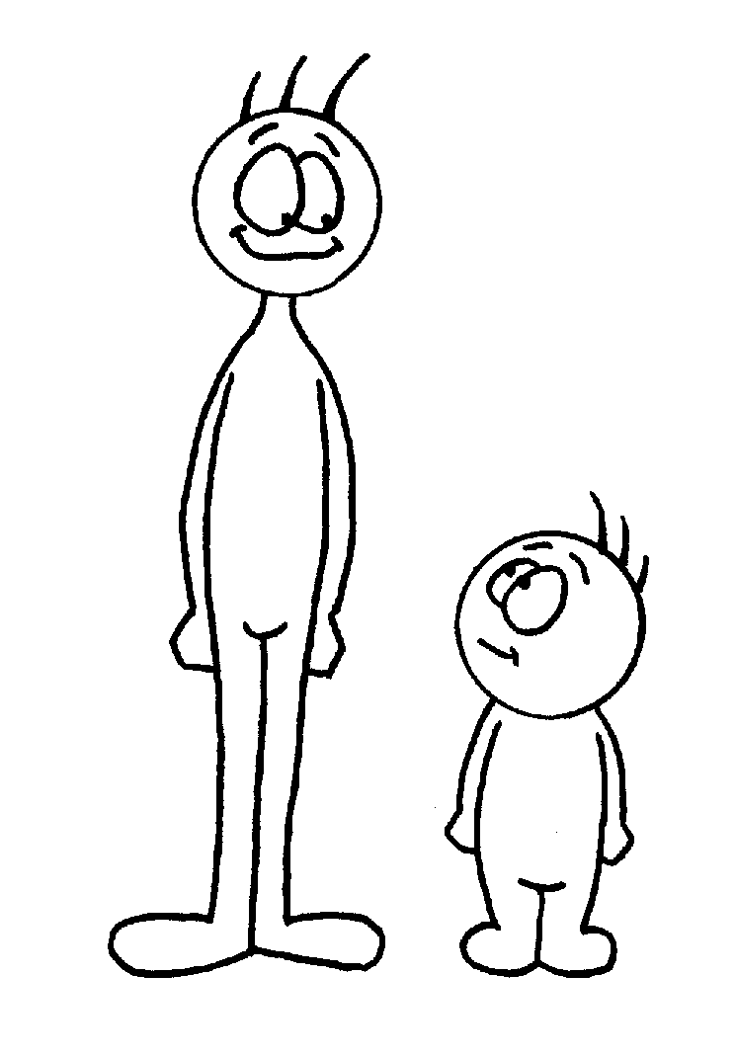
- Tim is（ short, tall ） .

Tom Tim

Ⅶ Read and judge (判断, 用T 表示正确，F 表示错误) 5%
1.妈妈请你试穿鞋子，说： Try on your shoes. ( )
2.老师请你给风筝画上色彩， 说： Pick up the kite. ( )
3.你想知道天空的色彩，问： What colour is it? ( )
4.你向小朋友表达你的爸爸是高个的，说：He is short. ( )
5. 你想知道那个叔叔是不是警察,应该问妈妈:Are you a policeman?( )
6 ．你不知道远处的某物是什么，应问：( ) A． What is this ? B． What is that ?
7 ．告诉妈妈“苹果是红的”应说：( ) A． It’s an apple． B． It’s red.
8 ．想知道对方看到什么，应问：( ) A．What do you see? B．What colour is it?
9 ．不确定那个男的是不是警察，应问：( ) A．Is he a policeman? B．He is a policman.
10 ．想知道有几个风筝，应问：( ) A． How many kites? B． Make eight kites.

