期末习题（四）班级 姓名 分数
用is , am 和are 填空：3`
1. She ______ a teacher . 2. They ________ cows.
3. What _______ these ? 4. I ______ a pupil ,too.
5. It _______ under the tree. 6. My father ________ a doctor .
7. This ________ our classroom . 8. These ________ eggs .
9. My name ______ Amy . 10. His hat ________ on the bed .
二、给下列单词图颜色：4`
1、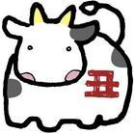———— 2、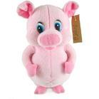———— 3 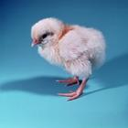 ————
4. 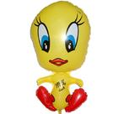 ———— 5、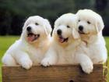 —————
三、按要求填单词：4`
A. his B. my C. her D. our E. their F. your.
1. This is ________ (她的)dress . 2. That is ________（我们的）classroom.
3. What’s ______（你的）name ? 4. Look! ______ （他们的）school bags .
5. ______（我的） name is Amy . 6. It is ________（他的） hat .
四 、比较大小；2.5`
1．Seven nine 2. ten twelve 3. three two
4. eight – one five+four 5. four + nine eleven – five
五、词汇连线；2.5`
school pencil ice class how

box bag old cream room

