牛津一年级英语期中考查试题
（完卷40分钟）

题型 | Ⅰ、听力 | Ⅱ、笔试 | 总分
得分
听力部分 50%
- 听录音，在你听到图片的括号内打“√”。12%
⒈ ⒉
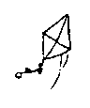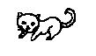
( ) ( ) ( ) ( )

⒊ ⒋
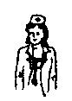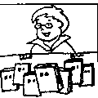
( ) ( ) ( ) ( )


⒌ ⒍
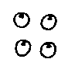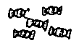
( ) ( ) ( ) ( )

- 听录音，判断图片是否正确，在括号内用“√”“×”表示。16%
⒈ ⒉ ⒊ ⒋
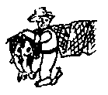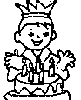
( ) ( ) ( ) ( )

⒌ ⒍ ⒎ ⒏
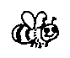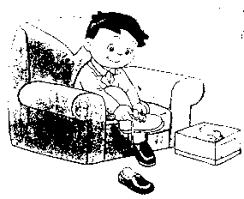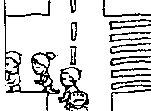
( ) ( ) ( ) ( )
- 听对话，圈出正确的内容 12%
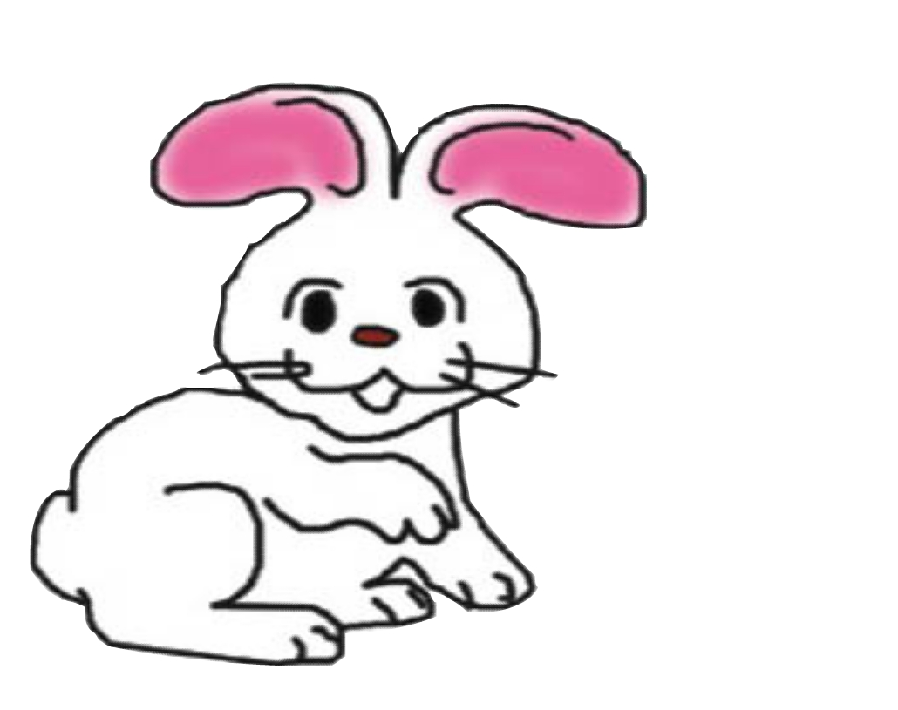
- This is a___________.

frog rabbit


2.This is a ______. I like to eat.

cake apple

3.I have got _________presents.

four six



4. She is a ________.

nurse doctor

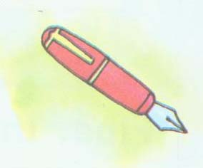
5. He has got a ________.

ruler pen

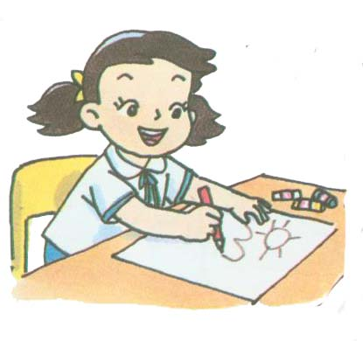
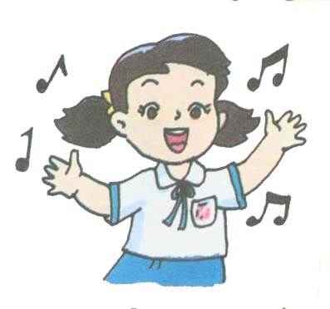
6. She can write and ________.

draw sing

- 根据听到的内容将人物和东西连接起来。5%
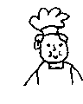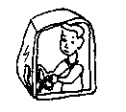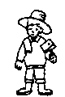
· · · · ·
· · · · ·


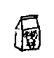

五、听问句，圈出正确的答句的编号。5%
⒈ A. I’m fine, thank you. B. I’m five years old.
⒉ A. I like fish. B. I see a frog.
⒊ A. Yes, I am. B. Yes, it is
⒋ A. It is an orange. B. It is purple.
⒌ A. Yes, I like chicken. B. No, I don’t like fish.

Ⅱ、笔试部分 50%
六、看图，在购物单上勾出已有的东西。8%
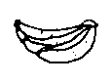
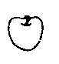
购 物 单
jelly ( )  juice ( )  cake ( )  milk ( )  apple ( ) | Coke ( )  bananas( )  sweets ( )  orange ( )  peach ( )
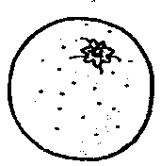

七、读句子，根据划线单词选择图片，圈在字母代号上) 10%

1. This is my grandmother. A. B.
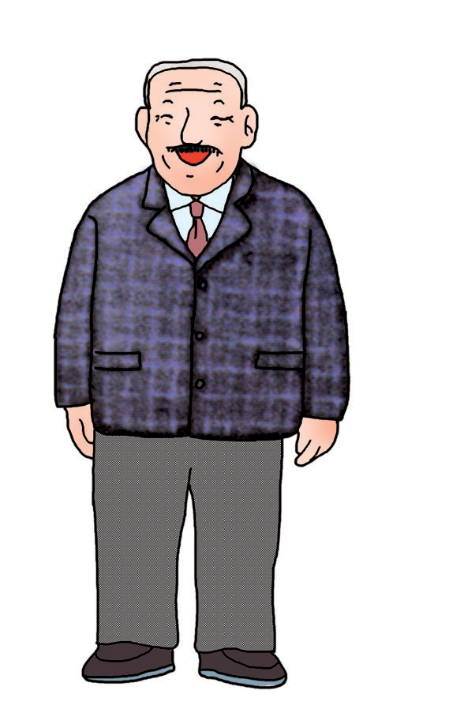
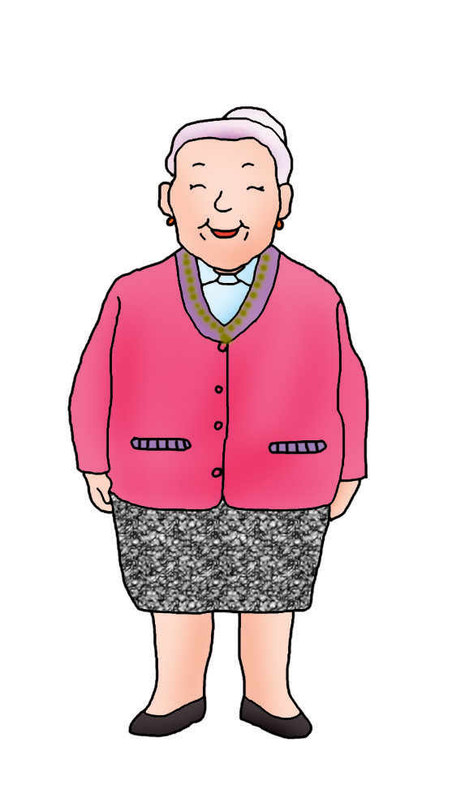


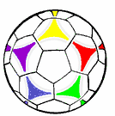
2. Eddie has got a small balloon. A. B.

3. I like to eat apples .
A. B.
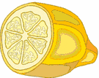

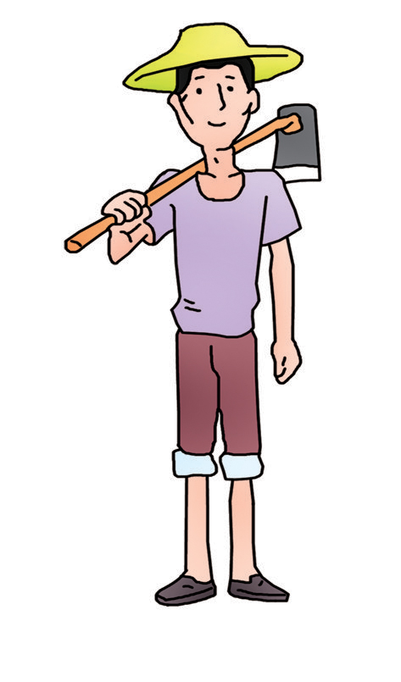
4. Look at the thin farmer. A. B.


5. Look at the sun. A. B.



八、判断下列图片是否与句子意思一致，在括号内用√或×表示。12%

⒈( )Eat some meat and fish. ⒉( )He’s a postman
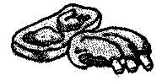

⒊( )This is a monkey. ⒋( )Happy New Year.
It is not fat.
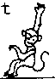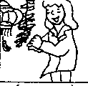
⒌( )What colour is it? ⒍( )How many birds?
It is red. Nine.
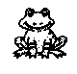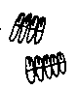

- 看图，根据问句，圈出正确答句的字母编号。12%

⒈What do you see? ⒉What colour is it?
A. I see seven books. A.It’s yellow.
B. I see eight books. B.Yes, it is yellow.
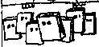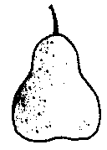

⒊Is he a milkman? ⒋Are you old?
A.Yes, he is. A.Yes, I am.
B.No, he is not. B.No, it is not.
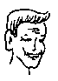

⒌Do you like noodles? ⒍What is it?
A.Yes ,I like noodle . A.It is a dress.
B.No, I like rice. B. It is a tree.
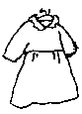

- 看图，在方框内圈出与图片内容相符的单词。8%
fat

thin

old

young

⒈She is a(n) doctor. ⒉He is a cook.

tall

short
mouth.

presentt
⒊This is a policeman. ⒋Open your

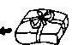
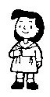
一年级牛津英语期终考查试题
听力内容:
一、听录音，在你听到图片的括号内打“√”。12%
1. Look. This is my aunt. 2. I see a kite.
3. She is a nurse. 4. My teacher is young.
5. I have got four apples. 6. Drink some Coke.
二、听录音，判断图片是否正确，在括号内用“√”“×”表示。16%
- What is that? It is a bag.
- He is a fisherman. He has got some fish.
- Happy birthday, Sam. Thank you.
- Do you like some juice? Yes.
- What do you see? I see two bees.
- Is this a butterfly? Yes, it is.
- Try your new shoes.
- Turn right.
三、听录音，圈出你听到的句子的编号。12%
- What is this ? It is a frog..
2. Here is a cake for you. Thank you very much.
3. How many presents. Six
4. Look, this is my mother. Is she a doctor? No, she is a nurse.
5. Here is a ruler for you, Eddie. Thank you
6. What can you do? Oh, I can sing .
四、根据听到的内容将人物和东西连接起来。5%
- You are a cook. You have got a cat.
- He is a driver. He has got a cake.
- Hello, I am a farmer. This is my pig. It’s fat.
- This is my teacher. He likes milk.
- He is a pupil. He likes to drink some orange juice.
五、听问句，圈出正确的答句的编号。5%
1. How are you? 2. What do you see?
3. Are you a milkman? 4.What colour is the kite?
- Do you like fish?

