Unit Three What’s your favourite food?
Class Name Mark

听力部分
- 听录音，给下列图片标号做（10分）







二、选择你听到的单词。（10分）
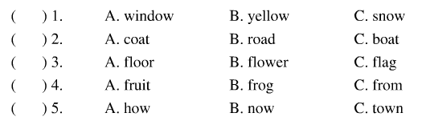
三、听录音，选出你听到的句子。
（ ）1. A. I’d like some hamburgers. B. They’re tasty.
（ ）2. A.I like apples. They’re sweet. B. I like tofu. It’s healthy.
（ ）3. A. What do you have for lunch today? B. They’re tasty.
（ ）4. A. I like tomatoes, fish and green beans.
B. I have tomatoes, fish and green beans.
（ ）5. A. I’d like beef and tomatoes. B. I have beef and tomatoes.
四、听音，标号
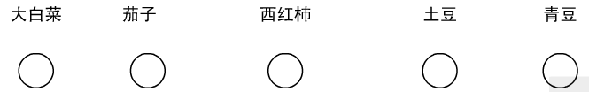

笔试部分
一、读一读，圈出不同类的单词。(10分)
（ ）1. A. mutton B. potato C. pork
（ ）2. A. green beans B. fish C. cabbagewww.xkb1.com
（ ）3. A. eggplant B. tomato C. tofu
（ ）4. A. sour B. healthy C. sweet
（ ）5. A. tofu B. juice C.onion
二、选出所缺的字母（10分）新-课- 标- 第-一-网
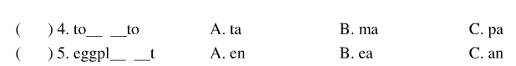
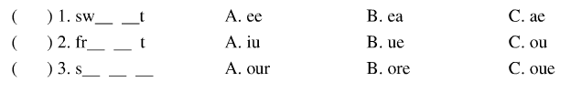
三、选择填空（10分）
（ ） 1. - would you like for lunch?
- I’d like mutton and cabbage.
A. What about B. What’s C. What
（ ） 2. – I’d like eggplant for lunch. What you?
- I’d like eggplant, too.
A and B. for C. About X k b1 .com
（ ） 3. I tomatoes and tofu for dinner.
A. likes B. would like C. would
（ ） 4. Vegetables and fruit are healthy for .
A. my B. me C.I
（ ） 5. The tofu is I like it.
A. sour B. salty C. healthy

四、完成句子（10分）
1. What’s your ______________ food?
2. What would you like ______________ lunch?
3. We have noodles ______________ Thursdays.
4. That sounds ______________
5. I ______________ grapes. They’re sour and______________（甜的）
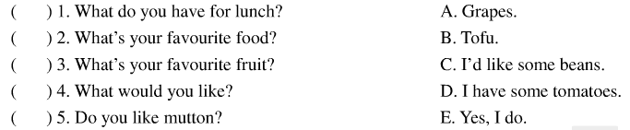
五、将左边的对话与右边的回答连线（10分）
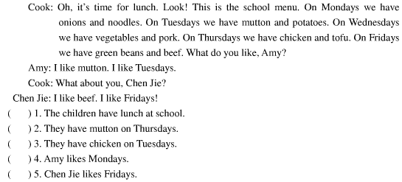
六、阅读理解，根据所给文章判断下面对与错（10分） www.xkb1.com

