四年级第二学期英语期中测试（无答案）
Class:____________ Name: __________________________
听力部分（50分）
听单词，辨别图片与单词是否相符，相符的打√，不相符的打×。（2*10）
1. ( )  2. ( )  3. ( )  4. ( ) 
5. ( )  6. ( ) 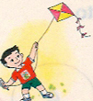 7. ( )  8. ( ) 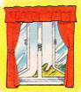
9. ( )  10. ( ) 
二．听单词，选择与它相符的图片的代号。（2*5）
11. ( ) A.  B.  C. 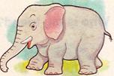
12. ( ) A. 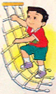 B. C. 
13. ( ) A.  B.  C.
14. ( ) A.  B. C. 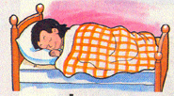
15. ( ) A. 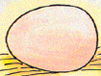 B.  C. 
三．听录音，用√和×判断句子正误。（2*5）
16. ( )  17. ( ) 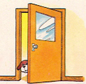 18. ( ) 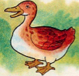
19. ( )  20. ( ) 
四．听录音，完成下列单词。（1*10）
1. tab___e 2. j___mp 3. s____eet 4._____rass 5. bic____cle
6. ____ly 7. li____e 8. cle____n 9. ____ose 10. b_____rd
笔试部分（50分）
读单词，在相应图片的方框内写上序号。
cow sofa walk rabbit umbrella


二．读单词，圈出不同类的词。
1. panda horse bird bear
2. skip climb fly bed
3. ferry plane train car
4. lamp vain bed table
5. duck sleep pig elephant
三．看图，在正确句子的前面打√。
1.  2. 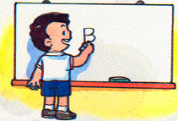 3. 
Spotty can climb. I like to write. It’s a table.
Spotty can swing. I like to dance. It’s a lamp
4. 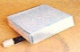 5.
The pencil is under the book. I can ride.
The pencil is on the book. I can fly.
四．读上句，圈下句, 在正确句子前面的括号里打√ 。
1. What can Spotty do? ( ) Spotty can run. ( ) I can run.
2. What do you see? ( ) I see a duck. ( ) I hear a duck.
3. How are you? ( ) Thank you. ( ) Fine, thank you.
4. Do you like winter? ( ) Yes, I don’t. ( ) No, I don’t.
5. Where do you live? ( ) I live in Shiyan. ( )I love Shiyan.
五．写出下面句子的书写形式。
1. Don’t ride a bicycle here.
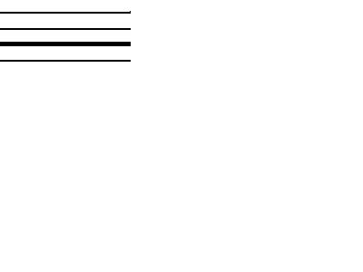
2. Kitty is under the sofa.
3. Close the window, please.
4. Spotty! Come here.
5. I’ve got four eggs.

