2011－2012学年度第一学期
小学四年级英语期中自测题
班级 姓名 学号 分数
(答题时间: 40分钟,满分100分)
同学们，半个学期过去了，相信大家都学了很多的英语知识吧，现在让我们来考考自己吧，相信你能行的。请认真书写哦，别丢了3分卷面分哦！

听力部分(57分)
听一听，圈一圈，圈出与录音内容相符的图片并将其下面的字母圈出来。每题将读两次，每次停留4秒供你选择。（10分）
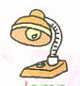
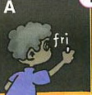
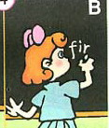
1. 2.
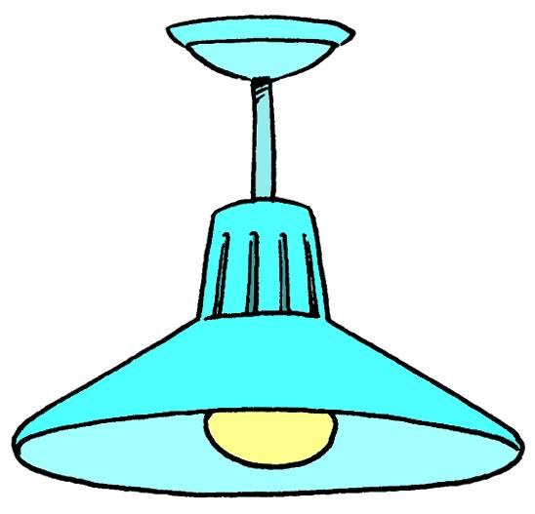
.

A B A B
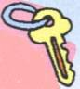
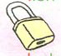
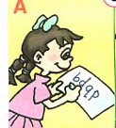
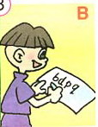
.3. 4.

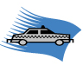
A B A B
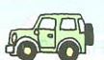
5.

A B

二、听一听，排一排，用阿拉伯数字写出下列各图的序号，每题将读两次，每次停留4秒供你选择。（10分）新课 标第 一网
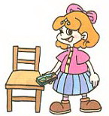
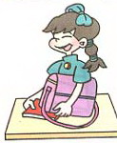
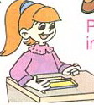

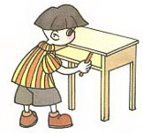

（ ） （ ） （ ） （ ） （ ）

三、听录音，圈出你所听到的数字，每题将读两次，每次停留4秒供你选择。
（7分）
① 40 50 20 ② 13 30 17 ③ 26 43 47
④ 8 10 13 ⑤ 13 18 12 ⑥ 33 43 53
⑦ 16 56 23
四、听录音，填字母，每题将读两次，每次停留4秒供你填写。（10分）

1.____pple 2.____K 3.____oke 4.____ouse 5. _____urse

6.____ueue 7. ____ice 8.bo____ 9.____oo 10. ___alkman

五、听录音,选出每题中正确的答句并将其字母编号写在括号里，每题将读两次，每次停留5秒供你选择。 (10分)
( ) 1. A. I have 2 books. B. I can see 10 books.
C. I like books.
( ) 2. A. Good idea. B. Good job. C. Goodbye.
( ) 3. A. Many desks and chairs. www.xkb1.com
B. 2 schoolbags, 12 crayons and 8 Chinese books.
C. 2 pencils and 4 rulers.
( ) 4. A. It’s yellow. B. They are white. C. It’s on the desk.
( ) 5. A. Her name is Amy. B. His name is Mike.
C. My name is Mike.
六、听录音，写出所缺单词，每题将读两次，每次停留5秒供你填写。(10分)
1. It is a ____________.
2. I have a ___________.
3. Amy and Chen Jie are ___________.
4. This is a _____________.
5. Where is the long _______________.
笔试部分（40分）
七、选出一个与其它三个不同类的单词,并将序号填入题前的括号里。（10分）
（ ）1. A. thirty B. fifty C. four D. too
（ ）2. A. math B. English C. book D. Chinese
（ ）3. A. blue B. ruler C. green D. purple
（ ）4. A. tall B. sports C. strong D. quiet
（ ）5. A. notebook B. floor C. wall D. door
（ ）6. A. apple B. big C. pear D. orange
（ ）7. A. cake B. car C. bike D. plane
（ ）8. A. crayon B. sharpener C. pen D. picture
（ ）9. A. cat B. peach C. rabbit D. duck
（ ）10. A. friend B. father C. brother D. grandpa
八、选词填空，把选出的单词填在横线上。（10分）
  - I (have/has) a friend.
  - She (like/likes) music.
  - How many (book/books) do you have?
  - This is my (story book/story-book).
  - He has big (eyes/eye).
  - Let (me/I) clean the desks.
  - My schoolbag (is/are) heavy.
  - This is (his/he’s) photo.
  - I (am/is) a boy.
  - Do you like apples? Yes, (I/he) do.
九、选句子补充对话，将正确句子的编号真在横线上。（10分）
A. A girl. B. I have a new classmate.
C. She likes singing. D. How many classmates do you have now ?
E. Her name is Kate. 新 课 标第 一网
A:____________________________________
B: Really ? Boy or girl?
A: ____________________________________
B: What’s her name ?
A: ____________________________________
B: Does she like music?
A: Yes, and _____________________________
B:____________________________________
A: I have 50.
十、阅读理解,根据短文内容判断对错,对的打“√”,错的打“×”.（10分）
I have a new friend. His name is Mike. This is his photo. He is strong. He has short brown hair. He likes sports. Look, this is his new schoolbag. There are many books in it. Two story-books, three picture books,four English books, and one Chinese book. It’s very heavy.
( )1. Mike is my friend.
( )2. He has short black hair.
( )3. There are seven books in the schoolbag.
( )4. He has a heavy bag.
( )5. Mike likes painting.
2011－2012学年度第一学期
小学四年级英语期中自测题
听力材料
听一听，圈一圈，圈出与录音内容相符的图片并将其下面的字母圈出来。每题将读两次，每次停留4秒供你选择。（10分）
- Turn on the light.
- Write the letters fri.
- The key is yellow.
- Read the letters bdpq.
- Drive the taxi. Xkb1.com
二、听一听，排一排，用阿拉伯数字写出下列各图的序号，每题将读两次，每次停留4秒供你选择。（10分）
- Put the eraser near the pencil-case.
- Put the pencil-case on the.chair
- Put the English book on your head.
- Put the notebook under your bag.
- Put the pencil in your desk.
三、听录音，圈出你所听到的数字，每题将读两次，每次停留4秒供你选择。
（7分）
- I have fifty books .
- There are thirteen dogs .
- There are forty-seven students in my class .
- I am ten years old .
- I can see twelve pictures .
6. There are fifty-three chairs in my classroom .
7.My sister is sixteen years old .
四、听录音，填字母，每题将读两次，每次停留4秒供你填写。（10分）
1.apple 2.OK 3.Coke 4.mouse 5.nurse
6.queue 7.rice 8.box 9.zoo 10.walkman
五、听录音,选出每题中正确的答句并将其字母编号写在括号里，每题将读两次，每次停留5秒供你选择。 (10分)
1.How many books can you see?
2.Let’s clean the desks and chairs.
3.What’s in your pencil-case?
4.What colour are they?
5.What’s her name?
六、听录音，写出所缺单词，每题将读两次，每次停留5秒供你填写。(10分)
1. It is a pencil-case.
2. I have a book.
3. Amy and Chen Jie are friends.
4. This is a student.
5. Where is the long ruler?
听力到此结束,请继续做笔试部分。

出卷人：袁崇焕小学 张美英

