长海县2011~2012学年度第一学期期末质量检测
小学四年级 英语 完成时间：60分钟
题号 | Ⅰ | Ⅱ | Ⅲ | Ⅳ | Ⅴ | Ⅵ | Ⅶ | Ⅷ | Ⅸ | Ⅹ | Ⅺ | Ⅻ | XIII | 总分
得分
听力部分(40分)
Ⅰ、听音排序，将单词的序号写在横线上。（10分）
A. wear B. wore C. wash D. went E. win
1.________ 2.________ 3.________ 4.________ 5.________
A. food B. finish C. finger D. fever E. feet
1.________ 2.________ 3.________ 4.________ 5.________
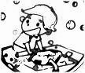
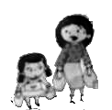
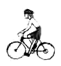
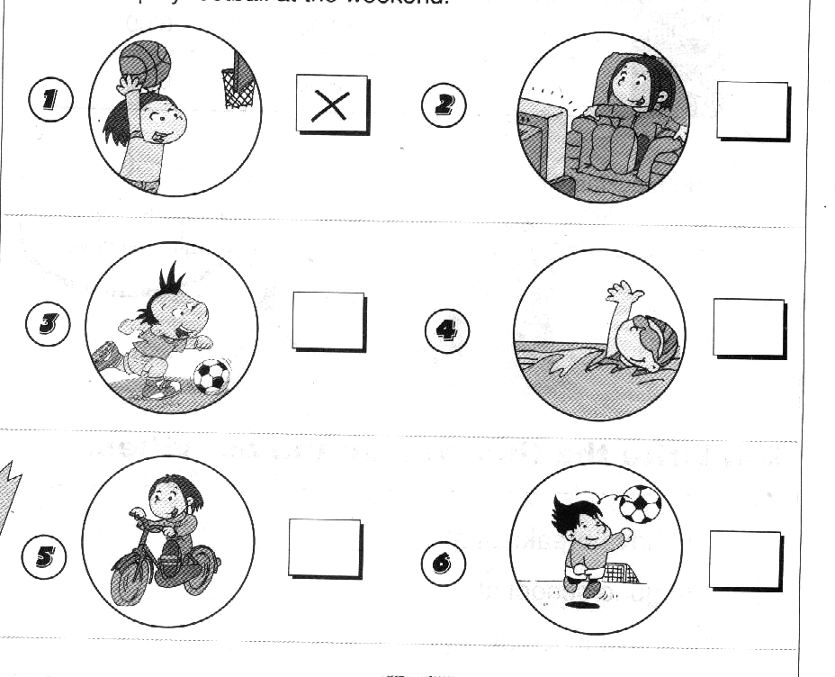
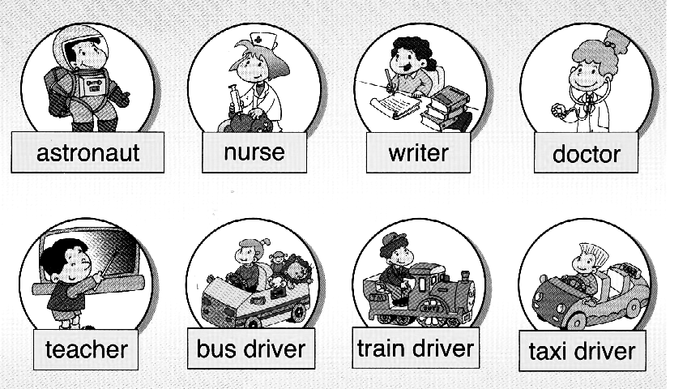
Ⅱ、 听音编号，用数字（1、2、3、4、5）给下列图片重新排序。（10分）

Ⅲ、 听音辨图，在正确的图片下打“√”。（10分）
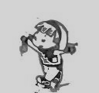
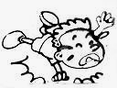
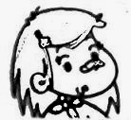
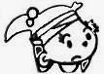

1. ( ) ( ) 2. ( ) ( )
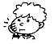
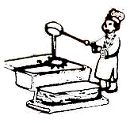
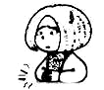
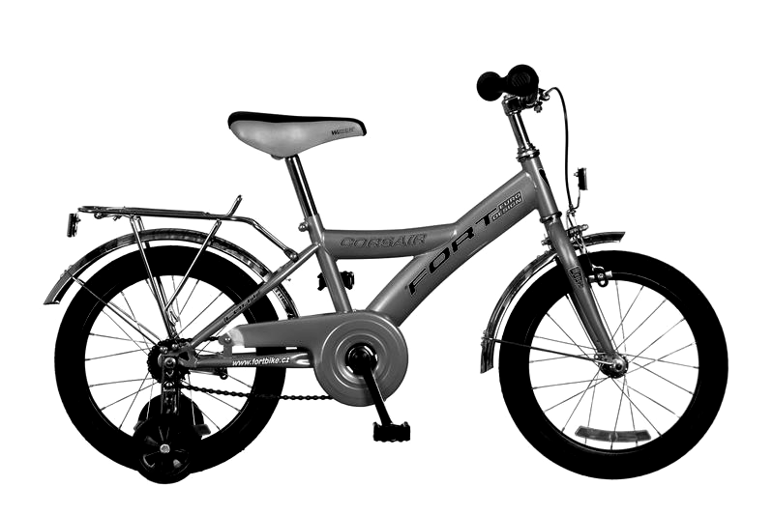
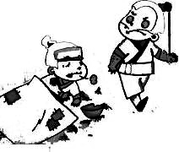
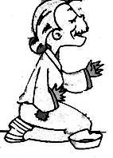

3.（ ） （ ） 4.（ ） （ ） 5.（ ） （ ）
Ⅳ、 听音选出你听到的句子，将其序号填在括号里。（6分）
( )1. A. I cleaned my room. B. I finished my homework.
( )2. A. Lingling didn’t get up at half past six. B. Lingling gets up at half past six.
( )3. A. Did you hurt your knee? B. Did you see a scary thing?
( )4. A. There was a big monster. B. There were three monsters.
( )5. A. When did they come? B. What did she play?
( )6. A. Sam fell off his bike. B. Sam fell on the watermelon.
Ⅴ、 听音用数字(1,2,3,4) 给下列句子重新排序。（4分）
( ) But she didn’t learn these things yesterday. Yesterday was National Day!
( ) She usually walks to school.
( ) She usually learns English and Maths.
( ) But she didn’t walk to school yesterday.
笔试部分（60分）
Ⅵ、 根据语境用“——”画出句中正确的单词。（5分）
1、Daming(has / have)got a pet dog.
2、Where( do / does)your mother work?
3、Lingling will be ten(on / in)April.
4、Amy ( learns / learnt)English and Maths yesterday.
5、She didn’t (walk / walked) to school yesterday.
Ⅶ、 根据语境补全句子中的单词。（10分）
1、I like _______________( 中国的) dancing.
2、He_________________ (发明) this bicycle in 1839.
3、He __________ (步行) to school yesterday.
4、We ______________(吃)a watermelon yesterday.
5、But he didn’t _____________(来)back.
6、Lingling went to a shop and____________(买)a present.
7、I ________（帮助）my mum yesterday.
8、This girl won a gold ____________ (奖杯).
9、Did you ______________（骑）your bike？
10、What’s the __________________(麻烦事) ?
Ⅷ、选择填空，将序号填在括号里。（10分）
( ) 1. ----- Where does she live? -----She _____ in London.
A. lives B. live C. lived
( ) 2. I am reading a letter. It’s_______ my friend, Lucy.
A. from B. on C. of
( ) 3. We went to _______.
A. the great wall B. the Great Wall C. Great Wall
( ) 4. Daming ___________ Grandma last Sunday.
A. phoned B. phone C. phoneed
( ) 5. I ______ a new friend.
A. has got B. got C. have got
( ) 6. Wang Fei ________ got a stomach ache.
A. has B. have C. is
( ) 7. How many ______ did you eat?
A. biscuit B. biscuits C. a biscuit
( ) 8. I went to Beijing ________ 2008.
A. at B. in C. on
( ) 9. We bought ________ a present.
A. your B. yours C. you
( ) 10. My trousers ________ very dirty. I washed them.
A. were B. is C. was
Ⅸ、 根据问句选答句，将序号写在前面的括号里。（5分）
( ) 1. Where did you go? A. I saw lions and tigers.
( ) 2. What happened to you ? B. No, I didn’t.
( ) 3. What did you see? C. I went to the zoo.
( ) 4. What did she play? D. She played the flute.
( ) 5. Did you fall? E. I ran for the bus.Then I fell over.

Ⅹ、 根据语境选词填空, 将序号填在前面的括号里。（5分）
A. last B. practise C. ice-skating D. only E. angry
( ) 1. The bad man was _______.
( ) 2. Yesterday, we went _______.
( ) 3. The magic paintbrush _______helped Ma Liang.
( ) 4. They came _______Wednesday.
( ) 5. So ______a lot. Then you will win a competition too.
Ⅺ、 连词成句。（10分）
1．watched / Sam / TV (.) _____________________________________
2. you/ toy / did/ break/ your ( ?) ________________________________

3. did / I / football / not / play (.)____________________________________
4. got/ I / cold / have/ a ( .) ______________________________________
5. invented /people /Chinese /printing (.) ____________________________
Ⅻ、 请用括号内单词的正确形式填空。（5分）
Yesterday, Lucy______(go) on a school trip. They went ice-skating. She________(wear) warm clothes. The ice______(is) very cold. First, Lucy_____ ______(fall over). At last, she _______(learn)to skate. It was easy. It was really fun.
XIII、 阅读理解，判断正(√)误(×)。（10分）
Yesterday was Sunday. Mr Smith took his two children to the park by car. Amy is his daughter and Jim is his son. They saw many people in the park. Some old people did taijiquan. Some young people rowed boats on the lake and some children ran fast . It was very funny. Jim said,“I like playing in the park.”
( ) 1. Mr Smith took his two children to the park by bike.
( ) 2. Mr Smith is Amy and Jim’s father.
( ) 3. Some old people rowed boats on the lake.
( ) 4. Some children painted pictures.
( ) 5. Jim had a good time in the park.
四年级英语听力题签:
※注意：每道听力试题读二遍。时间控制在20分钟以内。

Ⅰ.听音排序，将单词的序号写在横线上。
1. wash 2. wear 3. win 4. went 5. wore
1. finish 2. fever 3. food 4. feet 5. finger
Ⅱ. 听音编号，用数字（1、2、3、4、5）给下列图片重新排序。
1. I washed my trousers.
2. I helped my mum.
3. I finished my homework.
4. I rode my bike.
5. I played football.
Ⅲ. 听音辨图，在正确的图片下打“√”。
1. I learnt to skate.
2. I bumped my head.
3. I’ve got a toothache.
4. This old woman didn’t have food.
5. Chinese people invented paper.
Ⅳ.听音选出你听到的句子，将其序号填在括号里。www.xkb1.com
1. I cleaned my room.
2. Lingling gets up at half past six.
3. Did you see a scary thing?
4. There was a big monster.
5. When did they come?
6. Sam fell on the watermelon.
Ⅴ.听音用数字(1,2,3,4) 给下列句子重新排序。
She usually walks to school. But she didn’t walk to school yesterday. She usually learns English and Maths. But she didn’t learn these things yesterday. Yesterday was National Day!
听力部分到此结束！
四年级英语答案及评分标准：xkb1.com
听力部分
Ⅰ、(1×10＝10分)
1 .C 2. A 3. E 4. D 5. B
1. B 2. D 3. A 4. E 5.C
Ⅱ、(2×5＝10分) 4 ---- 5 ----- 3 ----- 1 ----- 2
Ⅲ、(2×5＝10分) 第一幅图，第二幅图，第二幅图，第一幅图，第一幅图
Ⅳ、(1×6＝6分) A B B A A B
Ⅴ、(1×4＝4分) 4 ---- 1 ----- 3 ----- 2

笔试部分
Ⅰ、(1×5＝5分)
1. has 2. does 3. in 4. learnt 5. walk
Ⅱ、(1×10＝10分)
1、Chinese 2、invented 3、walked 4、ate 5、come
6、bought 7、helped 8、cup 9、ride 10、matter
(备注：如画有“—”的部分无相应的词形变化扣0.5分，其余单词必须完全准确方可得1分。）
Ⅲ、(1×10＝10分) A A B A C A B B C A
Ⅳ、(1×5＝5分) C E A D B
Ⅴ、(1×5＝5分) E C D A B
Ⅵ、(2×5＝10分)
1．Sam watched TV.
2. Did you break your toy ?
3. I didn’t play football.
4. I have got a cold.
5. Chinese people invented printing.
Ⅶ、(1×5＝5分) 1. went 2. wore 3.was 4. fell over 5. learnt
( 备注：每空单词必须完全准确方可得1分。）
Ⅷ、(2×5＝10分) × √ × × √
备注：卷面满分为100分。（听力40分，笔试60分。）

优秀：90---100
良好：80---89
及格：60---79
不及格：0---59 2012年1月1日

