四年级英语第二学期期末检测模拟试题
卷面（5☆） 听力部分（48☆）
一、请选出你听到的单词或短语，每个单词读两遍（12☆）
（ ）1、 A．nice B. noodles C. naughty
（ ）2. A. take B. help C. picnic
（ ）3. A. beautiful B. young C. quiet
（ ）4. A. country B. wide C. ride
（ ）5. A. carry B. clever C. small
（ ）6. A、housework B、homework C、headache
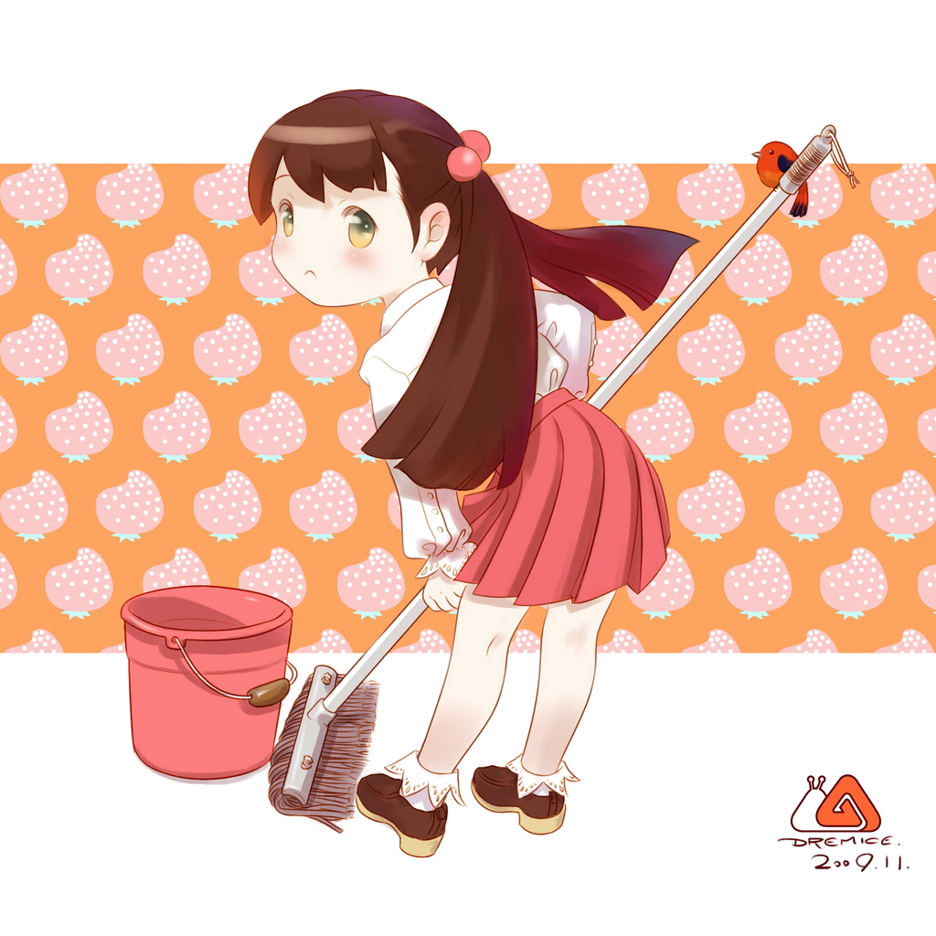
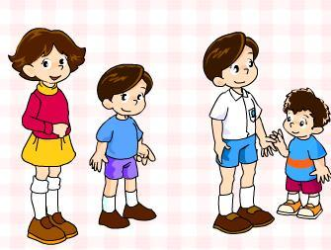
二、根据所听内容给下列图片排列顺序。（12☆）
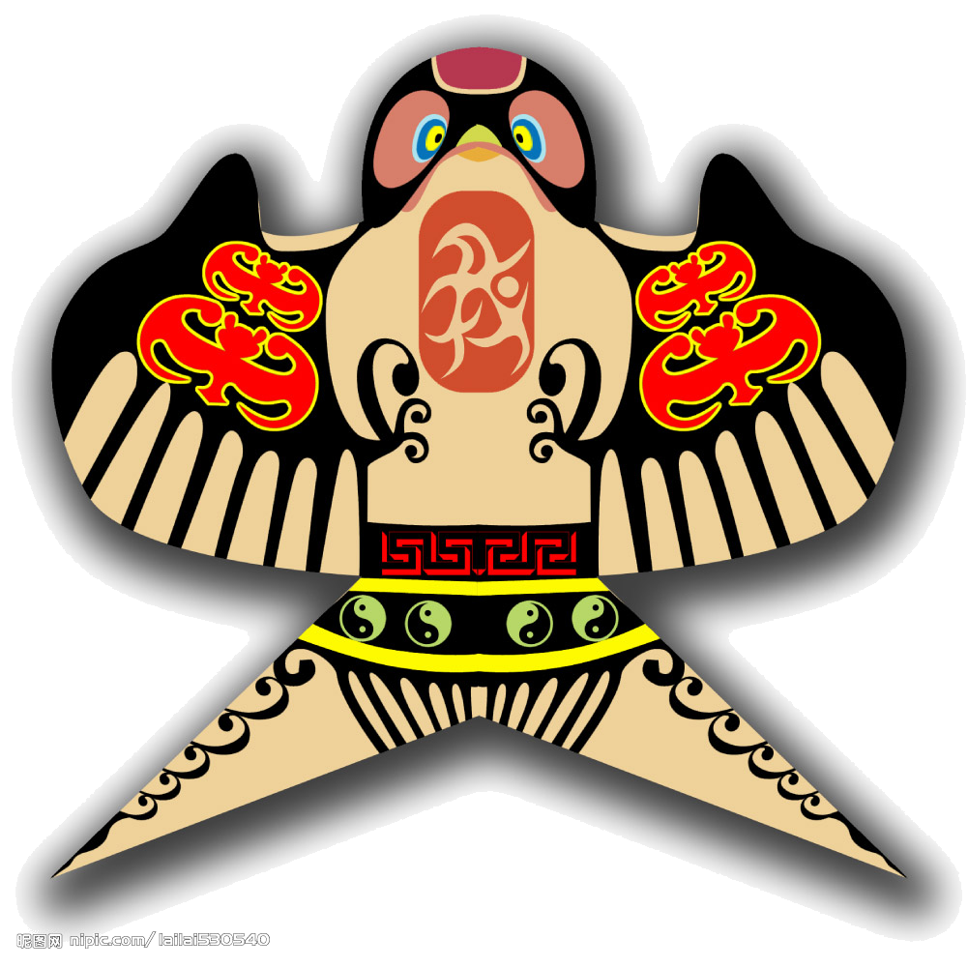

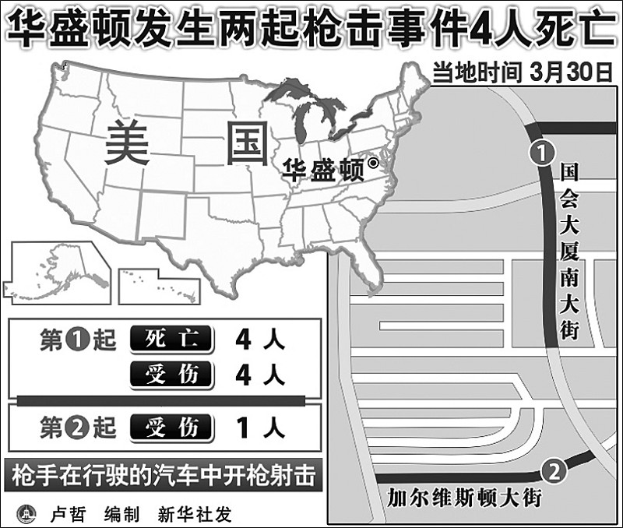
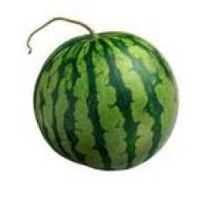

( ) ( ) ( ) ( ) ( ) ( )
三、判断图与所听内容是否相符，相符写T，不相符写F。（12☆）
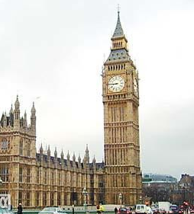
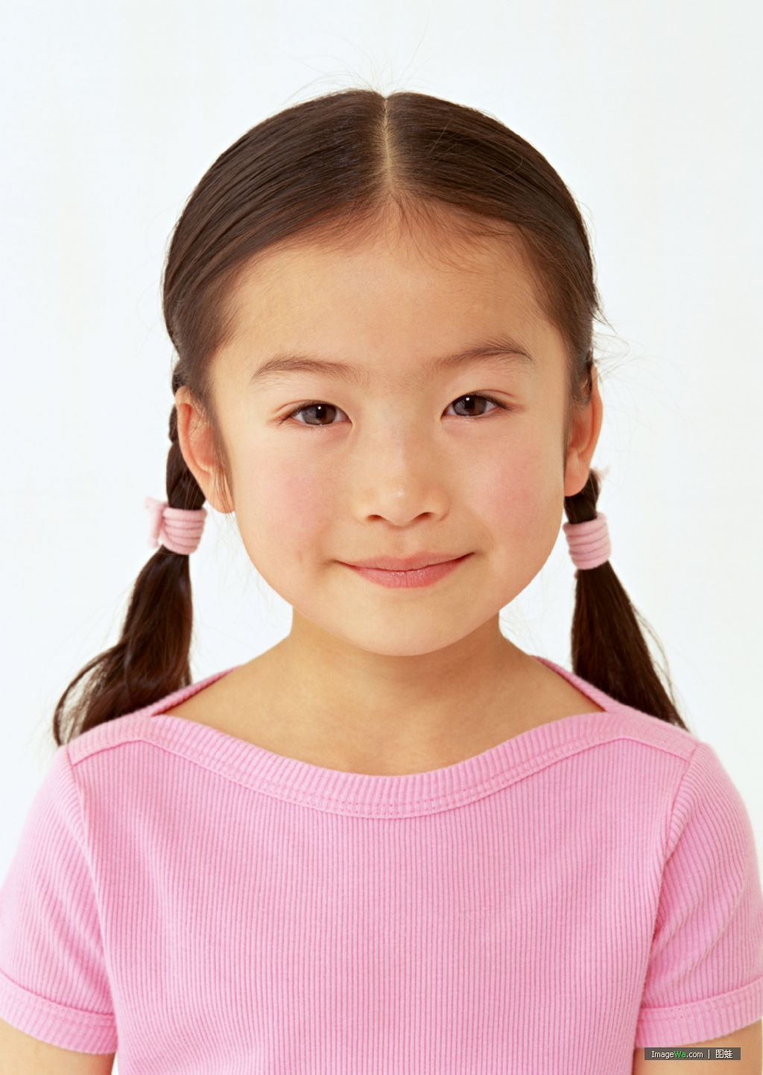
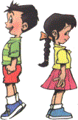
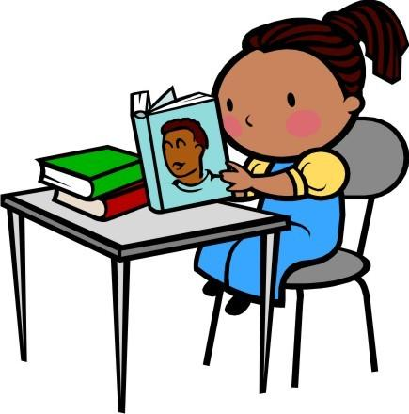

星期三

（ ） （ ） （ ） （ ） （ ） （ ）
四、根据所听问句，选择应答语。（12☆）ww w.xk b1.c om
( )1. A. Yes , I do. B . Yes , I will.
( ) 2. A. Because it’s Friday. B. So it’s Friday.
( )3. A. Yes, it is. B. No, he isn’t.
( )4. A. No, I didn’t. B. Yes, I was.
( )5. A. I’ll go to the park. B. Yes, I will.
( )6. A. It’s in the east. B. I’ll go to Weihai.
笔试部分（47☆）
ir ur or ear ea
一、补全单词（10☆）
n____th 北边 Th____sday 星期四 th___sty口渴的 w___ther天气 l____n学习
二、从A和B两个选项中，选出合适的词填空。（10☆）
( )1. They will______ for a bike ride tomorrow. A. went B. go
( )2.My hair _______short then . A. is B. was
( )3. My brother _________ meat yesterday. A. cook B. cooked
( )4. Bejing is _________ than Weihai. A. big B . bigger
( )5. _____ is that boy? He’s Tom. A. What B. Who
三、选择适当的介词填空，每词只用一次。( of , on, in, off, about )（10☆）
1. Beijing the capital_____ China.
2. It will be hot _____ Sanya.
3. It’s a book ______ London.
4. I’ll visit my grandma ______ Sunday.
5. Sam fell ____ his bike yesterday.
四、阅读理解。根据短文判断对错，相符写T，不相符写F。（10☆）
I have a good friend. He is Bob. He is from London. Now he lives in China. He is a nice boy. He is a clever pupil, too. Bob is taller than me. In summer, he will go swimming. He will have a picnic with his friends, too. And yesterday we went for a bike ride. He bought a kite. We flied the kite. We were very happy.
( )1. Bob is from America.
( )2. Bob is a naught boy.
( )3. I am taller than Bob. w ww.x k b1.com
( )4. He will have a picnic in summer.
( )5. We bought a watermelon yesterday.
五、书写。请用手写体抄写下列句子。（7☆）
I’ll watch IV with my friend on Friday.

四年级英语听力材料
一、
1、naughty
2. help
3. quiet
4. wide
5. clever
6. homework
二、
1、Washington D.C. is the capital of the USA.
2. On Saturday I’ll do the housework.
3. I went swimming yesterday.
4. I will take my kite tomorrow.
5. I bought a watermelon yesterday.
6. The girl is taller than the boy.
三、
1. This is Big Ben. It’s very tall.
2. My hair was very short then.
3. The girl is taller than the boy.
4. I’ll help my mother on Sunday.
5.It will be windy in Beijing.
6. I’ll go to school on Wednesday.
四、
1. Will you go the park on Tuesday?
2. Why not?
3. Is that your house?
4. Did you listen to music yesterday?
5. What will you do On Monday?
6. Where’s Weihai?

