无锡市新联小学四年级英语期末测试
班级________ 姓名________ 得分__________
听力部分（30分）
一、听录音，选出你所听到的选项。（听两遍）（5%）
( ) 1、 A. cap B. cup C. cat
( ) 2、 A. ear B. eye C. here
( ) 3、 A. box B. books C. biscuits
( ) 4、 A. there B. where C. they
( ) 5、 A. park B. puppet C. party
( ) 6、 A. how much B. how old C. how many
( ) 7、 A. come in B. come on C. come down
( ) 8、 A. on the blackboard B. on the cupboard C. on the playground
( ) 9、 A. listen to B. want to C. would like to
( ) 10、A. I like this balloon. B. I like that balloon. C. I’d like these balloons.
二、听录音，按听到的顺序给下图编号。（听两遍）（8%）
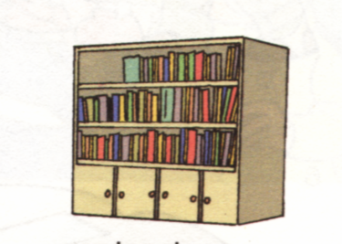
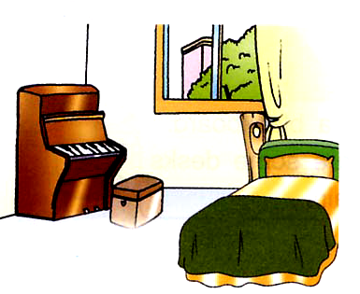
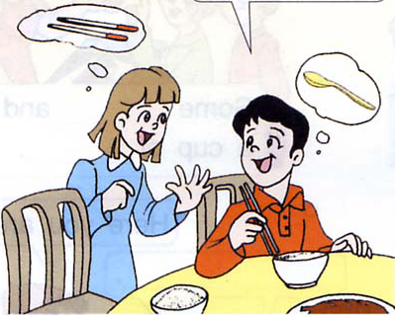
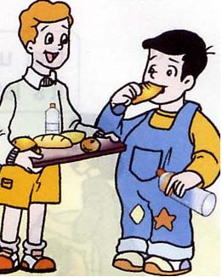

( ) ( ) ( ) ( )
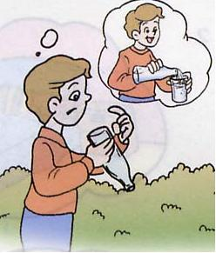
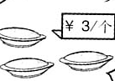
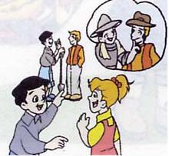
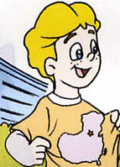

( ) ( ) ( ) ( )
三、听录音，根据所听内容选择正确的应答。（听两遍）(6分) 新 课标 第 一网
( ) 1、A. She’s Miss Wang. B. He’s Mr Wang. C. She’s a nurse.
( ) 2、A. Yes, it’s for the airport. B. No, it isn’t. C. Yes, it isn’t.
( ) 3、A. Some chocolate, please. B. Some coffee, please. C. Some cakes.
( ) 4、A. Yes, I can. B. Yes, I do. C. Yes, I am.
( ) 5、A. It’s a pencil. B. There’s a pen. C. There’s pencil.
( ) 6、A. It’s on the table. B. It’s in the music room. C. They’re over there.
四、听录音，判断所听内容是否与句意相符，用T或F表示。（听两遍）(5分)
( ) 1、Nancy would like the white T-shirt.
( ) 2、There is no rubber in the pencil case.
( ) 3、The old man is Helen’s grandfather.
( ) 4、The man is at a snack bar.
( ) 5、The woman is a nurse.
五、听录音，写出所听到的单词，补全对话。（听三遍）（6分）
A: What would you like, Yang Ling?
B: I’d like a _________ of _________ _________.
A: Something to _________ ?
B: Some _________.
A: How about your _________ ? What would she like?
B: She would like some _________, _________ and a carton of _________.
A: How much _________ _________?
C: _________ yuan.
笔试部分（70分）
一、下列各组单词中画线部分发音是否相同，相同用“ T”，不相同用“ F”表示。（5分）
( )1 what who ( )2 dress trousers
( )3 chair picture ( )4 black jacket
( )5 birds cats ( )6 three the
( )7 know kite ( )8 very football
( )9 sure shoe ( )10 zebra bananas
二、英汉互译。（17分）www .xk b1.c om
1. 一位老朋友 __________ __________
2. 冰箱里的橘汁 the_______ in the __________
3. 买一些葡萄_________ some __________
4. 这个长着大嘴巴的司机 the __________ __________ a big __________
5. 乘出租车去医院 go to the __________ by __________
6. 去北京的火车 the __________ __________ Beijing
7. 许多桃子和梨__________ of __________ and __________
8. 他们的孩子们__________ __________
9. 又大又明亮 __________ and __________
10. 用刀叉 use _________ and __________
11. Don’t climb the trees again.______________________
12. Anything else?______________________
13. I’d like to try. ______________________
14. I can’t move now. ______________________
15. the wheels on the bus
三、单项选择。（15分）新 课标 第 一网
( )1. What are ______? They are pineapples.
A. this B. these C. it
( )2. We can see lots of bowls in the _________.
A. classroom B. study C. cupboard
( )3. There is ______ bread in the fridge. Let’s go and buy some.
A. some B. no C. a
( )4. There _______a pen and some books on the desk.
A. is B. are C. have
( )5. Welcome _______ my home.
A. at B. to C. in
( )6. _______ my chopsticks? They’re in the glass.
A. Where is B Which is C. Where are
( )7. Mr. Green is my mother’s brother. He’s my ______
A. brother B. uncle C. aunt
( )8. Harry Potter (哈利•波特) is English boy.
A. a B. an C. the
( )9. ________ climb trees again.
A. Not B. Don’t C. Do
( )10. The girl over there is friend . _________ name is Helen.
A his His B. my I C. his Her
( )11. _______ is your grandfather? About seventy.
A. How much B. How many C. How old
( )12. ______ is her job?
A. What B. Which C. Who
( )13. Can you read _______?
A. they B. their C. them
( )14. There are no birds _____ the tree. But there are some bananas _____ the tree.
A. in on B. on in C. in in
( )15. – These or those? -- _____________
A. The red one. B. The red ones. C. They’re watermelons.
四、对话配对(5分) X kb1 .co m
（ ）Look, I’ve got a new watch. A. Some biscuits, please.
（ ）Something to eat？ B. How smart!
（ ）I love China. C. Milk and bread.
（ ）Can you play basketball? D. No, thanks.
（ ）How about a glass of milk? E. Yes, I can.
（ ）It’s hot today, isn’t it? F. Yes, he is.
（ ）Don’t watch TV, now. G. Yes, it is.
（ ）What’s for breakfast? H. A cat.
（ ）What can you see in the picture? I. All right.
（ ）Is your father a worker? J. Me ,too.
五、连词成句。（5分）
1. in is blue who the girl the skirt ( ? )
__________________________________________________________________
2. for here of chopsticks you is a pair ( . )
__________________________________________________________________
3. doctor let to see us go the ( . )
__________________________________________________________________
4. the are for they late school ( . )
__________________________________________________________________
5. are lot there of a chairs in desks library the and( . )
__________________________________________________________________
六、把下列句子排成一段通顺的对话。（3分）
A. Good idea, but how? B. OK.
C. All right. D. The cinema, please.
E. Shall we go by bus? F. Let’s go to the cinema.
G. Oh, we’re late. Let’s go by taxi. H. No, it isn’t.
I. Excuse me, is this bus for the cinema?
F |  |  | C |  |  |  | B

七、根据实际情况回答问题。（6分）(答句要完整)
1. Do you like Chinese food ? www .x kb1. om
__________________________________________________________________
2. Are you a teacher ?
__________________________________________________________________
3. What’s in your study?
__________________________________________________________________
4. How do you go to school?
__________________________________________________________________
5. Where’s your English teacher?
__________________________________________________________________
6. What do you want to be?
__________________________________________________________________

八、看图完成短文。(每空只填一词，5分)
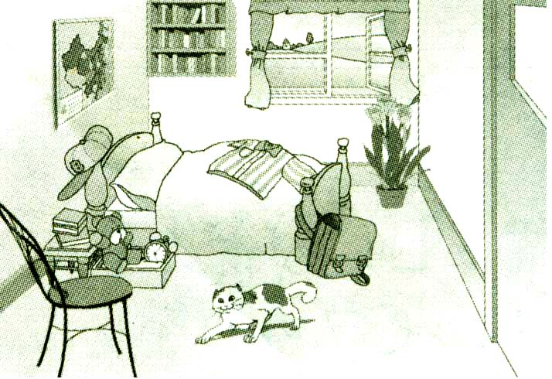

Look __________ my bedroom, please. It’s big and __________. There is a bookcase __________ the window and there’re many __________ in it. On the wall, there is a __________ of China. __________ a shirt __________ the bed. How many __________ can you see? I can see one chair. Look, there is a lovely __________ near the chair. I like my __________ very much.

九、阅读短文，判断下列句子是否与短文内容相符，相符的写“T”，不相符的写“F”。（9分）新课 标 第 一 网
(A)
My name is Tom. I’m a student. My school is big and beautiful. Look, this is my classroom. It’s very clean. My school has two libraries. The big one is for the students. The small one is for the teachers. There’s a big playground in our school. I like to play football. I like my school very much.
( ) 1. The boy’s name is Tom.
( ) 2. Tom’s school isn’t very big.
( ) 3. The big library is for the teachers.
( ) 4. Tom can play football.
( ) 5. Tom likes his school.

(B)
I usually get up at 7 o’clock. I have a cup of coffee and some sandwiches for my breakfast. Then I go to school by bus . I get to school at seven fifty, and I come home at four o’clock in the afternoon. I have rice and fish for my supper.
( ) 1、I have breakfast .
A. at seven B. before eight C. at eight
( ) 2、I go to school by .
A. bus B. bike C. car
( ) 3、I come home at
A. five o’clock in the morning
B. six o’clock in the afternoon
C. four o’clock in the afternoon
( ) 4、I have for my supper.
A. rice and meat B. rice and fish C. meat and noodles

