小学2012年秋季第三次月考
四年级英语试卷
学校 班别 姓名 考号_____________
听力部分

一、听一听，圈出正确的图片编号（10分）

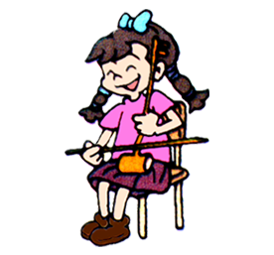
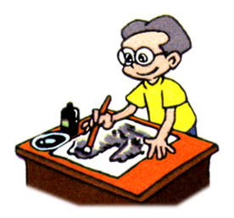
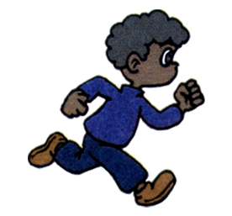


1． 2. 3.

A B A B A B
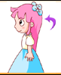
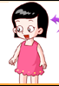
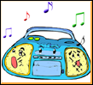
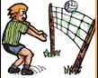
4. 5.

A B A B

二、听一听，用阿拉伯数字排序。（10分）


( ) ( ) ( ) ( ) ( )

三、选出你所听到的单词 （10 分）
( ) 1. A. friend B. fan
( ) 2. A. strong B. thin http:// www.xkb1 .com
( ) 3. A. long hair B. short hair
( ) 4. A. teacher B. student
( ) 5. A. bag B. bed
( ) 6. A. wall B. floor
( ) 7. A. vest B. violin
( ) 8. A. music B.walkwan
( ) 9. A.window B. yellow
( ) 10. A.boy B. girl

- 听录音，选出合适的答句，并将其编号填入前面括号里。（15分）

( ) 1. A. He is Zhang Peng. B. She is Amy

( ) 2. A. OK! B. It’s green.

( ) 3. A. 12 yuan B. I can see 12

( ) 4. A. How nice ! B. good job

( ) 5 A. You’re welcome B..Sure .Here you are.

笔试部分
五．根据上下文和图画，填上句子所缺的单词，使句子完整。（20分）
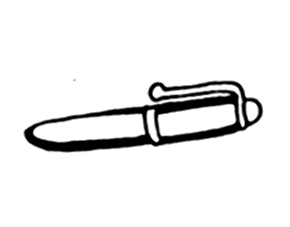
1. I have a w w w .x k b 1. c o m
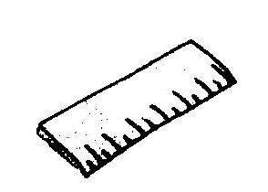
2.This is my
.
3.She ’ a nice (女孩).

Mike is a (男孩).

4. Miss Liu is our English (老师).

六.把句子与相应的意思连线。（10分）
1．Where is my ruler? 你的书包里面有什么？
2 . What in your schoolbag? 我的尺子在哪里？
3 . What’s his name? 他的名字叫什么？
4 .What color is it? 谁是你的好朋友？
5 . Who’s your best friend? 这是什么颜色？

七．写出下列字母的大写或者小写（10分）
Y _____ R_____ t______ h______ U______
m _____ b_____ D______ F______ H______
八.阅读短文，根据短文内容选择合适的答案（15分）X k b 1 . c o m
I have a new friend. His name is Mike. This is his photo. He is strong. He has short black hair. He likes sports. Look, this is his new schoolbag. There are 15 books in it. It’s very heavy.

( )1.Mike is my ________.
A. friend B. teacher
( )2.Mike has short ________ hair.
A. black B. brown
( )3.Mike is _______.
A. thin B. strong
( )4.There are _________ books in the schoolbag.
A.15 B. 18
( )5.Mike likes ________.
A. painting B. sports

四年级第二次月考听力

一、听一听，圈出正确的图片编号（10分）
1.I like music. 2. do sports 3.He is strong.
4.I have long hair. 5.Listen to music.

二、听一听，用阿拉伯数字排序。（10分）
No .1 do sports No .2 make friends

No .1 paiting No .1 science

No .1 listen to music

三、选出你所听到的单词 （10 分）
1.friend 2.thin 3.short hair 4. teacher 5.bag
6. floor 7.vest 8. music 9. yellow 10.boy

四．听录音，选出合适的答句，并将其编号填入前面括号里。（15分）
1. Who is she? 2. what colour is it?
3. how much is it?
4．I have a new schoolbag. 5. may I have a look?

