牛津小学英语3B期末测试卷
班级____________ 姓名 ______________ 学号_________________
-----------------------------------------密---------------------------封--------------------------线------------------------------------------------------------
听力部分（40%）
一、听录音，将所听到的内容序号填写在题前的括号里。（听两遍）（1×8=8分）
1. ( ） A. swimming B. jogging C. climbing D. rowing
2. ( ) A. volleyball B. baseball C. basketball D. football
3. ( ) A. bedroom B. bathroom C. sitting-room D. kitchen
4. ( ) A. plane B. plus C. please D. pretty
5. ( ) A. mother B. father C. grandmother D. grandfather
6. ( ) A. tape B. stapler C. crayon D. copybook
7. ( ) A. camera B. computer C. radio D. key
8. ( ) A. 11 B. 17 C. 7 D.12
二、听录音，圈出你所听到的图片。（听两遍）（2×6=12分）新 课标 第 一网
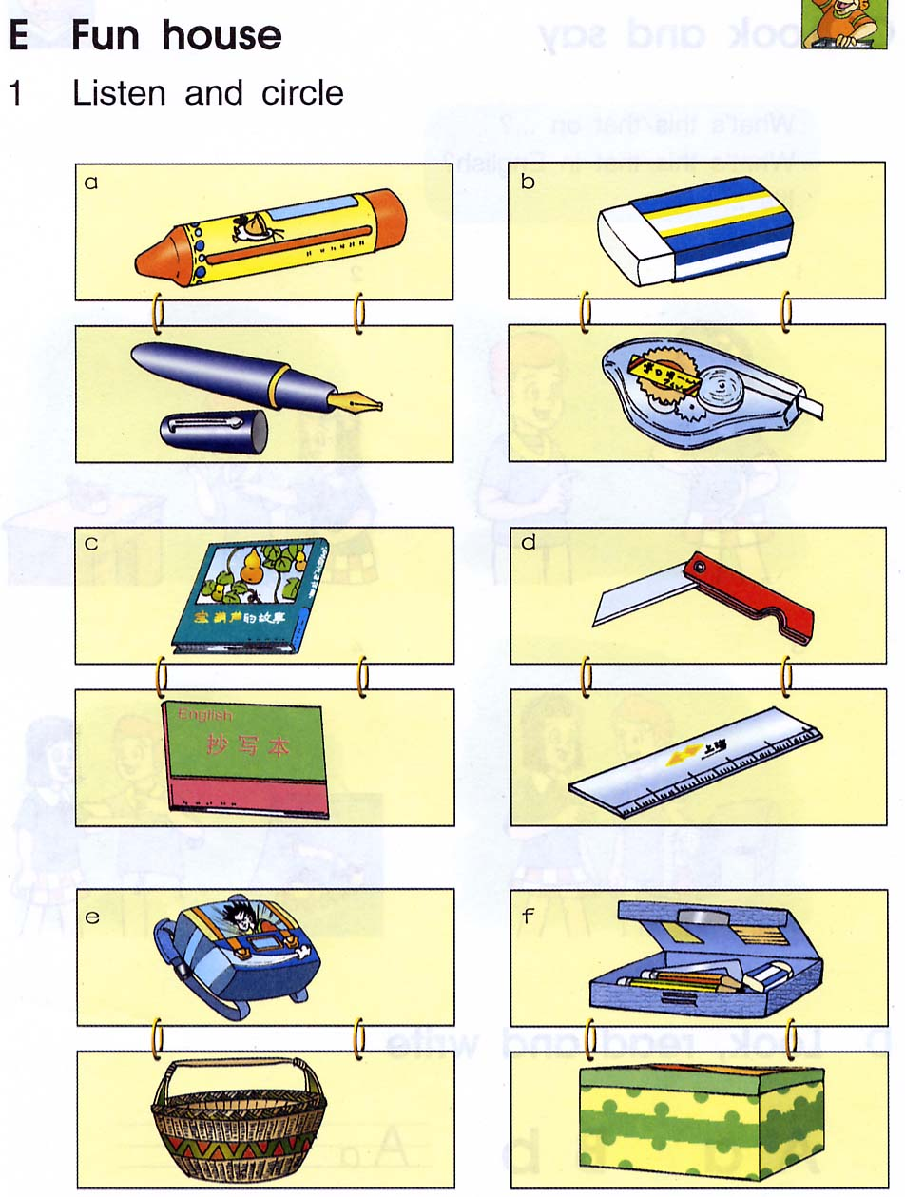
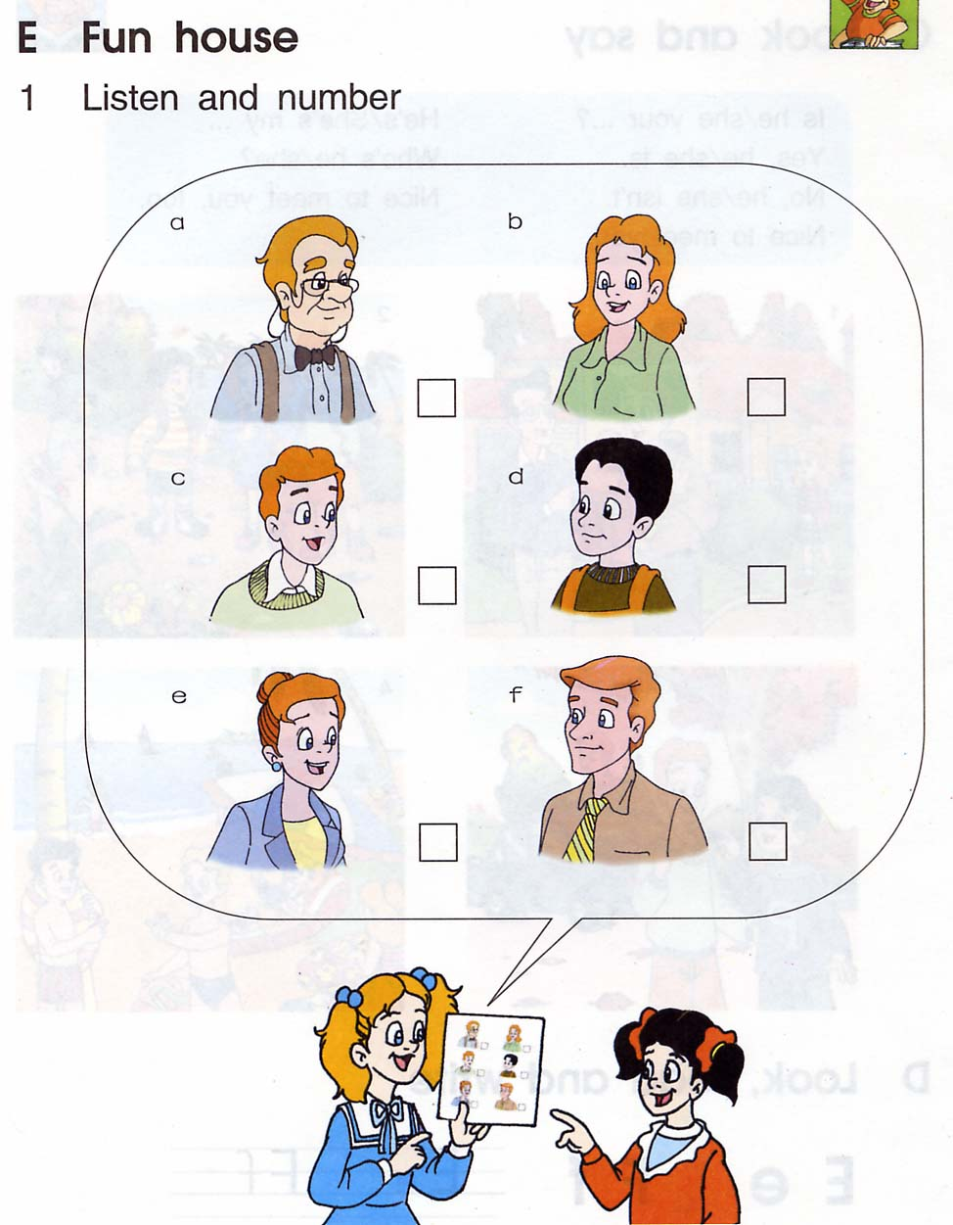
1. 2.

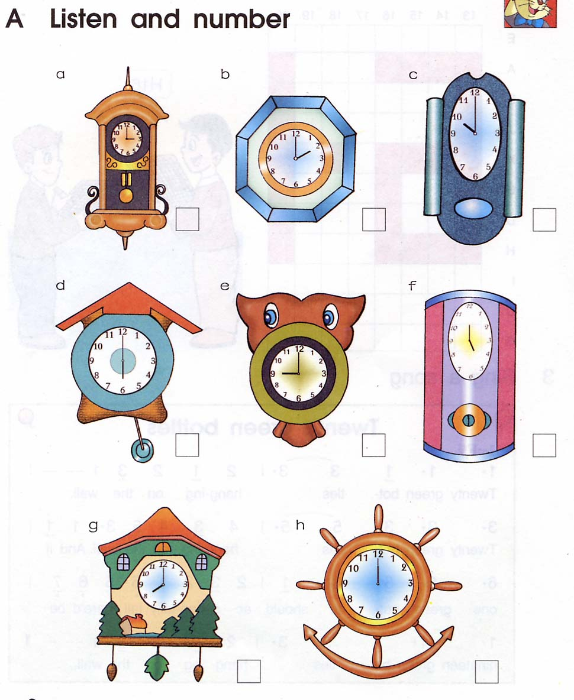
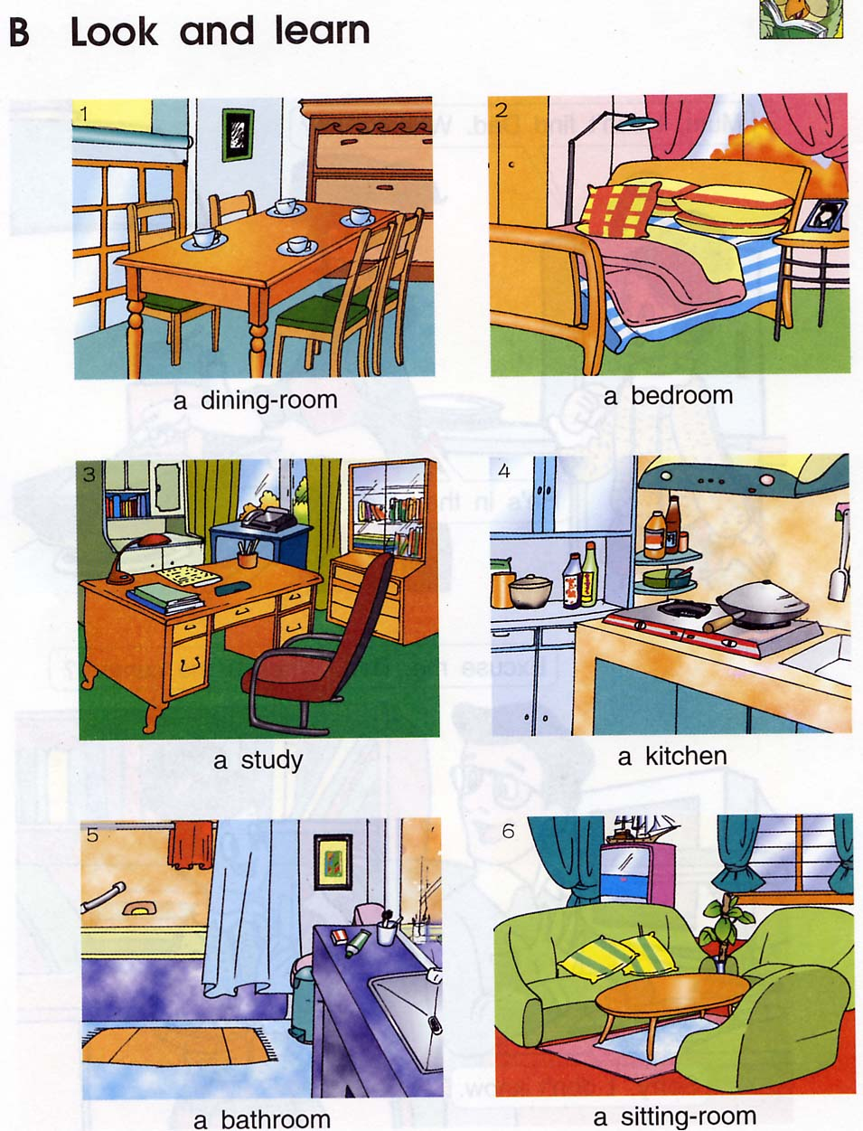
3. 4 4.

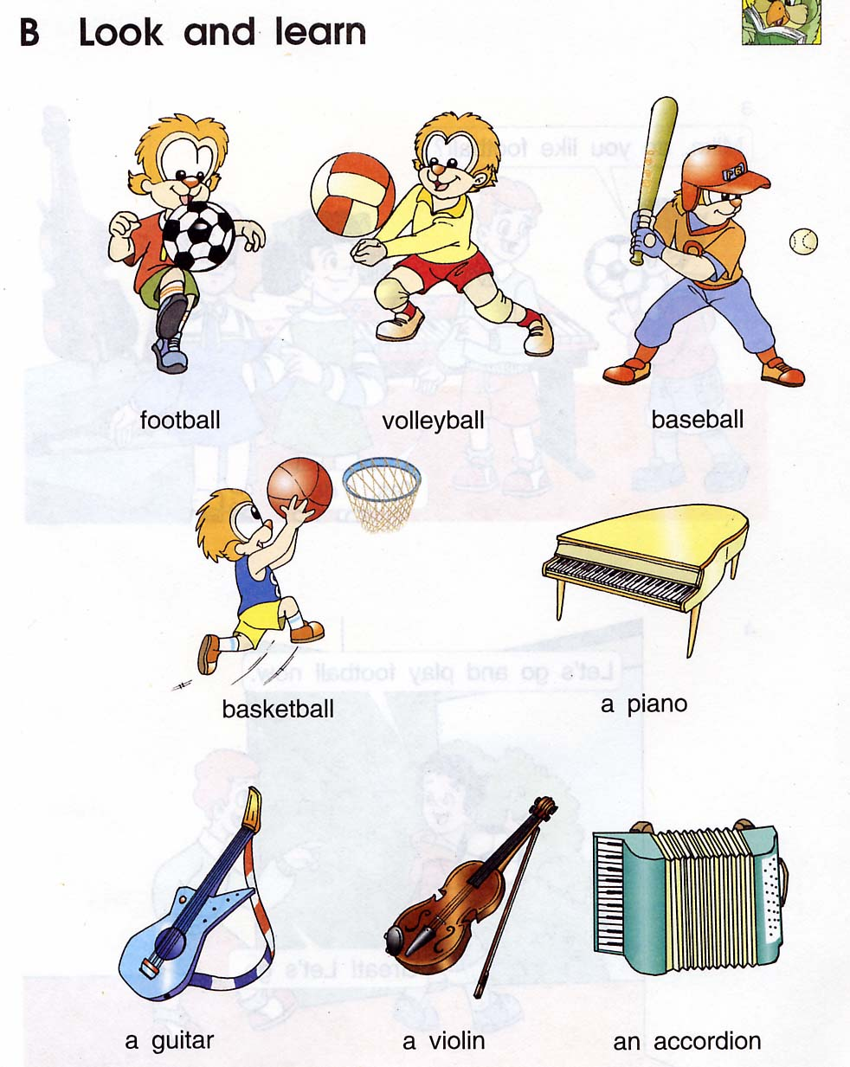
6. 6.
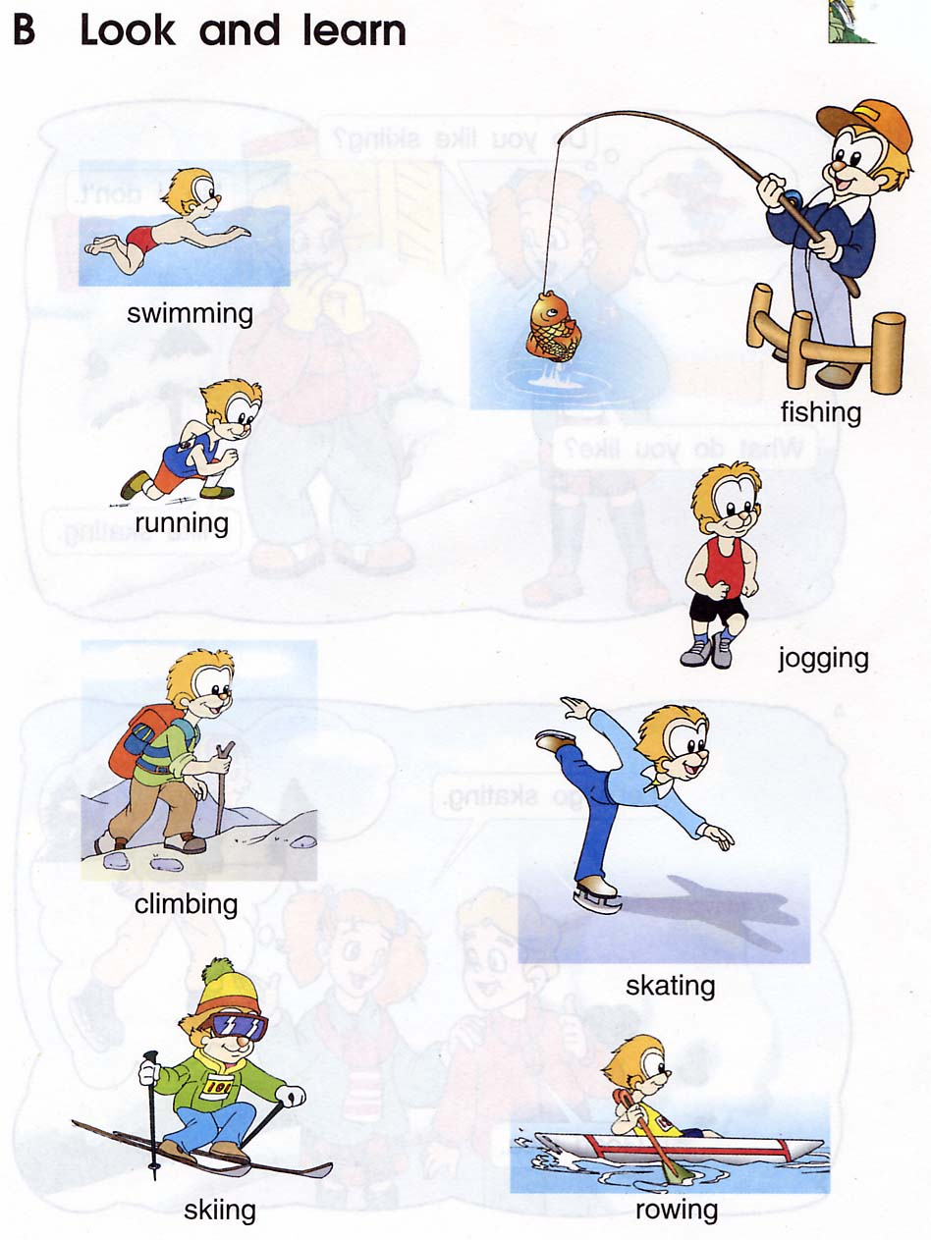
5.

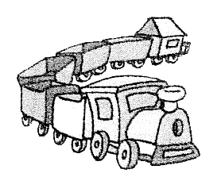
三、听录音，判断图意与所听内容是否一致，用“√”或“×”表示。（听两遍）（1×8=8分）
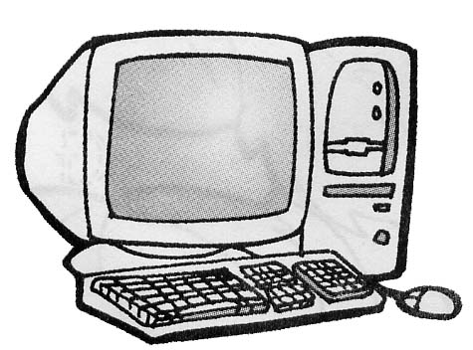
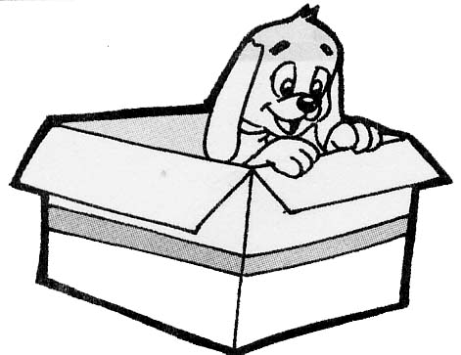
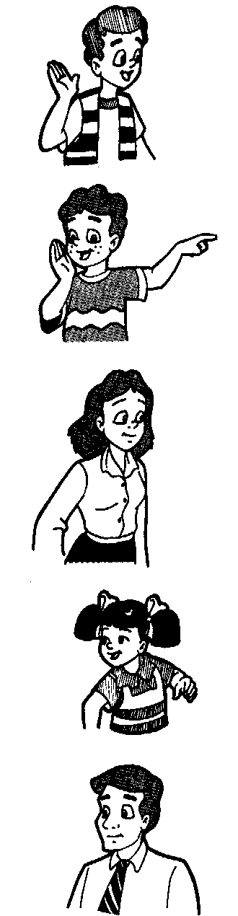
1. 2. 3. 4.

（ ） （ ） （ ） （ ）

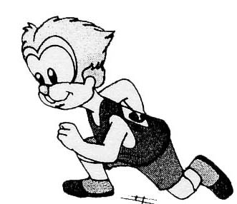
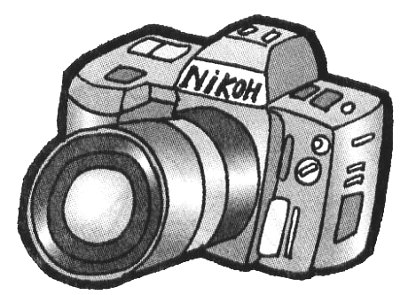
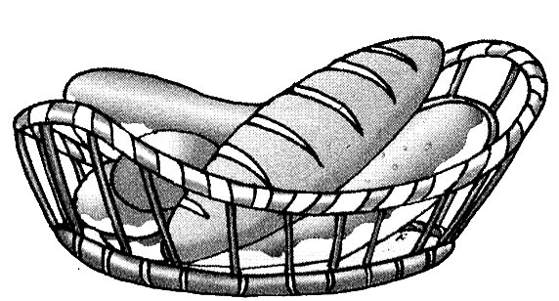
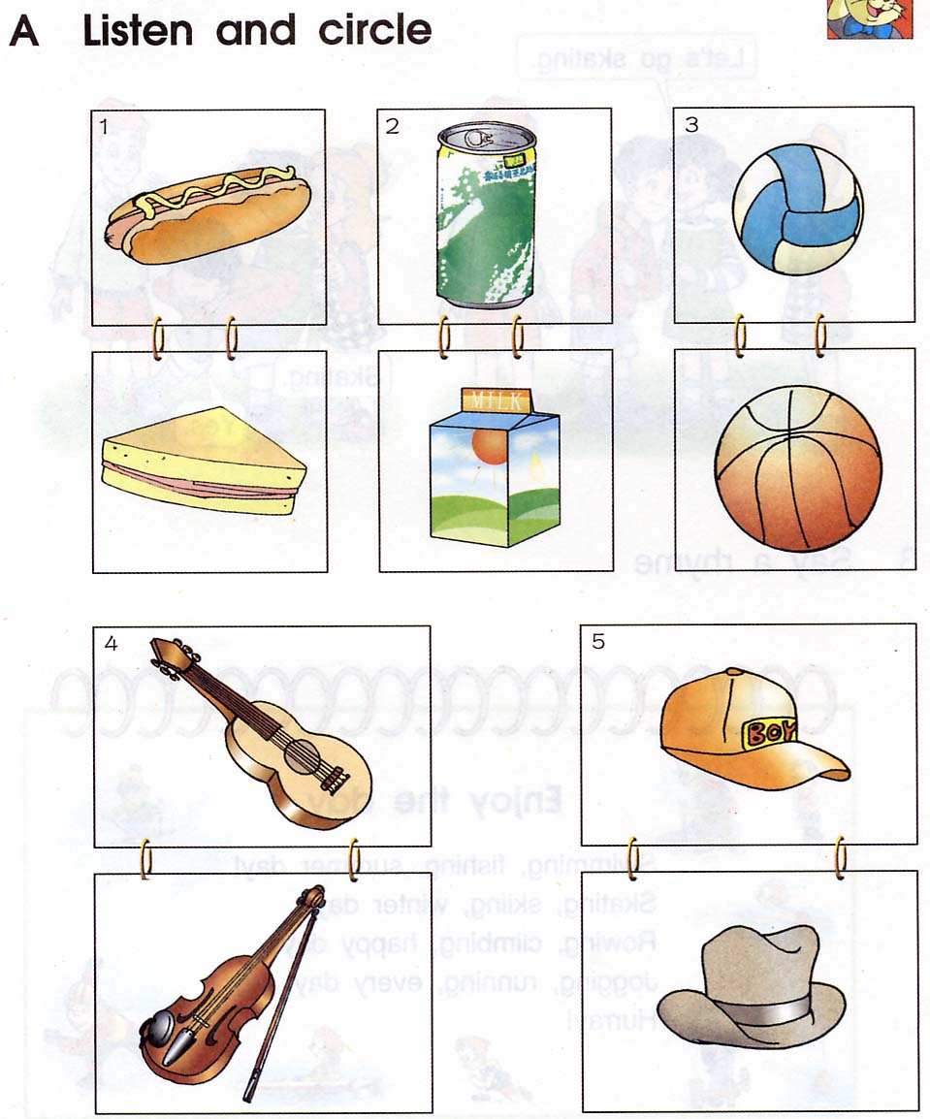
5. 6. 7. 8.

（ ） （ ） （ ） （ ）
四、听录音，选择正确的答句（听两遍）（2×6=12分）
( ) 1. A. I’d like a soft drink. B. Sounds good.
( ) 2. A. Yes, I do. B. Yes, I am.
( ) 3. A: He’s in the study. B: She’s in the study.
( ) 4. A: It’s white. B: Twenty yuan.
( ) 5. A: It’s a table. B: On the table.
( ) 6. A: I play basketball. B: I like fishing.

笔试部分(60%)
六、找出不同类型的单词，将序号填在题前括号内。（1×6=6分）
（ ）1.A.volleyball B. football C. key
（ ）3.A.bag B. camera C. radio
（ ）4.A.sandwich B. chocolate C. vest
（ ）5.A.climbing B. fourteen C. skating
( ) 6. A. piano B. ruler C. violin

七、看图写出相对应的英语单词。（2×8=16分）
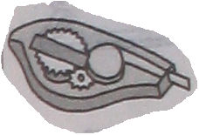
Xk b1.c o m
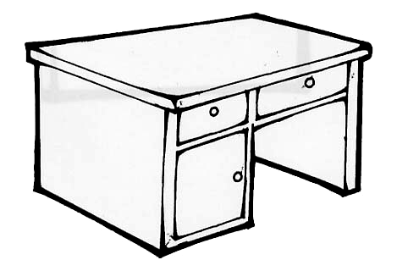
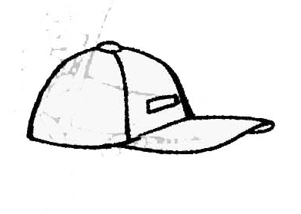
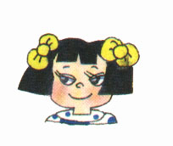

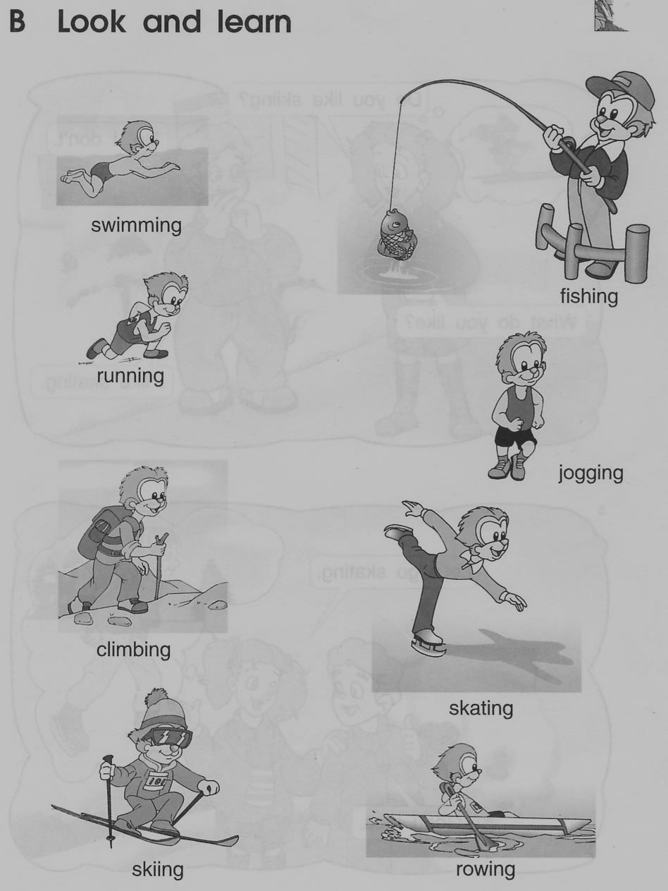

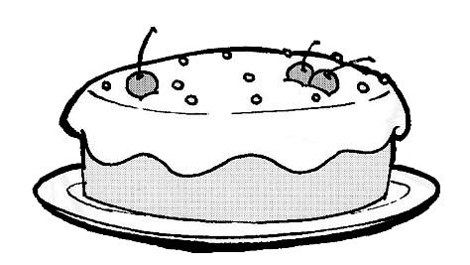
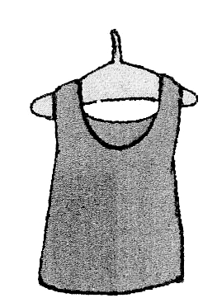
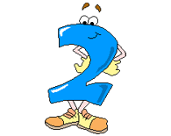
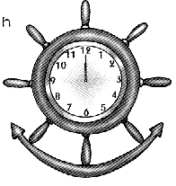

八．选择填空，将正确答案的序号写在题前括号里。（1×10=10分）
（ ）1.I’m ,Mum. I’d like some soft drinks.
A.thirsty B.hungry C.happy
（ ）2. —What’s eighteen two? —It’s sixteen.
A.plus B.minus C.and
（ ）3.—Where’s Dad? — in the sitting-room.
A.he’s B.He C.He’s
（ ）4. —Do you like rowing? —Yes, I .
A.do B.am C.like
（ ）5. —Shall we TV ? Good idea.
A.look B.watch C.see
（ ）6. —Do you play accordion ?— No I don’t.
A.a B.an C.the
（ ）7.你想知道远处桌上的东西用英语怎么说，你应该问：
A. What’s this on the desk? B. What’s that on the desk?
C. What’s this in English?
（ ）8. 当你想叫别人过来时，你说：
A. Come in, please. B. Come here, please. C. Excuse me.
( )9. 通过别人的回答，你弄明白了，你应说：
A. That’s all right. B. Oh, I see. C. Thank you.

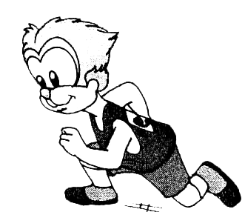
（ ）10.你夸朋友的包好看时，你可以说：
A. What a nice bag! B. How a nice bag. C. What nice!
九、根据提示将下列句子排列成对话。（2×4=8分）
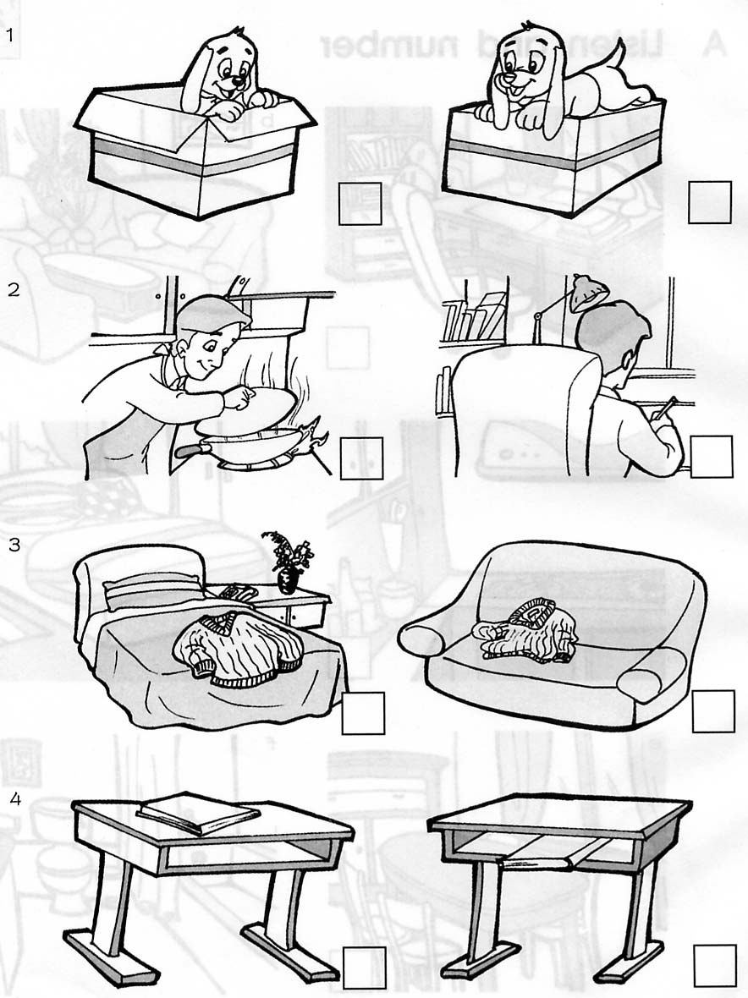
1. A. Is he in the sitting-room?
B. Oh, he’s in the study.
C. Mum, I can’t find my Dad. Where is he?
D. No, he isn’t there.
E. Thank you.
C
十、从B栏中找出A栏相应的答句，将序号填入题前的括号内。（1×7=7分）
（ ）1.What do you like? A.Come in ,please.
（ ）2.Can I have a look? B.Yes,he is.
（ ）3.May I come in ? C.I like climbing.
（ ）4.This is your brother, I think. D.Sure,Here you are
（ ）5.What do you play? E.I can see two bikes.
（ ）6.How many bikes can you see? F.A toy train ,please
（ ）7.What would you like? G. I play football.
连词成句（用序号表示）（2×4=8分）
1．① mother, ② I, ③your, ④This, ⑤think, ⑥is, ( , . )

○→○→○→○→○→○
2．① father, ② Is, ③ your, ④ that, ( ? )

○→○→○→○
3．① What, ② in, ③ that, ④ English, ⑤ is (?)

○→○→○→○→○
4．① time, ② It’s, ③ go, ④ to, ⑤ home, (.)

○→○→○→○→○

十一、阅读理解，用“√”或“╳”表示。（1×5=5分）
My name is Xiao Qiang . Look, this is my family photo . The old man is my grandfather. He is thin . The old woman is my grandmother .She is fat . This man is my father. He is tall . This woman is my mother . Her hair is long . She is a teacher . Who is the boy in blue ? Ha, ha , it’s me .
( )1、This is XiaoQiang’s (小强的) family photo .
( )2、Xiao Qiang’s grandfather is fat .
( )3、Xiao Qiang’s father is tall .
( )4、Xiao Qiang’s mother is a teacher .
( )5、The boy in blue is Xiao Qiang’s brother.
听力材料：
- 听录音，将所听到的内容序号填写在题前的括号里。（听两遍）
１. climbing ２. baseball ３. kitchen ４. plus
５. grandmother ６. tape ７. computer ８. 17

答案：ＣＢＤＢ ＣＡＢＢ新 课标 第 一网
二、听录音，圈出你所听到的图片。（听两遍）
1. What’s this in English? It’s a crayon.
2. Who’s that woman? She’s my mum.
3. What’s the time now? It’s nine o’clock.
4. Where is Tom? He’s in the kitchen.
5. What do you play? I can play the violin.
6. Shall we go skating? Great! Let’s go.
答案略．
三、听录音，判断图意与所听内容是否一致，用“√”或“×”表示正误（听两遍）
１.a boy 2.a camera 3.a toy train 4.The cat is in the box.
5.some bread 6.a basketball 7.rowing 8.radio
答案：××√× √√××
四、听录音，选择正确的答句（听两遍）.
１.What would you like?
2.Do you play the piano?
3.Where’s my mother?
4.What colour is it?
5.Where’s my watch?
6.What do you like?
答案：ＡＡＢＡＢＢ

