《牛津英语》第四册Unit 3测试
班级__________ 姓名__________ 成绩__________
- 听力部分（40%）
  - Listen and judge（听录音，用“×”或“√”判断正误）10%
1) jyqr ( ) 2) akmt ( ) 3) BLRW ( ) 4) AQVF ( )
5) swim ( ) 6) winter ( ) 7) love ( ) 8) play ( )
9) bird ( ) 10) clock ( )

  - Listen and complete（听录音，完成单词） 10%
s ___ ng b___ ___t wh ___ t s ___ ___ p p ___ ___ k b ___sc___ ___t
wh ___ r ___ ___e___ly d__ g e ___ g n___s___ r ___ ad

  - Listen and judge（听录音，用“√”或“×”判断是否与图片内容一致）10%
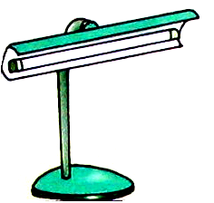

( ) ( ) ( ) ( ) ( )

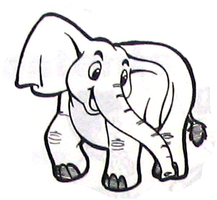

( ) ( ) ( ) ( ) ( )

  - Listen and tick（听录音，勾出听到的句子）5%
1) ( ) A. I live in China.
( ) B. I love China.
2) ( ) A. Mother likes to swim.
( ) B. Father likes to sleep.
3) ( ) A. She goes to Beijing by train.
( ) B. She goes to Beijing by plane.
4) ( ) A. Wash your hands, Sam.
( ) B. Wash your face, Sam.
5) ( ) A. Colour three kites brown.
( ) B. Colour three kites blue.

  - Listen and fill (听录音，选择并填入听到的词)5%
- ________ (Open\Close) your mouth.
- You are ________ (five\fine).
- Say hello ________ (go\to) Alice.
- They like to ________ (play\plane).
- ________ (Funny\Happy) birthday, Sam.

- 阅读部分：60%
  - Think and write（想一想，写出下列小写字母的邻居）10%
1) ___ b ___ 2) ___ q ___ 3) d ___ ___
4) s ___ ___ 5) ___ v___

- Finish the words (完成下列单词) 15%
s___f___(沙发) r___b___ ___r(橡皮) s___ee___(糖果) j___mp(跳)
t___ble(桌子) cl___ ___n(干净) w___nd___w(窗户) ___p___n(开)

3. read and circle (读单词，圈出不同类的词) 10%
1)( )A. apple B. run C. orange 2)( )A. climb B. hen C. chick
3)( )A. write B.swim C. panda 4)( )A.bear B.tiger C.table
5)( )A.window B.door C.banana 6)( )A.lamp B.bed C.fly
7)( )A.horse B.sing C.sheep 8)( )A.tree B.run C.sleep
9)( )A.nose B.pencil C.hand 10)( )A.cat B.ferry C.taxi

4. read and match(把下列句子和图片配对)5%
1)Spotty can run. A.

2)I hear a sheep. B.

3)There are five birds in the sky. C.

4)I see a bear. D.

5)There is a lamp on the table. E.

5. Read and choose（选择填空）10%
1)( )Look _______ the window.
A. on B. at C. in
2)( )_______ do you live? I live in Ningbo.
A. Who B. What C. Where
3)( )There is _______ dog in the room.
A. am B. a C. an
4)( )May I have a _______?
A. pizza B. pizzas C. a pizza
5)( )I like _______ play.
A. to B. in C. on
6)( )Come and play _______ me.
A. for B. with C. and
7)( )There are some _______ on the farm.
A. sheep B. sheeps C. a sheep
8)( )_______light! Stop!
A. Green B. Yellow C. Red
9)( )I have _______ apple.
A.am B.a C.an
10)( )There _______ some books on the table.
A.are B. is C. am

6. Read and fill(选择并填入正确的单词。)5%
1)I see a ________(pencil\pencils).
2)There is an ________(egg\eggs) on the desk.
3)May I have three ________(cake\cakes).
4)There are some ________(girl\girls) in the classroom.
5)There is some _______(water\waters) in the bowl.

- Look, choose and write(看图选词填空)5%
in on under

  - The cat is ________ the table.
  - The bed is ________ the ground.
  - The bag is ________ the bed.
  - The fish is ________ the water.
  - The table is ________ the room.

