2012年下学期仁寿联校初中2013届12月检测
英 语 试 题
（总分120分，120分钟完卷）
第Ⅰ卷
第一部分 听力（ 共三节 ，满分20 分）
第一节：（共5个句子；每小题1分，满分5分）
下面你将听到5个句子，根据每个句子的内容，从每组图片的A、B、C三个选项中选出相应的图片。听完每个句子后，你将有10秒钟的时间来回答有关小题和阅读下一小题。每个句子读两遍。
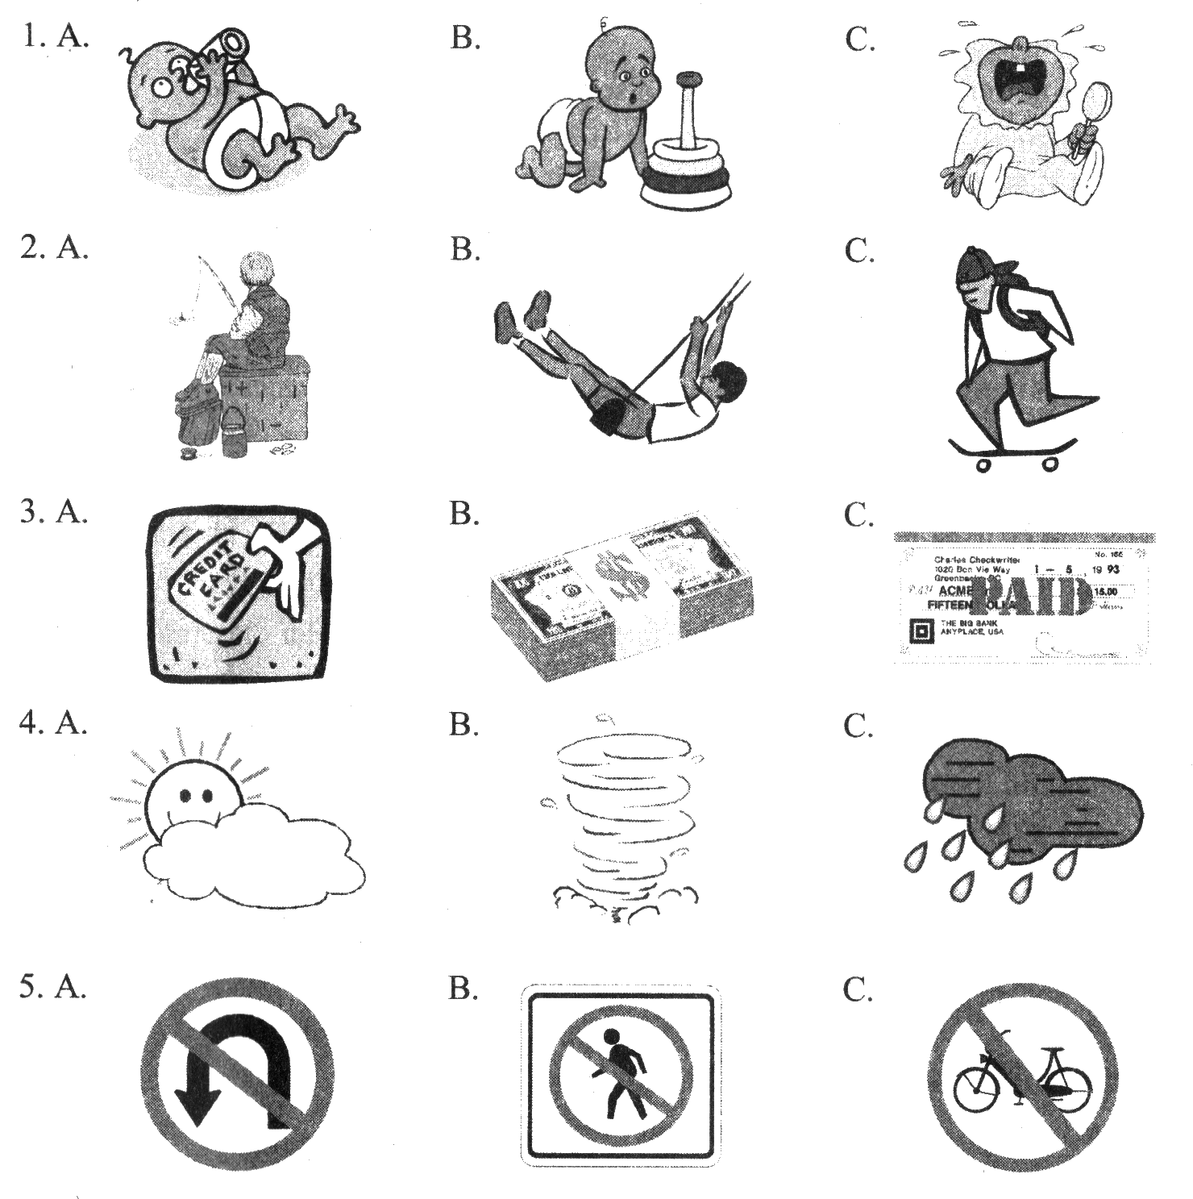
第二节：（共10个小题；每小题1分，满分10分）
下面你将听到4段对话，每段对话后有几个小题，从题中所给的A、B、C三个选项中选出最佳选项。听每段对话前你将有时间阅读各个小题，每小题5秒钟；听完后，各小题将给出5秒钟的作答时间。每段对话读三遍。
听第一段对话，回答第6、7小题。
6. Where are the speakers？
A. At a railway station. B．At a fruit store. C. On a train.
7. What will the woman probably do next?
A. Buy a ticket. B．Buy some fruit. C．Get on the train.
听第二段对话，回答第8----10小题。
8. When did the man return the book Walt Disney?
A. Last month. B. Last week. C. Yesterday.
9. Where are the speakers probably?
A. In a library. B. In a bookstore. C. In a classroom.
10. Where did the man meet his classmate?
A. On the plane. B. On the train. C. On the bus.
听第三段对话，回答第11、12小题。
11. What does the man want to buy?
A. Italian newspapers. B .English newspapers. C .French newspapers.
12. Where will the man probably go next?
A. To a post office. B .To a high school. C. To a bookstore.
听第四段对话，回答第13---15小题。
13. Who is the man？
A. The woman’s friend. B．Frank’s classmate. C．Frank’s teacher.
14. What does the man ask the woman to do？
A. Take a message for him. B .Go to the concert with him. C. Buy a concert ticket for him.
15. When will the concert begin?
A. At 6:00. B. At 6:30. C. At 7:00.
第三节：（共5小题；每小题1分，满分5分）
下面你将听到一段独白，请根据你所听到的内容，用适当的单词补全下面五个句子，每空一词。独白读三遍。
16. When I was young I lived in Scotland, in a village the sea.
17. There weren’t any computers, but my family had a TV, and we it every evening.
18. My parents didn’t have a car, so I to school by bicycle一six miles every day!
19. When I was fifteen my parents sold our house and the family to England.
20. I never went back to my village, but I can still the sea in my head.
第二部分 基础知识运用（共两节）满分25分 ）
第一节 单项选择（共15题，每小题1分，共15分）
从A、B、C、D四个选项中，选出可以填入空白处的正确答案
（ ）21---Did you use to ____ a bus to school?
---Yes .But now I am used to ____ a bike to school .
A .take , riding B. taking , riding C. taking , ride D. taking . riding
（ ）22---.Look! It _____be your uncle .
----It_____ be him . He has gone to Xi’an.
A. can, mustn’t B. can , can’t C. must, can’t D. must, may
（ ）23. _______ has donated much money to the charity .
A. Hers friend B. A friend of her C. Some of her friends D A friend of hers
（ ）24. The bike boy fixed up all the bikes then he ______ to the poor children .
A. gave them away B. gave away them C. give it away D. give away it
（ ）25. —Tom has made great progress this term.
— , and .
A. So he has, so you have B. So he has, so have you
C. So has he, so have you D. So has he, so you have
（ ）26. — useful invention it is.
—Yes, It helps us a lot.
A. What an B. What a C. How D. How a
（ ）27. He saw a little boy a kite on the road when he drove to the village.
A. flew B. to fly C. flying D. is flying
（ ）28. .He must stay at home to look after his ____ mother . She has been _____for a week.
A, ill . sick, B. sick ,ill C. ill ; ill D. sick ; illness
（ ）29 I didn’t understand , So I put up my hand to ask.
A. what my teacher says B. what does my teacher say
C. what my teacher said D. what did my teacher say
（ ）30. Have you found the information about famous people you can use for the report?
Not yet. I’ll search some on the internet.
A. that B. who C. what D. whom
（ ）31. Can you provide us _________ some information _______ the computer?
A. for, with B. with, about C. about, with D. with, with
（ ）32. The milk____ _strange .but it suits me_______.
A. was tasted , good . B .tasted ,good C is tasting . fine D .tastes ,fine
（ ）33.We____here two hours ago . So we___ _here for two hours .
A. have arrived , have been B .have come , have been
C. came , have come D. arrived , have been
（ ）34.----What will we do if we want to develop our village ?
---- A lot of roads ______. I think .
A. have to build B. are build C must be built D. will build
( )35. —Oh, Mary is not here these days. Is she ill?
— Her mother told me that she was in hospital.
A. I am afraid so B. I hope so C. I don’t mind D. I don’t think so
第二节：完形填空（共10小题；每小题1分, 满分10分）
阅读下列短文，掌握其大意，然后从36~45各题所给的四个选项中，选出最佳选项，并在答题卡上将该项涂黑。
A man walked into a restaurant. The restaurant advertised it had the 36 menu in the world. The manager was very proud of being able to provide any dish, no matter how 37 it was.
At the bottom of the 38 , there was a notice that said, “If you do not see the dish you need on this menu, please tell us and we will add it to the menu right away.”
The man 39 the menu and decided to make sure if it was true. He would order 40 that was very unusual.
When a waiter came up to take his order, he said, “You say you can serve any dish, even if it’s not on your longest menu in the world.”
“That is correct, sir. We are able to meet everyone’s requirements.”
“Well,” the man said, “bring me a sandwich with two elephant ears. 41 , not African.”
The waiter wrote down in his paper: Two Indian elephant ears on toast.
“Very good, sir,” he said. “That shouldn’t 42 long.”
The waiter walked away quickly.
The man was very surprised and rather disappointed.
Then he smiled 43 the waiter returned with a very unhappy look on his face.
“Ah!” the man said. “You can’t 44 it to me, can you?”
The waiter made an apology (道歉).
“I’m very sorry, sir, and this is the 45 embarrassing,”（ （ 困窘 ） he said, “but I’m afraid we can’t because we’ve run out of bread.”
36. A. biggest B. thickest C. heaviest D. longest
37. A. unfair B. unusual C. beautiful D. important
38. A. menu B. dish C. restaurant D. table
39. A. looked for B. took out C. looked at D. picked up
40. A. anything B. nothing C. everything D. something
41. A. American B. Indian C. Canadian D. Australian
42. A. pay B. cost C. take D. spend
43. A. as B. and C. so D. though
44. A. catch B. take C. fetch D. bring
45. A. least B. most C. less D. more
第三部分：阅读理解（共20小题；每小题2分,满分40分）
A
Some people think only school children do not agree with their parents, however, it is not true. Communication is a problem for parents and children of all ages. If it’s hard for you to communicate with your parents, don’t worry about it. Here are some advice for you to bridge the generation gap (代沟).
Don’t argue with your parents. Don’t get to your parents when you are angry. Your parents probably won’t consider your ideas if you are shouting at them. And you can’t express yourself well if you are angry. Go someplace to cool off. Make sure you understand why you are unhappy. Then think about what you want to say to your parents. If you don’t think you can speak to them at the moment, try writing a letter.
Try to reach a compromise (和解). Perhaps you and your parents disagree on something. You can keep your disagreement and try your best to accept each other. Michael’s mother didn’t agree with him about buying a motorbike. They argued over it. But they finally came to a compromise. Michael bought the motorbike, but only drove it on certain days.
Of course, your parents might refuse to compromise on something. In these situations, it is especially important to show love and respect to them. Showing respect will keep your relationship（关系） strong.
Talk about your values. The values of your parents are probably different from those of your own. Tell your parents what you care about, and why. Understanding your values might help them see your purposes in life.
A good relationship with your parents can make you a better and happier person. It is worth having a try!
根据短文内容，选择正确答案。
﹙ ﹚46. According to the passage who have a communication problem?
A. parents and other people B. only school kids and their parents
C. teachers and their students D. parents and children of all ages
﹙ ﹚47. How many pieces of advice does the writer give us to bridge the generation gap?
A. 5. B. 4. C. 3. D. 2.
﹙ ﹚48. The underlined word “bridge” in the passage means “______”.
A. 建立 B. 消除 C. 通过 D. 到达
﹙ ﹚49. If the values of your parents are different from those of yours, you’d better ______.
A. argue with them B. keep away from them
C. agree with them all the time D. tell your parents what you care about
﹙ ﹚50. The best title for the passage is______.
A. How to bridge the generation gap B. How to deal with family problems
C. How to be good parents D. How to be a good child
B
DNA is the whole “map” of the human body. It is something that all humans have, and it tells the body what to do. DNA is the reason that we look like our parents, because we get some of their DNA to make our own.
People have been trying to understand the human body for a long time, In1860, Mr Mendel discovered why we look the same as other people in our family. It is because of small things called “genes”(基因) in our body. In 1953, two scientists, Watson and Crick, found out that those small parts are really messages . They’re written in the DNA with a special language.
In1961, another two scientists found the first “word” that they could understand in that language. It shows how DNA tells the cell﹙细胞﹚to build its parts. So far, scientists have found all the words in the DNA map, but we still do not understand what they all do. By understanding what just one “word ”means, we can help to save people from several illness. So the more we understand, the more doctors will be able to do.
Most people hope that this will help to make better medicine and help sick people. Other people worry that when we learn more “words” and find out more information, we will use it in the wrong way, just to make people more attractive (有吸引力的)，or stop sick people getting jobs.
( ) 51. When did Mr Mendel discover why we look the same as other people in our family?
A. In 2000. B. In 1961 C. In 1953 D In 1860
( )52. What did the two scientists find in 1961? They found_____.
- all the words in the DNA map
- Small things called “genes” in our body
- The first “word” they could understand in that language
- those small parts are written in the DNA with a special language
( )53. How can we help sick people if we understand more “words” in the DNA map?
A. Make better medicine. B. Make them get jobs.
C. Make maps for them. D. Make them attractive
( )54. Which one is not true according to the article?
- We look like our parents because of “genes” in our body
- We have understand what all the words in the DNA map do
- DNA is the whole “map” of the human body.
- DNA tells the cell to build its parts.
( )55. What do people think about this research about DNA?
A. It can be only bad B. It can be only good
C. It can be good but won’t work D. It can be good and bad
C

Many believe that life has smiled on Yang Mi: at the age of 4, she got her first TV drama（剧）role; at 16, she became a model for a fashion magazine; at 18, she went to her dream college — Beijing Film Academy (学院).
Last year, the 24-year-old actress played bad girl Luo Qingchuan in the time-traveling TV drama, Palace. The drama became a big success and made Yang very famous. The number of her micro blog followers soared from several thousand to more than 3 million overnight.
Could she be any luckier? Yang doesn’t think luck had anything to do with her success. She paved her way all by herself. “Every chance comes from the efforts I’ve made,” said Yang. People now think she’s very hard-working.
She doesn’t forget the time when people gave her the cold shoulder. Some treated her with little respect. They didn’t want to help her in her time of need. “I have to thank them because they gave me the drive to prove myself,” she said. That’s why she is eager to help others when they are in need.
In May, Yang became the ambassador (大使) for the Climate Group. She calls on people to join the Million-Miracle (百万奇迹) project and plant trees on China’s dry land. Together we’ll fight the bad weather!
根据短文内容，选择正确答案。
﹙ ﹚56. What happened to Yang Mi when she was sixteen years old?
A. She got her first drama role. B. She played a bad girl in Palace.
C. She became a fashion model. D. She went to a film college.
﹙ ﹚57. The underlined word “soared” in Paragraph 2 can be replaced(代替)by ________.
A. fell B. increased C. stayed D. disappeared
﹙ ﹚58. Why did Yang Mi succeed in life?
A. Because she caught every chance luckily.
B. Because she often helped workers to pave the road.
C. Because she put more efforts into her work.
D. Because she wrote her micro blog to attract fans.
﹙ ﹚59. If Yang Mi meets an actress in need of help, she will _________.
A. show her a cold shoulder B. treat her impolitely
C. criticize her seriously D. give her a hand
﹙ ﹚60. The last paragraph is mainly about_________.
A. what Yang has done for the Climate Group B. the Million-Miracle project
C. planting trees on China’s dry land D. Yang’s courage to fight the bad weather

第Ⅰ卷 非选择题部分
任务型阅读（共5小题，每小题2分）
One afternoon ,Mrs Stone decided to visit her friend Mrs King . Mrs king lived in a nice house with a large garden far from the city center .Mrs Stone took her dog with her . While the women were having coffee outside the house , the dog was running around in the garden . The two friends were very unpleasantly surprised when the dog appeared after some time with a dead rabbit in his mouth. Mrs King began to feel sick because she knew that her neighbor kept rabbits in a hutch (兔窝 ) in his garden . As the dog and the rabbit were both covered with earth and dirt , the women took the rabbit and carefully cleaned it in the bathroom .When it got dark ,they went quietly through the trees into the neighbor’s garden and put the dead rabbit into the hutch .
The next afternoon .Mr king’s neighbor , the one with the rabbit ,found her in the garden called her over . She walked towards the neighbor and she felt very afraid because she knew that she did something wrong “You know what ? ”her neighbor said , “ Yesterday morning I found one of my rabbits dead in the hutch . So I put it in the ground in the garden and this morning ,”he started to whisper( 耳语 ), “It’s back to the hutch ! I’m going to take it to a right pet cemetery （ 墓地）
61 . Who was the owner of the dog ?
____________________________________________________________________________
62 .Why were Mrs Stone and Mrs King very unpleasantly surprised ?
____________________________________________________________________________
63 .Where did Mrs Stone and Mrs King put the dead rabbit ?
____________________________________________________________________________
64.The rabbit wasn’t bitten to death by the dog , was it ?
____________________________________________________________________________
65.How would Mrs King’s neighbor deal with the rabbit ?
____________________________________________________________________________
第Ⅱ卷（共35分）
第一节 口语应用。(每小题1分，共5分)
阅读下面对话，从方框内7个选项中选择5个恰当的句子完成此对话，并将其番号填入题前括号内。
A :Hi, Tongtong!
B: Hi, Bruce! ___66___
A: Very well, thank you.
B:I know the 30 th Olympic Games is coming next month._67____
A: Yes, that’s right.
B: Will you go back to your hometown soon?
A: Of course. And I will be a guide during the Olympics.
B: __68___ I was once a guide in the 2008 Beijing Olympics, too.
A: Thank you! ____69_
B: Sure! We can help people to find their ways. Also, we can introduce the place of interest to the friends both at home and overseas.
A: Excellent! I hope to become a guide like you! __70___ Thanks a lot!
B: You are welcome!
- Would you please tell me what to do as a guide?
- What would you like to do?
- How is it going?
- It will be held in your country, won’t it?
- Oh, congratulations(祝贺)!
- It’s very nice of you to tell me so much.
- I’m afraid not.

66________ 67 _________ 68 _________ 69 ________ 70 _______
第二节 短文填空，从下面方框中选出10个单词，用它们的适当形式填入短文空格内，使短文意思正确、通顺(每词限用一次)。请将答案依次填入下边表格内。（每小题1分，共10分）
come other one something help give small wake good sleep
These days, a Chinese girl’s travel diary has become a hit online.
Zhao Xing, with only a map, a travel bag and 30 yuan, left the Chinese mainland for the 71 time to Taiwan. At the airport, she 72 by a man who even told her his phone number. A bus driver was kind enough 73 her up when she fell 74 on the ride.
In Taiwan, Zhao told the man who 75 her a ride that she was from Beijing. The man asked if there was 76 else he could do to help make her journey 77 .
“After 78 back and thinking over everything I’ve experienced, I realized that the people impressed me the most, not the beautiful scenes or tasty food,” Zhao wrote in her online diary.
From Beijing to Taiwan, so close, so far away. Zhao’s wish is to encourage 79 to realize their own dreams of making the world a 80 , more friendly place for all.
第三节 完成句子（共5个小题，20个字，每空0.5分，满分10分）
根据汉语提示，完成句子，一空一词。
81.很感谢你给我们提供有关度假的信息。
Thank you _____ ______ us_____ some information about ______
82.如果我是你，我就不会把这件事告诉其它任何人。
I tell about it if I you.
83.他现在还不可能买得起一个属于他自己的房子。
It is for him to a new house that him now.

84.全体英语教师共同制定的计划实施得很好。
The plan that ______ ______by all the English teacher _______ _______ fine.
85.他妈妈尽力地照看好他。
His mother ______ ______him as _______ ________she could.
第五节 书面表达（满分10分）
请根据下面的提示写一篇60 字左右的短文
张明是九年级三班的一名学生。他乐于助人，梦想长大后能当一名医生。上周星期六他骑车去了当地的一所医院当志愿者。他去为病人唱歌，使他们振奋起来。他认为当一名志愿者真的很棒。
____________________________________________________________________________________________________________________________________________________________________________________________________________________________________________________________________________________________________________________________________________________________________________________________________________________________________________________________________________________________________________________________________________________________________________________________________________________________________________________________________________
__________________________________________________________________________________

联谊学校英语月考答案（十二月份）
一，听力部分：
1—5. CABCA 6—10. ACCAC 11—15. AABAC
16. near 17. watched 18. went 19. moved 20 hear
二，单项选择：21—35 A C D A B A C B C A B D D C A
三，完形填空：36—45 D B A C D B C A D B
四，阅读理解： A篇 46—50 D C B D B
B篇 51---55 D C A B D
C篇 56—60 C B C D A
（选择题部分：1——45每小题1分；46——60每小题2分，共70分）
任务型阅读 61—65
61. Mrs Stone
62. Because the dog appeared with a dead rabbit in it’s mouth.
63, They put it back into the butch.
64. No/ No ,it wasn’t
65. He would take it to a right pet cemetery.
五，补全对话： 66—70 C D E A F
六，短文填空
71 first 72 was helped 73 to wake 74 asleep 75 gave
76 anything 77 better 78 coming 79 others 80 smaller
七，完成句子
81 for providing with vacation
82 wouldn’t anything else were
83 impossible buy belongs to
84 was made worked out
85 looks after well as
八，书面表达（略）

