登瀛小学2011学年第一学期二年级英语期中试卷
班级 姓名 学号

Part 1 听力部分
一、 在听到的字母或单词下打勾：16%
1. b d 2. h k
( ) ( ) ( ) ( )
3. eic cej 4. fhm fng
( ) ( ) ( ) ( )
5. New York London 6. thirsty happy
( ) ( ) ( ) ( )
7. eleven twelve 8. near under
( ) ( ) ( ) ( )
二．按听到的顺序给下列图片或单词编号: 16%新|课 |标|第|一|网
1.

( ) ( ) ( ) ( )
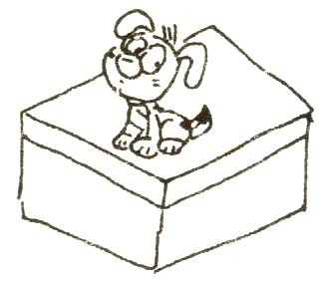
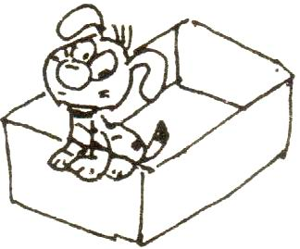
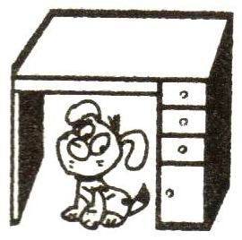
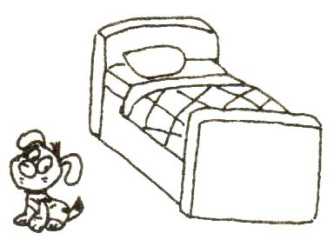
2．

( ) ( ) ( ) ( )
3． happy sleepy thirsty sad
( ) ( ) ( ) ( )
4．computer room dining room reading room classroom
( ) ( ) ( ) ( )
三．听录音， 将人物与图片用线连起来：8%
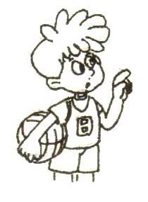
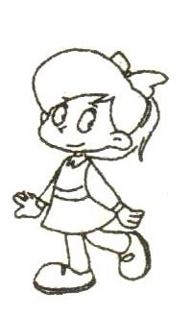
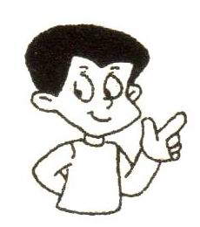
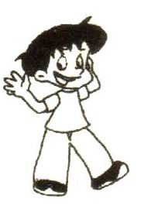
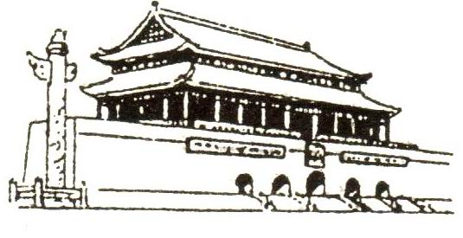
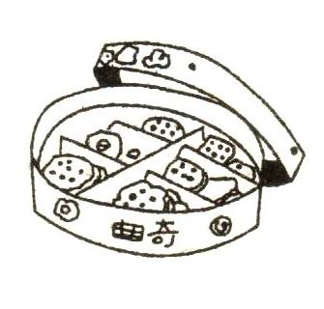
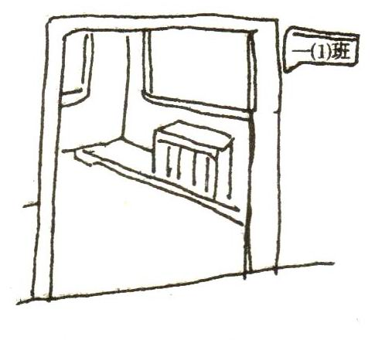
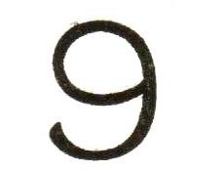
1． A.
新|课|标 |第|一|网

2. B.

3. C.

4. D.

四、听音编号: 12%
( ) I’m from New York.
( ) It’s in the USA.
( ) Hello, I am Tom. Where are you from?
( ) Hello, I am Yang Mingming. Where is New York?
( ) This is Mike, a new boy.
( ) Welcome to our class.
五、听句子，圈单词: 8%
1． Are you in Class ( Three, Two) ? No, I’m not.
2. What ( colour, shape) is it? It’s a (square, circle).
3. Where is the cat? It’s ( under, near) the desk.
4. I’m (hungry, thirsty). I want some (coke, juice)
5. How old are you? I’m ( eight, ten). X|k | b| 1 . c|o |m
6. Where are you from? I’m from (Sydney, Paris)

Part 2笔试部分
- 按顺序写出字母a-n 14%
b k h e j g n a i c l m f d

二．圈出不同类的词：5％
1．A. black B. red C. green D. star
2．A. apple B. circle C. orange D. banana
3．A. five B. seven C. four D. candle
4．A. on B. near C. two D. under
5．A. bone B. coke C. milk D. juice
三、圈出符合图意的单词10%
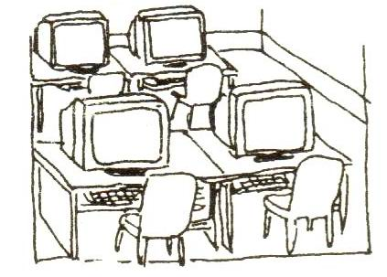
1． I’m in the ( computer room, dining room).
2. What shape is it? It’s a ( triangle, circle)
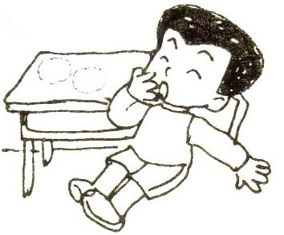
3. Tom is ( sleepy, sad)
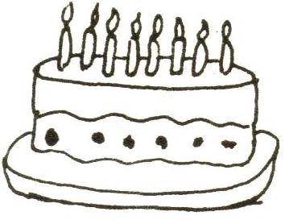
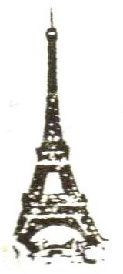
4. Today is my birthday. I am (eight, nine)
5. Alice is from ( Paris, London)
四、选出正确的应答句:5%
1. Are you in the reading room?
A. Yes, I am. B. Yes, I’m not.
2. Here’s a star for you.
A. Yes. B. Thank you.
3. Where are you from?
A. I’m nine. B. I’m from Hangzhou.
4. Is the cat on the box?
A. Yes, it is. B. Yes, I am.
5. I’m hungry.
A. Here is a cake for you. B. Here’s some milk for you.
五．根据短文判断正误，对的用 “T”, 错的用 “F”表示：6%
Hello, I’m Sandy. I’m ten. I’m from Shanghai. I’ve got a new eraser. It’s a circle. This is Sue. She’s from Sydney. She’s pretty. She’s got a new pencil-box. It’s a rectangle. We are in Class Three, Grade Two. We are good friends.
1.( ) I’m eleven.
2.( ) I’ve got a new eraser.
3.( ) My eraser is a circle.
4.( ) Sue is from Shanghai.
5.( ) Sue’s new pencil-box is a triangle.
6.( ) Sue is in Class Three.
二年级第一学期英语期中考试听力部分
一、 在听到的字母或单词下打勾：16%
1.d 2. h 3. eic 4. fng 5. New York 6. thirsty 7. twelve 8. under
二．按听到的顺序给下列图片或单词编号: 16%
1. square triangle circle rectangle
2． under the desk in the box near the bed on the box
3． thirsty sleepy happy sad
4．computer room dining room classroom reading room
三．听录音， 将人物与图片用线连起来：8%
1． A: Hello, are you Norman? B: Yes, I am.
A: Where are you from? B: I’m from Beijing.
- A: Good morning. I’m Alice. I’m new here.
B: Good morning. How old are you?
A: I’m nine.
3． A: Tommy, are you in Class One?
B: No, I’m not. I’m in Class Two. X k b 1 . c o m
A: This is Class One. B: I’m sorry.
4． A: Sandy, are you hungry? B: Yes, I am.
A: Do you like cake? B: No, I like cookies.
四、听音编号: 12%
This is Mike, a new boy.
Welcome to our class.
Hello, I am Tom. Where are you from?
I’m from New York.
Hello, I am Yang Mingming. Where is New York?
It’s in the USA.
五、听句子，圈单词: 8% X k b 1 . c o m
1． Are you in Class ( Three) ? No, I’m not.
2. What (shape) is it? It’s a (square).
3. Where is the cat? It’s (near) the desk.
4. I’m (thirsty). I want some (coke)
5. How old are you? I’m ( eight).
6. Where are you from? I’m from (Paris)

