五年级上册

Unit 6 Part A Read and write

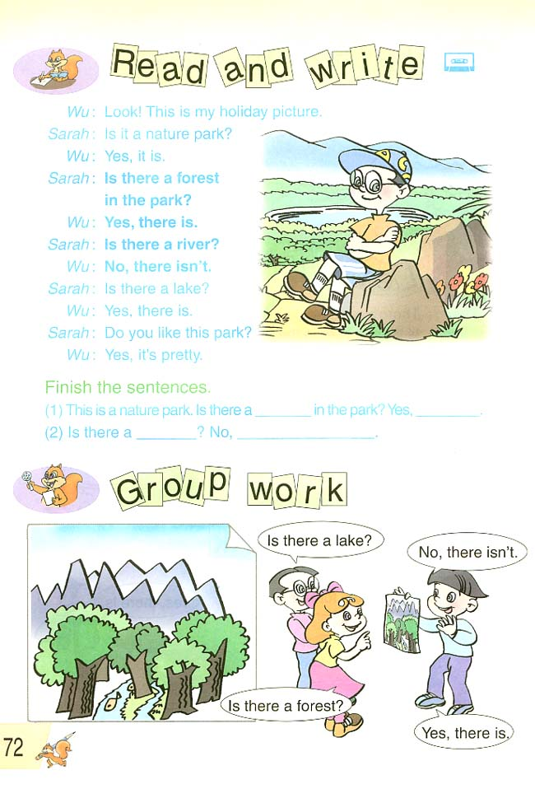

一 教学目标与要求
1. 能够听说读写句型：Is there … ? Yes, there is. No, there isn`t.
2. 能用Is there … ? Yes, there is. No, there isn`t. 谈论假日照片。
3. 能够理解Story time的故事内容。
二 教学重难点分析
本课的教学重点是使学生掌握Is there … ? Yes, there is. No, there isn`t.句型，培养学生在实际情景中运用对话的能力是本课的难点，教师应注意设计一些真实的情景让学生练习主句型。
三 课前准本
1. PPT
2. 一本挂历
3．若干词卡
四 教学步骤
(一) Preparation
1. Let`s chant.
2. 分组闪现单词，生速记
T: Do it like this. 双手呈望远镜状
3. PK: spelling
4. 千里传音
T: Is there a mountain?
5. 囊中猜物
T: There are some fruits in the bag.
Guess, is there … ?
6. 猜猜山水画中有什么？
T: What about the picture?
Is there … ?
Is it beautiful?
We can also say, it`s pretty！
7. holiday
T: In January, we have the final exam.
期中考试之后，什么就到了？
Ss：寒假！
T: Bingo! It`s winter holiday.
holiday
(二) In-reading
1. Detail-reading
T: Wu Yifan has a holiday picture.
There are 3 questions.
( ) (1) Is there a forest in the park?
A. Yes, there is. B. No, there isn’t.
( ) (2) Is there a river in the park?
A. Yes, there is. B. No, there isn’t
( ) (3) Is there a lake?
A. Yes, there is. B. No, there isn’t
2. Read and write
T: Boys and girls, read the dialogue again and finish the blanks, OK?
(1) This is a nature park. Is there a ________ in the park ?
Yes, ______________ .
(2) Is there a ____________? No, __________________ .
(三) Practice
1. Post reading
(1) Listen to the tape
(2) Listen and follow
(3) 找找老师的错
T: 听听看，老师读的问题吗？
(4) Boys vs girls
Read in pairs
(5) 配音
T: 快慢跟着它来，OK?
(四) Production
1. 心有灵犀
T：Can you read ?
谁来用动作表演，我们大家来猜？
2. 小小代言人
T: Let`s enjoy some other holiday pictures.
你去过什么自然公园或名胜古迹？
(五) Progress
1. 有关美国黄石公园
T: Do you know the Yellow Stone National Park?
Here is a dialogue about it.
Let`s see.
2. Homework

